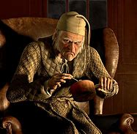
Scrooge’s Diary Entry
Pretend that you are Scrooge and describe 1 event that has happened to you in the story.
You are Scrooge, and you were there, so make sure you give details about the following:
1.Describe the setting in good detail.
2.Explain what happened in your own words.
3.Give details from the story.
4.How did you feel?
5.How did it change/affect you?

Scrooge’s Diary Entry
Pretend that you are Scrooge and describe 1 event that has happened to you in the story.
You are Scrooge, and you were there, so make sure you give details about the following:
1.Describe the setting in good detail.
2.Explain what happened in your own words.
3.Give details from the story.
4.How did you feel?
5.How did it change/affect you?

