Anthology Poetry – Love Poems. Using SMILE to analyse a poem and writing a personal response.
Read the poem and write notes on your first impressions.
Pick out 3 words and brainstorm what they make you think about.
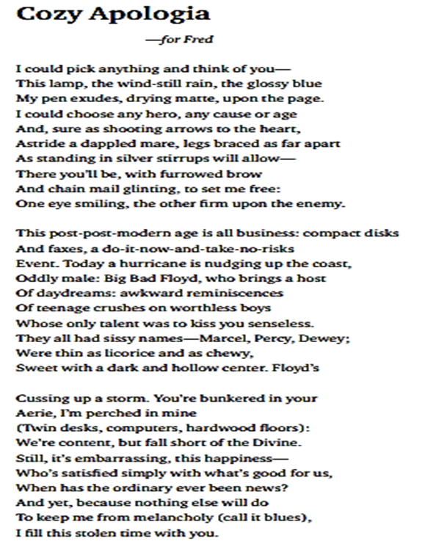
Re-read the poem and make notes next to the questions on the following page. Annotate the poem using the questions to guide you.

Structure:
When you have finished your notes and preparation – use them to answer the following question.

Write about the poem and the ideas the poet presents. Explain what techniques are used and what these make you think and feel and why. Aim for at least 5 PETER paragraphs.
How is the piece organised on the page?
How many stanza’s / verses are there?
Are the stanzas equal or unequal?
What is the line length?
Is there a rhyme scheme? What is it?
Can you identify the topic of each stanza? Label it..
Is there any repetition? Enjambment? Where? What is the effect?
Meaning:
What is the poem about?
Can you discover more than one meaning?
What ideas and themes is the poet portraying?
What is the poet’s point of view?

Imagery
Which images are conveyed to the reader?
Does the poem contain metaphors, similes, personification?
Why do you think the poet has included the images in the poem?

Language
Which words has the poet used to convey meaning?
What are the connotations fo the language used? Is there more than one meaning of a word or phrase?
Has the poet used figurative language (onomatapoeia, alliteration. assonance)
How has the poet used language to infer meaning?

For each category above, remember to explain the effect on the reader.
What effect on the reader is the poet trying to achieve and how? What do the words make you think and feel and why? Why is the purpose of the poet’s choice of langauge/theme/opinion?
What is your overall impression of the poem and why?

