Year 10
Wider Reading

Booklet 2

Contents Page

Week 1: Dark Secrets – Conspiracy Theories Non-Fiction

Week 2: Northern Lights by Philip Pullman Fiction

Week 3: The History of Lego Non-Fiction

Week 4: The Curious Incident of the Dog in the Night-Time Fiction
by Mark Haddon

Week 5: Boat, Bus or Box – Schools of the World Non-Fiction

Week 6: Power by Naomi Alderman Fiction

Week 7: Social Distancing Non-Fiction

Week 1: Dark Secrets – Conspiracy Theories
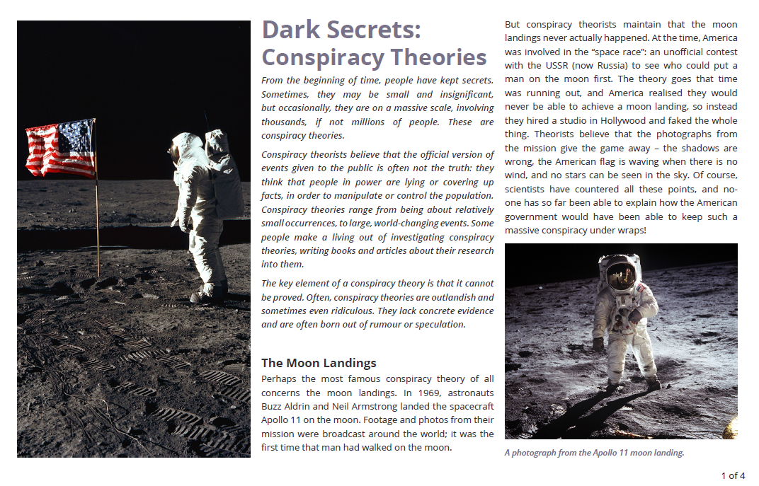
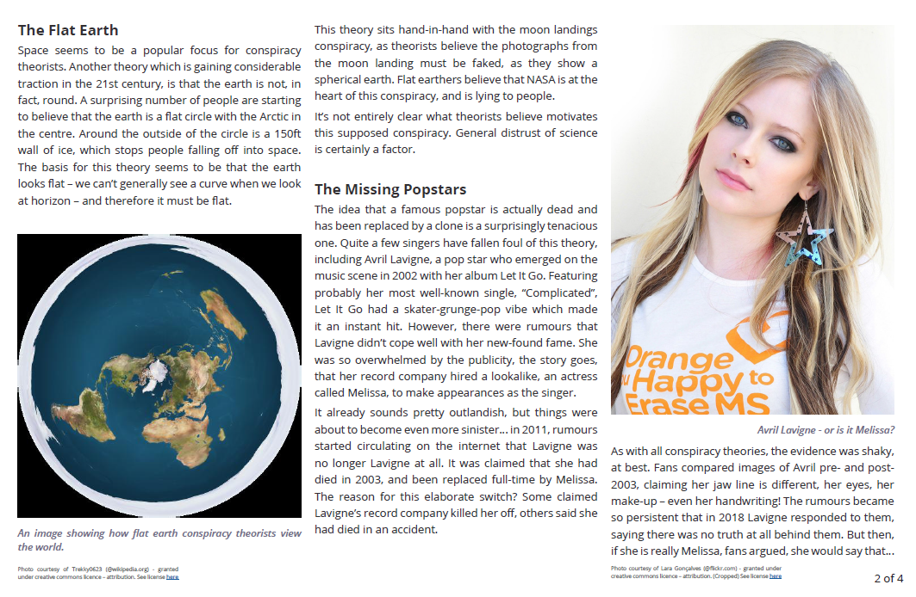

Questions
- What do conspiracy theorists believe was the motivation for the faking of the moon landings in 1969?

- What do flat earthers think the world looks like?

- What do conspiracy theorists believe happened to Avril Lavigne?

Extended Responses:
Why do you think people believe in conspiracy theories?
____________________________________________________________________________________
____________________________________________________________________________________
____________________________________________________________________________________
____________________________________________________________________________________
____________________________________________________________________________________
____________________________________________________________________________________
____________________________________________________________________________________
____________________________________________________________________________________

Do you think there is any harm in conspiracy theories?
____________________________________________________________________________________
____________________________________________________________________________________
____________________________________________________________________________________
____________________________________________________________________________________
____________________________________________________________________________________
____________________________________________________________________________________
____________________________________________________________________________________
____________________________________________________________________________________

Week 2: ‘Northern Lights’ by Philip Pullman
‘Northern Lights’ is the first part in a trilogy which follows the story of Lyra, who travels between worlds to discover the secrets of her family and the universe. In this passage, Lyra, a young girl, and Pan, her daemon, are captured by strangers and then rescued. Daemons are creatures which have a special bond with the human they are connected to. A daemon can change its form and appear as a variety of different animals.
Lyra tiptoed up to the hut and peeped in at the window. An old man was laboriously reading a picture-story paper and smoking a pipe, with his spaniel daemon curled up asleep on the table. As she looked, the man got up and brought a blackened kettle from the iron stove and poured some hot water into a cracked mug before settling back with his paper.
"Should we ask him to let us in, Pan?" she whispered, but he was distracted; he was a bat, an owl, a wildcat again; she looked all round, catching his panic, and then saw them at the same time as he did: two men running at her, one from each side, the nearer holding a throwing net.
Pan uttered a harsh scream and launched himself as a leopard at the closer man's daemon, a savage-looking fox, bowling her backward and tangling with the man's legs. The man cursed and dodged aside, and Lyra darted past him toward the open spaces of the wharf. What she mustn't do was get boxed in a corner.
Pan, an eagle now, swooped at her and cried, "Left! Left!"
She swerved that way and saw a gap between the coal-spirit barrels and the end of a corrugated iron shed, and darted for it like a bullet. But those throwing nets!
She heard a hiss in the air, and past her cheek something lashed and sharply stung, and loathsome tarred strings whipped across her face, her arms, her hands, and tangled and held her, and she fell, snarling and tearing and struggling in vain.
"Pan! Pan!"
But the fox daemon tore at the cat Pan, and Lyra felt the pain in her own flesh, and sobbed a great cry as she fell. One man was swiftly lashing cords around her, around her limbs, her throat, body, head, bundling her over and over on the wet ground. She was helpless, exactly like a fly being trussed by a spider. Poor hurt Pan was dragging himself toward her, with the fox daemon worrying his back, and he had no strength left to change, even.
The whole world grew still as the man tying the net saw it too.
Pan sat up and blinked, and then there was a soft thud, and the net man fell choking and gasping right across Lyra, who cried out in horror: that was blood gushing out of him!
Running feet, and someone hauled the man away and bent over him; then other hands lifted Lyra, a knife snicked and pulled and the net strings fell away one by one, and she tore them off, spitting, and hurled herself down to cuddle Pan.
Kneeling, she twisted to look up at the newcomers. Three dark men, one armed with a bow, the others with knives; and as she turned, the bowman caught his breath.
"That en't Lyra?"
A familiar voice, but she couldn't place it till he stepped forward and the nearest light fell on his face and the hawk daemon on his shoulder. Then she had it. A gyptian! A real Oxford gyptian!

Questions
- List the different forms Lyra’s daemon Pan takes.

- How does Lyra feel as she is captured?

- Who rescues Lyra at the end of the extract?

- What impression do you get of Lyra in this extract? Why?

Vocabulary
Match a word in bold to teach of the definitions. Memorise the words.
bound, trapped | with difficulty | quickly | horrible

Your interpretations
Complete the paragraph opening. Include short embedded quotations in your answer.
The author creates an atmosphere of shock and confusion through _____________________________
____________________________________________________________________________________
____________________________________________________________________________________
____________________________________________________________________________________
____________________________________________________________________________________
____________________________________________________________________________________
____________________________________________________________________________________
____________________________________________________________________________________
____________________________________________________________________________________
____________________________________________________________________________________
____________________________________________________________________________________
____________________________________________________________________________________
____________________________________________________________________________________
____________________________________________________________________________________
____________________________________________________________________________________

Week 3: ‘The History of Lego’

Questions
- Why do you think the article starts with a rhetorical question?

- Chose one of the subheadings in the text. Why did the author choose this and why is this effective?

- How did Kristiansen settle on the name LEGO? Give two facts from the text.

- What was the philosophy behind the LEGO System of Play? Why did Godtfred Kirk Kristiansen develop it?

Extended Response:
One pupil wrote, “The author of the article seems to clearly appreciate the hard work ethic and business success of the LEGO company.” To what extent do you agree with this statement?
_______________________________________________________________________________________________________________________________________________________________________________________________________________________________________________________________________________________________________________________________________________________________________________________________________________________________________________________________________________________________________________________________________________________________________________________________________________________________________________________________________________________________________________________________________________________________________________________________________________________________________________________________________________________
_______________________________________________________________________________________________________________________________________________________________________________________________________________________________________________________________________________________________________________________________________________________________________________________________________________________________________________________________________________________________________________________________________________________________________________________________________________________________________________________________________________________________________________________________________________________________________________________________________________________________________________________________________________________

Week 4: ‘The Curious Incident of the Dog in the Nighttime’ by Mark Haddon
‘The Curious Incident of the Dog in the Night-Time’ is a popular novel and play. It is narrated by Christopher Boone, a character who describes himself as “a mathematician with some behaviour difficulties”. Although Christopher’s condition is not stated, the blurb refers to high-functioning Autism, or Asperger’s Syndrome. In the novel, Christopher is investigating the murder of his neighbour’s dog.
It was 7 minutes after midnight. The dog was lying on the grass in the middle of the lawn in front of Mrs Shears' house. Its eyes were closed. It looked as if it was running on its side, the way dogs run when they think they are chasing a cat in a dream. But the dog was not running or asleep. The dog was dead. There was a garden fork sticking out of the dog. The points of the fork must have gone all the way through the dog and into the ground because the fork had not fallen over. I decided that the dog was probably killed with the fork because I could not see any other wounds in the dog and I do not think you would stick a garden fork into a dog after it had died for some other reason, like a road accident. But I could not be certain about this.
I went through Mrs Shears' gate, closing it behind me. I walked onto her lawn and knelt beside the dog. I put my hand on the muzzle of the dog. It was still warm.
The dog was called Wellington. It belonged to Mrs Shears who was our friend. She lived on the opposite side of the road, two houses to the left.
Wellington was a poodle. Not one of the small poodles that have hairstyles but a big poodle. It had curly black fur, but when you got close you could see that the skin underneath the fur was a very pale yellow, like chicken.
I stroked Wellington and wondered who had killed him, and why.
***
My name is Christopher John Francis Boone. I know all the countries of the world and their capital cities and every prime number up to 7,057.
Eight years ago, when I first met Siobhan, she showed me this picture
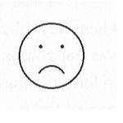
and I knew that it meant 'sad,' which is what I felt when I found the dead dog. Then she showed me this picture
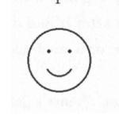
and I knew that it meant 'happy', like when I'm reading about the Apollo space missions, or when I am still awake at 3 am or 4 am in the morning and I can walk up and down the street and pretend that I am the only person in the whole world.
Then she drew some other pictures
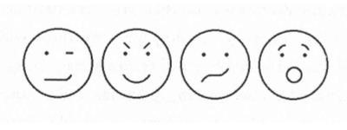
but I was unable to say what these meant.
I got Siobhan to draw lots of these faces and then write down next to them exactly what they meant. I kept the piece the piece of paper in my pocket and took it out when I didn't understand what someone was saying. But it was very difficult to decide which of the diagrams was most like the face they were making because people's faces move very quickly.
When I told Siobhan that I was doing this, she got out a pencil and another piece of paper and said it probably made people feel very
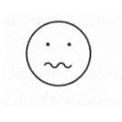
and then she laughed. So I tore the original piece of paper up and threw it away. And Siobhan apologised. And now if I don't know what someone is saying I ask them what they mean or I walk away.
***
I pulled the fork out of the dog and lifted him into my arms and hugged him. He was leaking blood from the fork-holes.
I like dogs. You always know what a dog is thinking. It has four moods. Happy, sad, cross and concentrating. Also, dogs are faithful and they do not tell lies because they cannot talk.
I had been hugging the dog for 4 minutes when I heard screaming. I looked up and saw Mrs Shears running towards me from the patio. She was wearing pyjamas and a housecoat. Her toenails were painted bright pink and she had no shoes on.

Questions
- What does Christopher see from his window and how does he describe it?

- Who do you think Siobhan is? How does she try to help Christopher?

- List four talents Christopher seems to have in this extract.

- Explain one thing Christopher finds challenging.

- What do you think Mrs Shears is thinking when she runs towards Christopher?

- The author, Mark Haddon, decided to use simple, straight-forward vocabulary in this novel. Why do you think this might be?

Your interpretations
Complete the paragraph opening.
‘The Curious Incident of the Dog in the Night-Time’ is an important book for Year 10 students to read because ______________________________________________________________________________ __________________________________________________________________________________________________________________________________________________________________________________________________________________________________________________________________________________________________________________________________________________________________________________________________________________________________________________________________________________________________________________________________________________________________________________________________________________________________________________________________________________________________________________________________________________________________________________________________________________________________________________________________________________

Week 5: ‘Boat, Bus or Box’

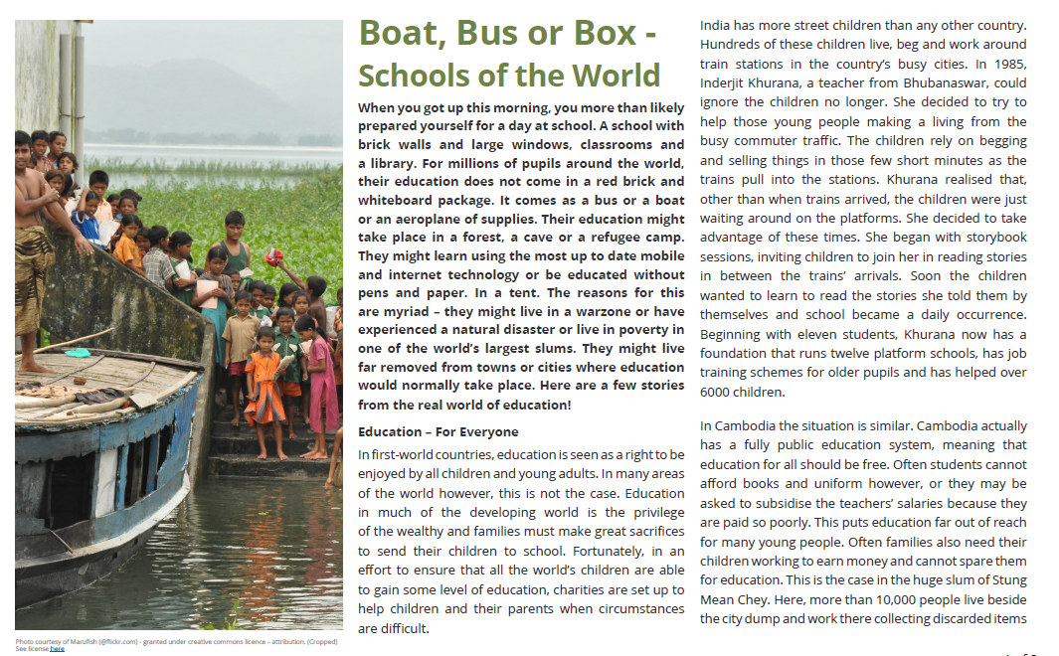

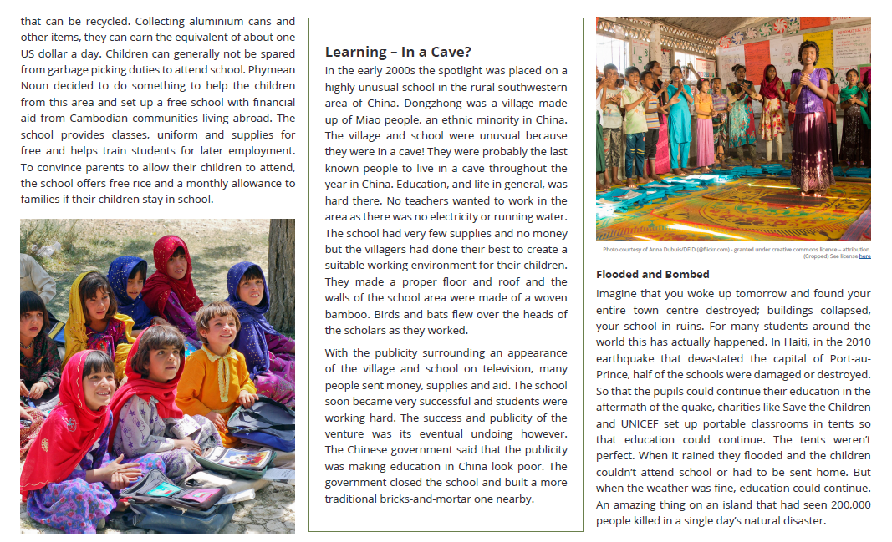
Questions
- Why might the author begin the article by questioning the reader about their school experience?

- Create a list of the reasons the author gives for needing an alterative to a school building.

- How does the author depict first-world education as different from education in the developing world?

- How does the author show us that platform schools have been successful?

Extended Response:
Why is education seen as important throughout the world?
__________________________________________________________________________________________________________________________________________________________________________________________________________________________________________________________________________________________________________________________________________________________________________________________________________________________________________________________________________________________________________________________________________________________________________________________________________________________________________________________________________________________________________________________________________________________________________________________________________________________________________________________________________________
__________________________________________________________________________________________________________________________________________________________________________________________________________________________________________________________________________________________________________________________________________________________________________________________________________________________________________________________________________________________________________________________________________________________________________________________________________________________________________________________________________________________________________________________________________________________________________________________________________________________________________________________________________________

Week 6: ‘The Power’ by Naomi Alderman
In ‘The Power’, females have developed the power to electrocute others. The world quickly develops into a system where women have control over men. In this extract, Margot talks to her daughter Jos about her new special abilities.
Jos frowns. ‘Plenty of girls started it before I did. It was. . . it was kinda funny. . . when it started, like static electricity.’
Static electricity. What was it, you combed your hair and stuck a balloon to it? An activity for bored six-year-olds at birthday parties.
‘It was this funny, crazy thing girls were doing. There were secret videos online. How to do tricks with it.’
It’s this exact moment, yes, when any secret you have from your parents becomes precious. Anything you know that they’ve never heard of.
How did you. . . how did you learn to do it?
Jos says, ‘I don’t know. I just felt I could do it, OK . It’s like a sort of... twist.’
‘Why didn’t you say anything? Why didn’t you tell me?’
She looks through the window to the lawn. Beyond the high back fence, men and women with cameras are already gathering. ‘I don’t know.’
Margot remembers trying to talk to her own mother about boys or the stuff that happened at parties. About how far was too far, where a boy’s hand should stop. She remembers the absolute impossibility of those conversations.
‘Show me.’
Jos narrows her eyes. ‘I can’t. . . I’d hurt you.’
‘Have you been practising? Can you control it well enough so you know you wouldn’t kill me, or give me a fit?’
Jos takes a deep breath. Puffs her cheeks out. Lets the breath out slowly. ‘Yes.’
Her mother nods. This is the girl she knows: conscientious and serious. Still Jos. ‘Then show me.’
‘I can’t control it well enough for it not to hurt, OK?’
‘How much will it hurt?’
Jos splays her fingers wide, looks at her palms. ‘Mine comes and goes. Sometimes it’s strong, sometimes it’s nothing.’
Margot presses her lips together. ‘OK.’
Jos extends her hand, then pulls it back. ‘I don’t want to.’
There was a time when every crevice of this child’s body was Margot’s to clean and care for. It is not OK with her not to know her own child’s strength. ‘No more secrets. Show me.’
Jos is near to tears. She places her forefinger and her middle finger on her mother’s arm. Margot waits to see Jos do something; hold her breath, or wrinkle her brow, or show exertion in the muscles of her arm, but there’s nothing. Only the pain.
From the place on her forearm where Jos is touching her, it starts as a dull bone-ache. The flu, travelling through the muscles and joints. It deepens. Something is cracking her bone, twisting it, bending it, and she wants to tell Jos to stop but she can’t open her mouth. It burrows through the bone like it’s splintering apart from the inside; she can’t stop herself seeing a tumour, a solid, sticky lump bursting out through the marrow of her arm, splitting the ulna and the radius to sharp fragments. She feels sick. She wants to cry out. The pain radiates across her arm and, nauseatingly, through her body. There’s not a part of her it hasn’t touched now; she feels it echo in her head and down her spine, across her back, around her throat and out, spreading across her collarbone.
The collarbone. It has only been a few seconds, but the moments have elongated. Only pain can bring such attention to the body; this is how Margot notices the answering echo in her chest. Among the forests and mountains of pain, a chiming note along her collarbone. Like answering to like.
There is a tingling feeling in her chest and arms and hands. Like a dead arm, waking up. The pain is not gone now, but it is irrelevant. Something else is happening. Instinctively, she digs her hands into Jocelyn’s patchwork comforter. She smells the scent of the beech trees of her childhood home, as if she were back beneath their woody protection, their musk of old timber and wet loam.
When she opens her eyes, there is a pattern around each of her hands. Concentric circles, light and dark, light and dark, burned into the comforter where her hands clutched it. And she knows, she felt that twist, and she remembers that maybe she has always known it and it has always belonged to her. Hers to cup in her hand. Hers to command to strike.
‘Oh God,’ she says. ‘Oh God.’

Questions
- What secret did Jos keep from her mother?

- Why do you think men and women with cameras are gathering on the lawn?

- What does Margot want her daughter to do?

- How does Margot describe the pain?

- What do you think might be happening to Margot at the end of the extract?

Vocabulary
emits, releases | feeling sick | getting longer | unconnected,  unrelated
hard physical work | mature, thoughtful | soil,  earth | core, centre

Your interpretations
Complete the paragraph openings. Include short quotations in your answer.
The author powerfully describes the pain of her daughter’s powers in ___________________________
____________________________________________________________________________________
____________________________________________________________________________________
____________________________________________________________________________________
____________________________________________________________________________________ ____________________________________________________________________________________

However, there is also a suggestion of excitement at the end of the extract because _______________
____________________________________________________________________________________
____________________________________________________________________________________
____________________________________________________________________________________
____________________________________________________________________________________
____________________________________________________________________________________
____________________________________________________________________________________ ____________________________________________________________________________________

Week 7: Social Distancing
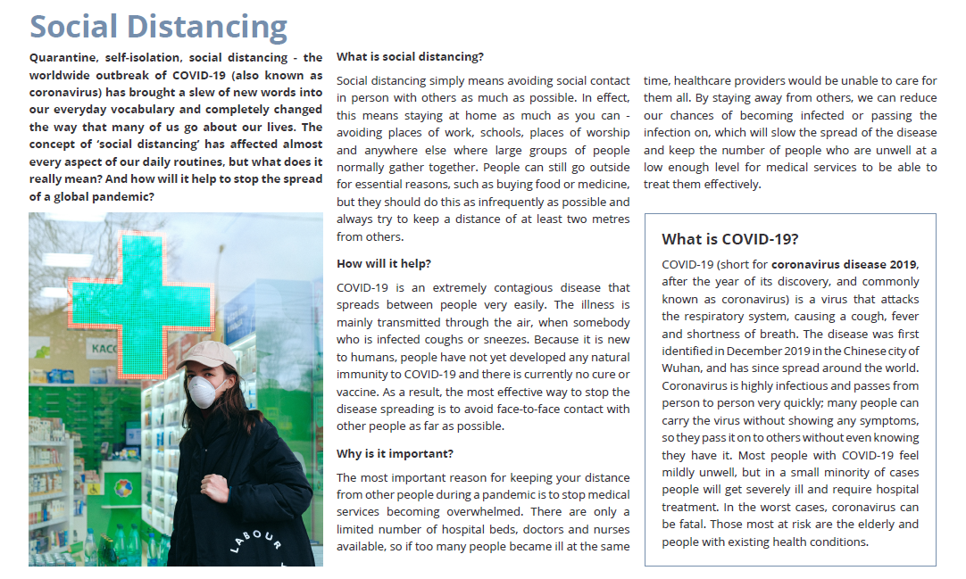

Questions

- Why is social distancing important when infectious disease breaks out?

- Why is it particularly difficult to stop the spread of COVID-19?

- What is the origin of the word ‘Quarantine’?

- Why were the Apollo 11 astronauts kept in quarantine when they returned to Earth?

Extended Response:
How would you encourage young people to stay at home and maintain social distancing? Write a short speech.
__________________________________________________________________________________________________________________________________________________________________________________________________________________________________________________________________________________________________________________________________________________________________________________________________________________________________________________________________________________________________________________________________________________________________________________________________________________________________________________________________________________________________________________________________________________________________________________________________________________________________________________________________________________
________________________________________________________________________________________________________________________________________________________________________________________________________________________________________________________________________________________________________________________________________________________________________________________________________________________________________________________________________________________________________________________________________________________________________________________________________________________________________________________________________________________________________

