Year 10
Wider Reading

Booklet 1

Contents Page

Week 1: The Hunger Games by Suzanne Collins Fiction

Week 2: Modern Spying Non-Fiction

Week 3: The Circle by Dave Eggers Fiction

Week 4: Ninja Know-How Non-Fiction

Week 5: The Outsiders by S.E. Hinton Fiction

Week 6: The World of Q Non-Fiction

Week 7: The Hate U Give by Angie Thomas Fiction

Week 1: ‘The Hunger Games’ by Suzanne Collins
‘The Hunger Games’ is the first part in the popular trilogy by Suzanne Collins. It is set in a dystopian future, where society has been split up into different districts. Inequality is rife, and the poorer districts revolve around the needs of the selfish rich who live in the Capitol. Each year, the Capitol organises a brutal fight to the death between the districts. Each district must send two Tributes to kill, or be killed. Katniss Everdeen is the chosen tribute from District 12. In this extract, the fight has just begun.
Sixty seconds. That’s how long we’re required to stand on our metal circles before the sound of a gong releases us. Step off before the minute is up, and land mines blow your legs off. Sixty seconds to take in the ring of tributes all equidistant from the Cornucopia, a giant golden horn shaped like a cone with a curved tail, the mouth of which is at least twenty feet high, spilling over with the things that will give us life here in the arena. Food, containers of water, weapons, medicine, garments, fire starters. Strewn around the Cornucopia are other supplies, their value decreasing the farther they are from the horn. For instance, only a few steps from my feet lies a three-foot square of plastic. Certainly it could be of some use in a downpour. But there in the mouth, I can see a tent pack that would protect from almost any sort of weather. If I had the guts to go in and fight for it against the other twenty-three tributes. Which I have been instructed not to do.
We’re on a flat, open stretch of ground. A plain of hard-packed dirt. Behind the tributes across from me, I can see nothing, indicating either a steep downward slope or even a cliff. To my right lies a lake. To my left and back, sparse piney woods. This is where Haymitch would want me to go. Immediately.
I hear his instructions in my head. “Just clear out, put as much distance as you can between yourselves and the others, and find a source of water.”
But it’s tempting, so tempting, when I see the bounty waiting there before me. And I know that if I don’t get it, someone else will. That the Career Tributes who survive the bloodbath will divide up most of these life-sustaining spoils. Something catches my eye. There, resting on a mound of blanket rolls, is a silver sheath of arrows and a bow, already strung, just waiting to be engaged. That’s mine, I think. It’s meant for me.
I’m fast. I can sprint faster than any of the girls in our school, although a couple can beat me in distance races. But this forty-yard length, this is what I am built for. I know I can get it, I know I can reach it first, but then the question is how quickly can I get out of there? By the time I’ve scrambled up the packs and grabbed the weapons, others will have reached the horn, and one or two I might be able to pick off, but say there’s a dozen, at that close range, they could take me down with the spears and the clubs. Or their own powerful fists. Still, I won’t be the only target. I’m betting many of the other tributes would pass up a smaller girl, even one who scored an eleven in training, to take out their more fierce adversaries.
Haymitch has never seen me run. Maybe if he had he’d tell me to go for it. Get the weapon. Since that’s the very weapon that might be my salvation. And I only see one bow in that whole pile. I know the minute must be almost up and will have to decide what my strategy will be and I find myself positioning my feet to run, not away into the surrounding forests but toward the pile, toward the bow.
When suddenly I notice Peeta, he’s about five tributes to my right, quite a fair distance, still I can tell he’s looking at me and I think he might be shaking his head. But the sun’s in my eyes, and while I’m puzzling over it the gong rings out.
And I’ve missed it! I’ve missed my chance! Because those extra couple of seconds I’ve lost by not being ready are enough to change my mind about going in. My feet shuffle for a moment, confused at the direction my brain wants to take and then I lunge forward, scoop up the sheet of plastic and a loaf of bread. The pickings are so small and I’m so angry with Peeta for distracting me that I sprint in twenty yards to retrieve a bright orange backpack that could hold anything because I can’t stand leaving with virtually nothing.

Questions
- Where is Katniss in the extract?

- How is she feeling? Why?

- What decision is she trying to make?

- Do you think she made the right decision? Why?

- What impression do you get of Peeta? Why?

Vocabulary
Match a word in bold to teach of the definitions. Memorise the words.
enemies | rewards | supporting, nourishing
thrown, scattered | of equal distance | thin, bare

Your interpretations
Complete the paragraph opening. Include short embedded quotations in your answer.
The author creates tension through ______________________________________________________
____________________________________________________________________________________
____________________________________________________________________________________
____________________________________________________________________________________
____________________________________________________________________________________
____________________________________________________________________________________
____________________________________________________________________________________
____________________________________________________________________________________ ____________________________________________________________________________________

Week 2: Modern Spying
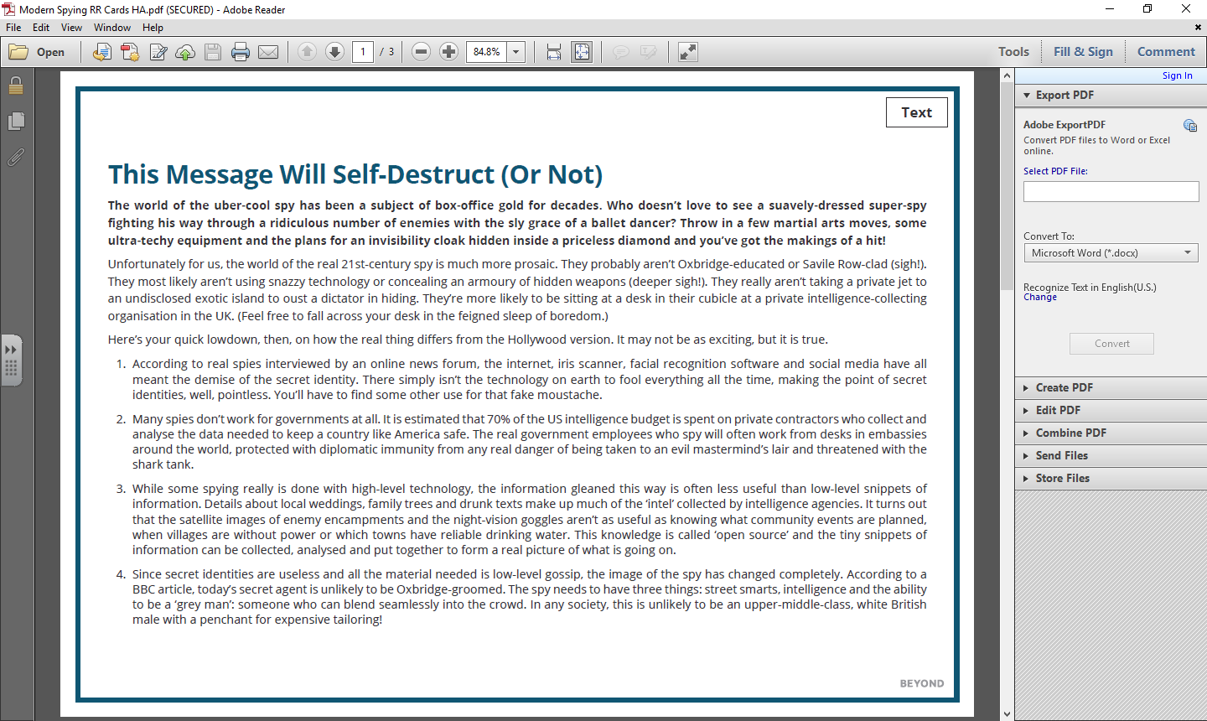

Questions
Analyse: How does the author use humour in the article?
____________________________________________________________________________________
____________________________________________________________________________________
____________________________________________________________________________________
____________________________________________________________________________________
____________________________________________________________________________________
____________________________________________________________________________________
____________________________________________________________________________________
____________________________________________________________________________________
____________________________________________________________________________________

Infer: In the final paragraph, the author describes the probable modern spy. What can you infer from this about the cultural and academic background MI5 and MI6 are looking for in future agents?
____________________________________________________________________________________
____________________________________________________________________________________
____________________________________________________________________________________
____________________________________________________________________________________
____________________________________________________________________________________
____________________________________________________________________________________
____________________________________________________________________________________
____________________________________________________________________________________
____________________________________________________________________________________

Personal Response: What do you think would make an effective spy in the 21st Century? Why?
____________________________________________________________________________________
____________________________________________________________________________________
____________________________________________________________________________________
____________________________________________________________________________________
____________________________________________________________________________________
____________________________________________________________________________________
____________________________________________________________________________________
____________________________________________________________________________________
____________________________________________________________________________________

Week 3: ‘The Circle’ by Dave Eggers
Dave Eggers is an American author. In his most famous novel a new tech company called The Circle has taken over Google, Facebook and Twitter. When Mae gets a job in its Californian campus, she is thrilled – until her life becomes enveloped by the Circle. The Circle is preparing to take full control over everyone and everything…
Mae opened the inbox and began. There were thousands upon thousands of messages, but she was determined to get through all the feeds that night. There were company-wide notices about each day’s menus, each day’s weather, each day’s words of the wise – last week’s aphorisms were from Martin Luther King, Gandhi, Salk, Mother Teresa and Steve Jobs. There were notices about each day’s campus visits: a pet adoption agency, a state senator, the director of Médecins Sans Frontières. Mae found out, with a sting of remorse, that she’d missed, that very morning, a visit from the winner of the Nobel Prize. She ploughed through the messages, every one, looking for anything she would have reasonably been expected to answer personally.
There were surveys, at least 50 of them, gauging the Circlers’ opinions on various company policies, on optimal dates for upcoming gatherings, interest groups, celebrations and holiday breaks. There were dozens of clubs soliciting members and notifying all of meetings: there were cat-owner groups – at least 10 – a few rabbit groups, six reptile groups, four of them adamantly snake-exclusive. Most of all, there were groups for dog-owners. She counted 22, but was sure that wasn’t all of them. One of the groups dedicated to the owners of very small dogs, Lucky Lapdogs, wanted to know how many people would join a weekend club for walks and hikes and support; Mae ignored this one. Then, realising that ignoring it would only prompt a second, more urgent, message, she typed a message, explaining that she didn’t have a dog. She was asked to sign a petition for more vegan options at lunch; she did. There were nine messages from various work-groups within the company, asking her to join their subgroups for more specific updates and information sharing. For now she joined the ones dedicated to crochet, soccer, and Hitchcock.
By 10pm, she’d made her way through all the messages and alerts, and now turned to her own private account. She hadn’t visited it in six days, and found 118 new notices from that day alone. She decided to plough through, newest to oldest. Most recently, one of her friends from college had posted a message about having the stomach flu, and a long thread followed, with friends making suggestions about remedies, some offering sympathy, some posting photos meant to cheer her up. Mae liked two of the photos, liked three of the comments, posted her own well wishes, and sent a link to a song, “Puking Sally”, that she’d found. That prompted a new thread, 54 notices, about the song and the band that wrote it. One of the friends on the thread said he knew the bassist in the band, and then looped him into the conversation. The bassist, Damien Ghilotti, was in New Zealand, was a studio engineer now, but was happy to know that “Puking Sally” was still resonating with the flu-ridden. His post thrilled all involved, and another 129 notices appeared, everyone thrilled to hear from the actual bassist from the band, and by the end of the thread, Damien Ghilotti was invited to play a wedding, if he wanted, or visit Boulder, or Bath, or Gainesville, or St Charles, Illinois, any time he happened to be passing through, and he would have a place to stay and a home-cooked meal. Upon the mention of St Charles, someone asked if anyone from there had heard about Tim Jenkins, who was fighting in Afghanistan; they’d seen some mention of a kid from Illinois being shot to death by an Afghan insurgent posing as a police officer. Sixty messages later the respondents had determined that it was a different Tim Jenkins, this one from Rantoul, Illinois, not St Charles. There was relief all around, but soon the thread had been overtaken by a multiparticipant debate about the efficacy of that war, US foreign policy in general, and whether or not we won in Vietnam or Grenada or even WWI.
Mae could no longer keep her eyes open. Though she’d only made it through three days of her social backlog, she shut down and made for the parking lot.

Questions
- Mae has two inboxes. List three of the items in her work inbox.

- List three of the items in her personal inbox.

- How do you think Mae is feeling in this extract? What’s causing the feeling?

- What might the author be warning the reader about?

- Does social media ever make you feel in a similar way? Explain your answer.

Vocabulary
Match a word in bold to teach of the definitions. Memorise the words.
ideal, perfect | asking for | confidently, without changing your mind
guilt | effectiveness, success | famous sayings or quotations

Your interpretations
This extract has lots of cultural references in it. Jot down what you know about each of these cultural references.
Martin Luther King | Médecins Sans Frontières
Gandhi | Steve Jobs
Mother Teresa | Hitchcock

Week 4: ‘Ninja Know-How’
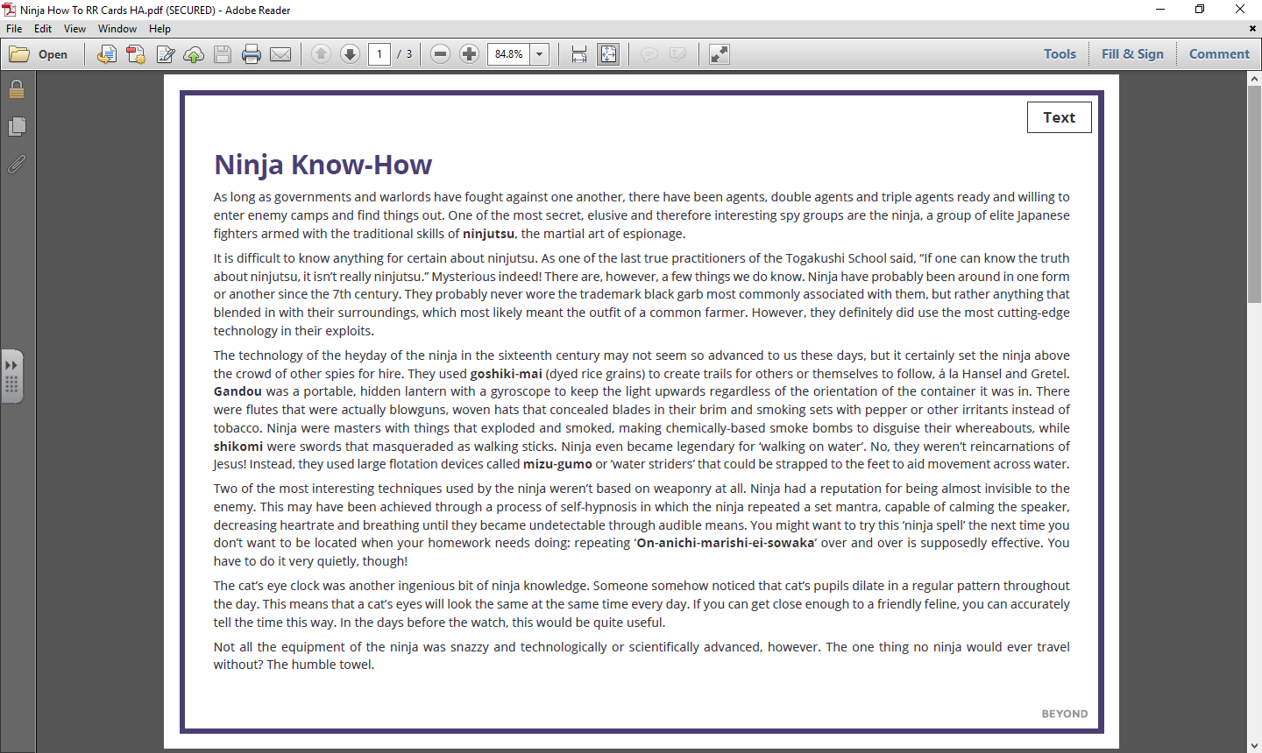

Questions
Analyse: How does the author structure the article to link each paragraph to the next?
____________________________________________________________________________________
____________________________________________________________________________________
____________________________________________________________________________________
____________________________________________________________________________________
____________________________________________________________________________________
____________________________________________________________________________________
____________________________________________________________________________________
____________________________________________________________________________________
____________________________________________________________________________________

Infer: What does the author think of the innovations of ‘ninja spells’ and the cat’s eye clock? How do you know?
____________________________________________________________________________________
____________________________________________________________________________________
____________________________________________________________________________________
____________________________________________________________________________________
____________________________________________________________________________________
____________________________________________________________________________________
____________________________________________________________________________________
Personal Response: A student has said that “the author seems to respect the innovations of the ninja.” To what extent do you agree with this comment? Provide quotations from the text to explain your response.
____________________________________________________________________________________
____________________________________________________________________________________
____________________________________________________________________________________
____________________________________________________________________________________
____________________________________________________________________________________
____________________________________________________________________________________
____________________________________________________________________________________
____________________________________________________________________________________
____________________________________________________________________________________
____________________________________________________________________________________
____________________________________________________________________________________

Week 5: ‘The Outsiders’ by S.E. Hinton
‘The Outsiders’ is a story of two rival gangs in 1960s America. The Greasers are poor and wear their hair long. The Socs (short for Socials) are wealthy, drive nice cars and live uptown. The main character Ponyboy is a misunderstood Greaser who lives with his two brothers. Incredibly, this very popular youth novel was written by a 16 year old! In this extract, Ponyboy is getting attacked by a group of Socs.
I about decided I didn't like it so much, though, when I spotted that red Corvair trailing me. I was almost two blocks from home then, so I started walking a little faster. I had never been jumped, but I had seen Johnny after four Socs got hold of him, and it wasn't pretty. Johnny was scared of his own shadow after that. Johnny was sixteen then.
I knew it wasn't any use though—the fast walking, I mean—even before the Corvair pulled up beside me and five Socs got out. I got pretty scared— I'm kind of small for fourteen even though I have a good build, and those guys were bigger than me. I automatically hitched my thumbs in my jeans and slouched, wondering if I could get away if I made a break for it. I remembered Johnny—his face all cut up and bruised, and I remembered how he had cried when we found him, half-conscious, in the corner lot. Johnny had it awful rough at home—it took a lot to make him cry.
I was sweating something fierce, although I was cold. I could feel my palms getting clammy and the perspiration running down my back. I get like that when I'm real scared. I glanced around for a pop bottle or a stick or something—Steve Randle, Soda's best buddy, had once held off four guys with a busted pop bottle—but there was nothing. So I stood there like a bump on a log while they surrounded me. I don't use my head. They walked around slowly, silently, smiling.
"Hey, grease," one said in an over-friendly voice. "We're gonna do you a favor, greaser. We're gonna cut all that long greasy hair off."
He had on a madras shirt. I can still see it. Blue madras. One of them laughed, then cussed me out in a low voice. I couldn't think of anything to say. There just isn't a whole lot you can say while waiting to get mugged, so I kept my mouth shut.
"Need a haircut, greaser?" The medium-sized blond pulled a knife out of his back pocket and flipped the blade open.
I finally thought of something to say. "No." I was backing up, away from that knife. Of course I backed right into one of them. They had me down in a second. They had my arms and legs pinned down and one of them was sitting on my chest with his knees on my elbows, and if you don't think that hurts, you're crazy. I could smell English Leather shaving lotion and stale tobacco, and I wondered foolishly if I would suffocate before they did anything. I was scared so bad I was wishing I would. I fought to get loose, and almost did for a second; then they tightened up on me and the one on my chest slugged me a couple of times. So I lay still, swearing at them between gasps. A blade was held against my throat.
"How'd you like that haircut to begin just below the chin?"
It occurred to me then that they could kill me. I went wild. I started screaming for Soda, Darry, anyone.

Someone put his hand over my mouth, and I bit it as hard as I could, tasting the blood running through my teeth. I heard a muttered curse and got slugged again, and they were stuffing a handkerchief in my mouth. One of them kept saying, "Shut him up, for Pete's sake, shut him up!"
Then there were shouts and the pounding of feet, and the Socs jumped up and left me lying there, gasping.

Questions
- What is following Ponyboy?

- What memory does Ponyboy recount in paragraph 1 and again in paragraph 2?

- How does this memory make Ponyboy feel?

- What does the Soc threaten to do?

- How does Ponyboy try to defend himself?

Vocabulary
Match a word in bold to teach of the definitions. Memorise the words.
punched  (slang) | a checked pattern, named after an area  in India | mugged  (slang) | a type of car

Your interpretations
Complete the paragraph opening. Include short embedded quotations in your answer.
The author immediately creates sympathy for Ponyboy because _______________________________
____________________________________________________________________________________
____________________________________________________________________________________
____________________________________________________________________________________
____________________________________________________________________________________
____________________________________________________________________________________
____________________________________________________________________________________
____________________________________________________________________________________
____________________________________________________________________________________
____________________________________________________________________________________
____________________________________________________________________________________

Week 6: ‘The World of Q’
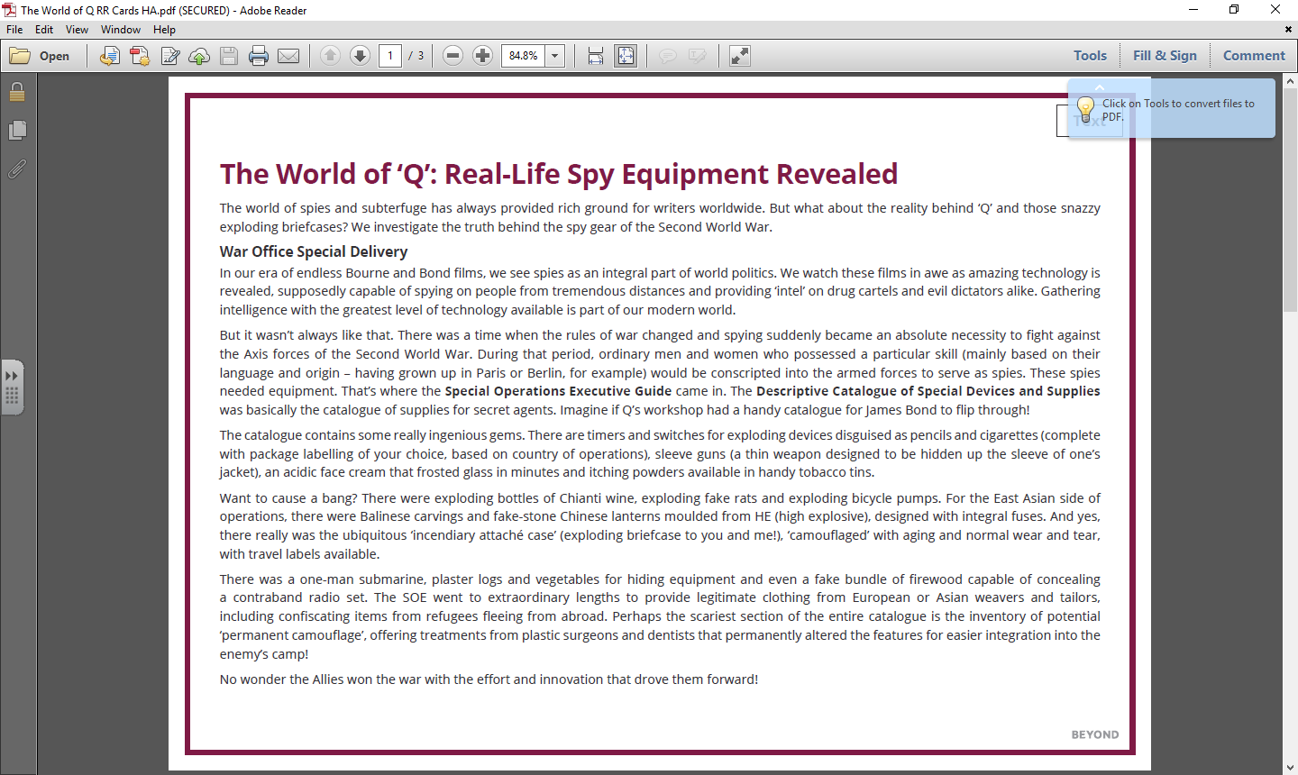
Questions
Analyse: What is the effect of the short sentences in the article? These include ‘But it wasn’t always like that.’ and ‘Want to cause a big bang?’
____________________________________________________________________________________
____________________________________________________________________________________
____________________________________________________________________________________
____________________________________________________________________________________
____________________________________________________________________________________
____________________________________________________________________________________
____________________________________________________________________________________
____________________________________________________________________________________
____________________________________________________________________________________
Infer: The author seems to have a set opinion about the spy equipment available in the Second World War. What does the writer think of it? What evidence supports your impressions?
____________________________________________________________________________________
____________________________________________________________________________________
____________________________________________________________________________________
____________________________________________________________________________________
____________________________________________________________________________________
____________________________________________________________________________________
____________________________________________________________________________________
____________________________________________________________________________________
____________________________________________________________________________________

Personal Response: Which of the devices mentioned in the article seems the most practical and useful? Explain your response in detail.
____________________________________________________________________________________
____________________________________________________________________________________
____________________________________________________________________________________
____________________________________________________________________________________
____________________________________________________________________________________
____________________________________________________________________________________
____________________________________________________________________________________
____________________________________________________________________________________
____________________________________________________________________________________

Week 7: ‘The Hate U Give’ by Angie Thomas
‘The Hate U Give’ is a young adult novel inspired by the Black Lives Matter movement in the USA. In this extract, Starr is sitting in a car with her friend Khalil. All of sudden, they are stopped by the police.
When I was twelve, my parents had two talks with me.
One was the usual birds and bees. The other talk was about what to do if a cop stopped me. Momma fussed and told Daddy I was too young for that. He argued that I wasn't too young to get arrested or shot.
"Starr-Starr, you do whatever they tell you to do," he said. "Keep your hands visible. Don't make any sudden moves. Only speak when they speak to you."
I knew it must've been serious. Daddy has the biggest mouth of anybody I know, and if he said to be quiet, I needed to be quiet. I hope somebody had the talk with Khalil. Khalil cusses under his breath, turns Tupac down, and manoeuvres the Impala to the side of the street. We're on Carnation where most of the houses are abandoned and half the streetlights are busted. Nobody around but us and the cop.
Khalil turns the ignition off. "Wonder what this fool wants."
The officer parks and puts his brights on. I blink to keep from being blinded. I remember something else Daddy said. If you're with somebody, you better hope they don't have nothing on them, or both of y'all going down.
"K, you don't have anything in the car, do you?" I ask.
He watches the cop in his side mirror. "Nah."
The officer approaches the driver's door and taps the window. Khalil cranks the handle to roll it down. As if we aren't blinded enough, the officer beams his flashlight in our faces.
"License, registration, and proof of insurance."
Khalil breaks a rule—he doesn't do what the cop wants. "What you pull us over for?"
"License, registration, and proof of insurance."
"I said what you pull us over for?"
"Khalil," I plead. "Do what he said."
Khalil groans and takes his wallet out. The officer follows his movements with the flashlight. My heart pounds loudly, but Daddy's instructions echo in my head: Get a good look at the cop's face. If you can remember his badge number, that's even better. With the flashlight following Khalil's hands, I make out the numbers on the badge—one fifteen. He's white, mid-thirties to early forties, has a brown buzz cut and a thin scar over his top lip.
Khalil hands the officer his papers and license. One-Fifteen looks over them. "Where are you two coming from tonight?"
"Nunya," Khalil says, meaning none of your business. "What you pull me over for?"
"Your taillight's broken."
"So are you gon' give me a ticket or what?" Khalil asks.
"You know what? Get out the car, smart guy."
"Man, just give me my ticket—"
"Get out the car! Hands up, where I can see them."
Khalil gets out with his hands up. One-Fifteen yanks him by his arm and pins him against the back door. I fight to find my voice. "He didn't mean—"
"Hands on the dashboard!" the officer barks at me. "Don't move!"
I do what he tells me, but my hands are shaking too much to be still. He pats Khalil down. "Okay, smart mouth, let's see what we find on you today."
"You ain't gon' find nothing," Khalil says.
One-Fifteen pats him down two more times. He turns up empty.
"Stay here," he tells Khalil. "And you," he looks in the window at me. "Don't move."
I can't even nod. The officer walks back to his patrol car. My parents haven't raised me to fear the police, just to be smart around them. They told me it's not smart to move while a cop has his back to you. Khalil does. He comes to his door. It's not smart to make a sudden move.
Khalil does. He opens the driver's door.
"You okay, Starr—"
Pow!
One. Khalil's body jerks. Blood splatters from his back. He holds onto the door to keep himself upright.
Pow!
Two. Khalil gasps.
Pow!
Three. Khalil looks at me, stunned.
He falls to the ground.

Questions
- How would you describe the atmosphere between the police officer and Khalil?

- How does Khalil respond to the officer?

- How does Starr respond to the officer differently?

- Whose response do you think is correct? Why?

- What words and sentence structures does the writer use to create dramatic tension at the end of the extract?

Vocabulary
Match a word in bold to teach of the definitions. Memorise the words.
sudden breath in | can be seen | movement in  a car | begs

Your interpretations
Complete the paragraph opening. Include these words in your answer: CRITICISE, EXPOSE, WARN
I think the author has written this extract in order to _________________________________________
____________________________________________________________________________________
____________________________________________________________________________________
____________________________________________________________________________________
____________________________________________________________________________________
____________________________________________________________________________________
____________________________________________________________________________________
____________________________________________________________________________________
____________________________________________________________________________________
____________________________________________________________________________________

