Unseen Poetry
The question will be:
Write about both poems and their effect on you. Show how they are similar and how they are different.
You may write about each poem separately and then compare them, or make comparisons where appropriate in your answer as a whole.
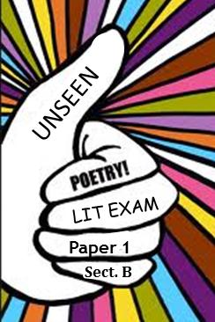
You may wish to include some or all of these points:
- the content of the poems – what they are about.
- the ideas the poets may have wanted us to think about - writer’s intentions.
- the mood or atmosphere of the poems.
- how they are written – words and phrases you find interesting, the way they are organised,
and so on – writer’s craft.
- your responses to the poems, including how they are similar and how they are different – personal response.
(20 marks) – 60 minutes approx.

Unseen Poetry
The question will be:
Write about both poems and their effect on you. Show how they are similar and how they are different.
You may write about each poem separately and then compare them, or make comparisons where appropriate in your answer as a whole.

You may wish to include some or all of these points:
- the content of the poems – what they are about.
- the ideas the poets may have wanted us to think about - writer’s intentions.
- the mood or atmosphere of the poems.
- how they are written – words and phrases you find interesting, the way they are organised,
and so on – writer’s craft.
- your responses to the poems, including how they are similar and how they are different – personal response.
(20 marks) – 60 minutes approx.

