‘Mind-blowing’ new AI can do ‘almost anything’ Monday, 27 July 2020
Should we be worried by AI? A groundbreaking program called GPT-3 can learn almost anything without human help. The possibilities are limitless, but some are saying so are the risks.

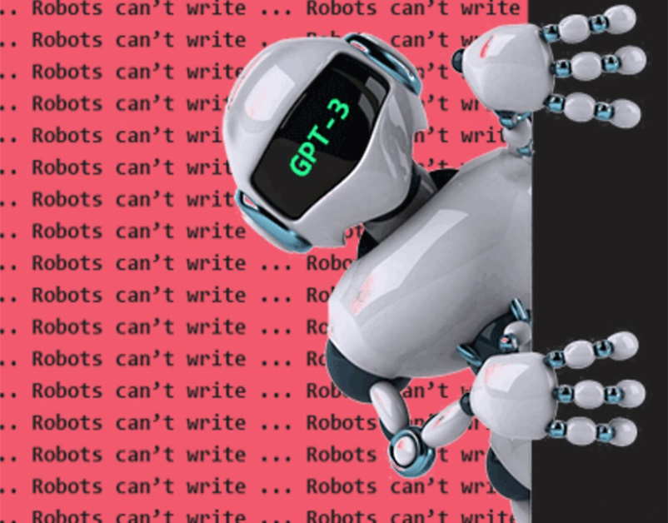
Did a human or a computer write this story? It just got much harder to tell.
A new artificial intelligence program called GPT-3 is creating a wave of excitement among scientists with its astonishing ability to learn and use language. Programmed with 175 billion rules and fed half a trillion words, GPT-3 is by far the most powerful language model ever built.
“Playing with GPT-3 feels like seeing the future,” says tech developer Arram Sabeti, who got the AI to write stories, articles, songs, and poetry. Other users described as “mind-blowing” its ability to code websites, compose music, and even diagnose diseases.
This ability to master all kinds of specific tasks without additional human input is a technological breakthrough with enormous implications.
But not everyone is enthusiastic. Entrepreneur Elon Musk has described AI technology as “summoning a demon” – even though he is one of the main funders of the company that designed GPT-3. He fears that we are approaching thetechnological singularity when computers will develop out of control and become more intelligent than humans.
We already live in a world run by AI. Many of us happily let it predict the words we type, choose our next song, control the temperature of our home, and even fly us 30,000 feet above the Earth. Because AIs don’t get tired or make human errors, they are also making driving much safer.
Others have raised warning voices. The rise of robots threatens many people’s jobs. And there is something particularly creepy about machines that appear to think and behave like humans.
The possibility that a machine may become conscious is a fear deeply rooted in science fiction, from Frankenstein to The Terminator.
However, GPT-3 is not conscious. It lacks many of the features of human intelligence, including common sense and narrative reasoning. Ask it a nonsensical question like, how many eyes does my foot have? It guesses two. GPT-3 has read half a trillion words, but it does not have an abstract understanding of what feet and eyes are.
Nor can it tell a complex story. We can hold a complex narrative in our mind over hundreds of pages. GPT-3 writes word-by-word, making grammatically correct sentences that often take surrealtangents and can quickly lose the plot. Writers and artists should not fear losing their jobs any time soon.
AI programs may not think like us, but that doesn’t stop them being dangerous in other ways. In 1950, Alan Turing designed a test for artificial intelligence to see if a computer could be mistaken for a human. By 2018, chatbots were getting close to passing the test. GPT-3 performs even better.
Critics say this ability to impersonate humans is the biggest risk. GPT-3 can read everything you have written and then pretend to be you, and convince other people that it is you. People who want to spread disinformation and fake news will find a powerful new tool.
So, should we be worried?

Deus ex machina
No. Humans have always been suspicious of new technology and we should embrace the wonders of artificial intelligence. Instead of worrying about it replacing us, we can focus on how AI will allow us to be more creative. Not only will we spend less time on routine tasks, but AI will give us easy access to a limitless source of information.
Yes. For the first time in human history, we are developing a tool that can learn to improve itself. The developers of AI admit they don’t know the full capabilities of their creation, but their goal is to develop a computer that surpasses human intelligence. This should frighten us because once it is achieved, there is no going back.

