5  10  15  20  25  30  35  40  45  50  55 | ROMEO  I dream'd a dream to-night.  MERCUTIO  And so did I.  ROMEO  Well, what was yours?  MERCUTIO  That dreamers often lie.  ROMEO  In bed asleep, while they do dream things true.  MERCUTIO  O, then, I see Queen Mab hath been with you.  She is the fairies' midwife, and she comes  In shape no bigger than an agate-stone  On the fore-finger of an alderman,  Drawn with a team of little atomies  Athwart men's noses as they lie asleep;  Her wagon-spokes made of long spiders' legs,  The cover of the wings of grasshoppers,  The traces of the smallest spider's web,  The collars of the moonshine's watery beams,  Her whip of cricket's bone, the lash of film,  Her waggoner a small grey-coated gnat,  Not so big as a round little worm  Prick'd from the lazy finger of a maid;  Her chariot is an empty hazel-nut  Made by the joiner squirrel or old grub,  Time out o' mind the fairies' coachmakers.  And in this state she gallops night by night  Through lovers' brains, and then they dream of love;  O'er courtiers' knees, that dream on curtsies straight,  O'er lawyers' fingers, who straight dream on fees,  O'er ladies ' lips, who straight on kisses dream,  Which oft the angry Mab with blisters plagues,  Because their breaths with sweetmeats tainted are:  Sometime she gallops o'er a courtier's nose,  And then dreams he of smelling out a suit;  And sometime comes she with a tithe-pig's tail  Tickling a parson's nose as a' lies asleep,  Then dreams, he of another benefice:  Sometime she driveth o'er a soldier's neck,  And then dreams he of cutting foreign throats,  Of breaches, ambuscadoes, Spanish blades,  Of healths five-fathom deep; and then anon  Drums in his ear, at which he starts and wakes,  And being thus frighted swears a prayer or two  And sleeps again. This is that very Mab  That plaits the manes of horses in the night,  And bakes the elflocks in foul sluttish hairs,  Which once untangled, much misfortune bodes:  This is the hag, when maids lie on their backs,  That presses them and learns them first to bear,  Making them women of good carriage:  This is she--  ROMEO  Peace, peace, Mercutio, peace!  Thou talk'st of nothing.  MERCUTIO  True, I talk of dreams,  Which are the children of an idle brain,  Begot of nothing but vain fantasy,  Which is as thin of substance as the air  And more inconstant than the wind.
 |  | agate: a precious stone
 |  | alderman: a rich person
 |  | atomies: microscopic creatures
athwart: across

traces: reins

joiner: carpenter
time out o’ mind: for a long time

sweetmeats: a delicacy; soft meat

a suit: a love affair
tithe-pig: a pig given to the church as a donation

benefice: blessing

breaches, ambuscadoes: attacks and ambushes
healths: drinking fathom: measure of depth of water (1.8m)

elflocks: fetlocks; part of a horse’s leg where long hair grows

learns them first to bear: teaches them about pregnancy
good carriage: good at child-bearing

begot: created from

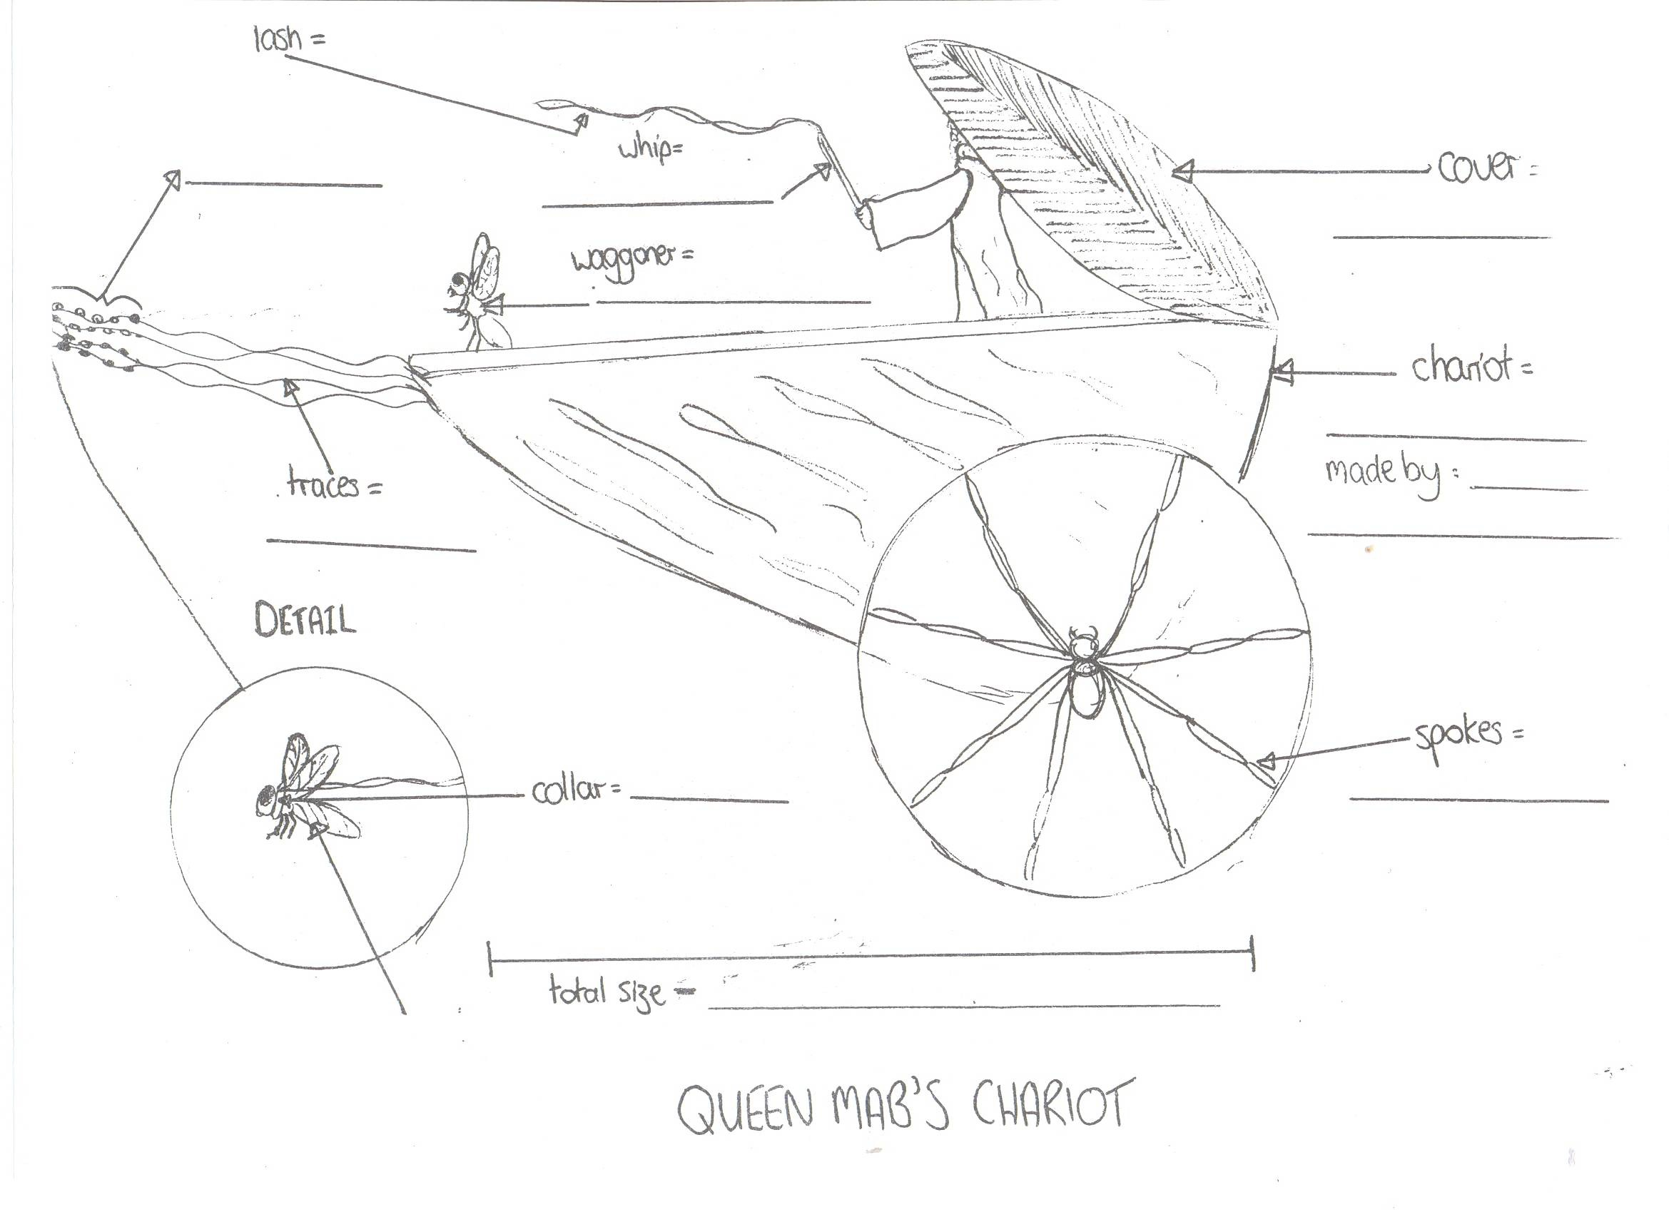

Lovers | Courtiers | Lawyers | Ladies | Courtier (again)
Parson | Soldiers | Horses | Maids

What dreams does Mab bring to these people? Or what does she do to them whilst they are asleep? Draw their dreams in the boxes provided.

