Private Peaceful
English Workbook
Year 7
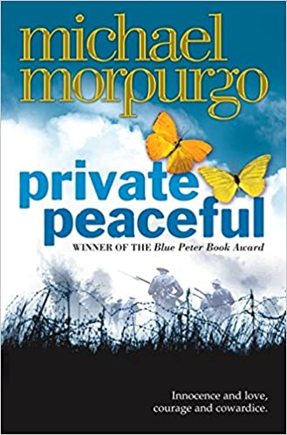

Please finish reading the novel which is attached in PDF copy.
Next work your way through the following FOUR tasks over the course of the final week while you are self-isolating.

Task 1:
Look at the extract below, where Tommo describes being on lookout once they’ve been placed in Ypres, before the big bombardment, and going over the top.
“I am on stand-to the next morning, locked inside my gas mask in a world of my own, listening to myself breathing. The mist rises over no-man’s-land. I see in front of me a blasted wasteland. No vestige of fields or trees here, not a blade of grass – simply a land of mud and craters. I see unnatural humps scattered over there beyond our wire. They are the unburied, some in field-grey uniforms and some in khaki. There is one lying in the wire with his arm stretched heavenwards, his hand pointing. His is one of ours, or was. I look up where he is pointing. There are birds up there, and they are singing. I see a beady-eyed blackbird singing to the world from his barbed-wire perch.”
Where else have we seen this image of a hand outstretched to the heavens?
Add ideas about the recurring image to a mind-map.
Consolidate: how and why does Michael Morpurgo use recurring images in Private Peaceful?
Think about these key questions:
- What is your point?
- What language is used by the writer?
- What does this make you think or feel?
- How does this language do this?
- Why has the author done this?
Writing Frame
At the start of Private Peaceful, the image of Father’s outstretched hand symbolises [MAKE YOUR POINT] in the quotation “[QUOTATION]”
This is clear because it has connotations of ………/makes me think….., which suggests that ………
Morpurgo used this image at this point to suggest/imply/encourage the reader to consider…
Morpurgo may wanted to create a sense of…
Later on, when [DESCRIBE EVENT IN NOVEL] the image of the outstretched hand begins to also represent [MAKE YOUR POINT] in line “[QUOTATION]” ….

Success Criteria
- Identify what image could represent
- Explain why you think this
- Use evidence from the novel to support your ideas
- Extension: explain how the symbol changes or becomes more complex in the novel
- Extension: explain in detail, and why Morpurgo may have chosen to do this

TASK 2: Creative writing – Life in the Trenches
Do Now – recap your learning.
- What is an adjective?
___________________________________________________________________________
- What is a verb?
___________________________________________________________________________
- What is a noun?
___________________________________________________________________________
- What is an adverb?
___________________________________________________________________________
- What is an adverbial phrase?
___________________________________________________________________________
Thinking task: you are going to write from the first-person narrative perspective, and in the narrative voice of a soldier in the trenches in WW1. You can use ideas from Private Peaceful and your contextual knowledge of WW1 to create authentic settings, characters and description.
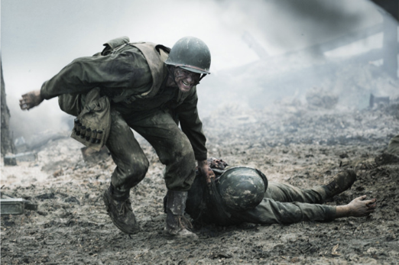
Look at the soldier in this picture:
- What can you hear?
- What can you taste?
- What can you smell?
Write at least one sentence using a simile or metaphor to describe these three senses, at this moment.

- Imagine that you are a young soldier. You and the men with you have been fighting for days and you are exhausted. You can't stand straight. You are all sick with chest complaints, and cough as you move around in the mud.
Sentence stem: For days we had been fighting,…
Vocabulary options: trudge / drag / stumble
- Describe the men in detail now. They appear too tired to think or to see where they are marching. Many have lost their boots, and have cuts on their feet. It is painful to walk. They don't even hear the flinch at the sound of the gas shells which begin to fall behind them.
Vocabulary options: stagger / twist / shiver

- EMERGENCY! You suddenly realise that you are being attacked with poisonous gas. Shout a warning to the others in your group. Use one line only.
Sentence option: use speech marks.

- Even though you are all exhausted, you use all the speed you can muster to put on the awkward gas marks you carry in your kits. Most of you are successful, but one man is too slow and staggers about, crying out as the gas gets in to his lungs.
Sentence option: show, don’t tell the reader what is happening.
Vocabulary options: duck / hide / stumble

- Describe how you feel as you see your comrade staggering towards you in the gas cloud. You feel totally helpless, as you know he is going to die, as the gas gets in to his lungs and you hear him coughing.
Vocabulary options: eyes / fear / horror

- Describe having to pick your comrade up, and put his body in a wagon to take to a medical tent. He is not yet dead; he is in great pain and is writhing around.
Vocabulary options: twitch / roll / hand

- You see your comrade being taken off the wagon, and the last thing you hear is the gurgling of blood and mucus in his lungs.
Vocabulary options: bubble / whisper / echo

- TASK THREE: Knowledge Quiz
- What is one symbol used throughout the novel?
___________________________________________________________________________
___________________________________________________________________________
___________________________________________________________________________
___________________________________________________________________________
- What is one recurring image that Morpurgo returns to?
___________________________________________________________________________
___________________________________________________________________________
___________________________________________________________________________
- What is a simile?
___________________________________________________________________________
___________________________________________________________________________
- What is a rhetorical question?
___________________________________________________________________________
___________________________________________________________________________
- What is the difference between the author and the narrator?
___________________________________________________________________________
___________________________________________________________________________
- What is a dual narrative?
___________________________________________________________________________
___________________________________________________________________________
- What are some of the causes of shell shock?
___________________________________________________________________________
___________________________________________________________________________
- Which war is the novel based in?
___________________________________________________________________________
___________________________________________________________________________

Task FOUR:
Choose THREE characters from the novel and create a poster with details about each character. Use quotes to show what they are like and how key ideas on how they feature in the novel.

