TASK 1
An extract from a school prospectus:
Not only are we proud of our academic achievements and the exceptional progress our students make but we place high value on the importance of enrichment, offering a wide range of quality learning experiences outside the classroom. We believe that these experiences are essential in helping young people to develop the lifelong skills required for the world beyond their secondary education.
Traditional values of courtesy, cooperation and respect underpin all aspects of school life and provide the solid foundations on which we build our students' talents and achievements. It is important to us that all our students feel valued as unique individuals and are given every opportunity to be the best they can. At ________ School our commitment to parents will be to ensure that every child makes outstanding progress, whatever their ability. We therefore pledge to provide your child with:
- A safe, welcoming environment which provides many opportunities for effective spiritual, moral, social and cultural development
- A rich curriculum with a focus on high quality teaching where learning is lively and challenging
- Effective, further support for those who need additional help outside the classroom
- A positive climate for learning characterised by excellent teacher-student relationships
The success of ____________ School has been based on students, parents, governors and staff working in partnership. The school values the high level of parental support and trust and we are constantly looking to move the school forward.

Task: 1
As a student, write a review of your school or college based on your experiences there.

Create your plan here:

TASK 2: Crap Towns

Your town has been included in a new book called ‘Crap Towns’. They say this about your home town...

- It’s dirty
- It’s smelly
- There’s nothing for people to do
- Lots of shops and factories have closed
- The schools and colleges have poor reputations
- There are no facilities for young people or families

Plan your paragraphs here:

Write a letter to your local newspaper in response to this book.

Correct Spellings here:

TASK 3:
You have a friend who is thinking of doing a parachute jump for charity. Write to your friend giving your opinions.
What you know about your friend.....
- He is pretty athletic, plays football and rugby and likes to be fit and healthy
- He has done lots for charity before. He even ran a marathon for Cancer Research.
- He is very unselfish and likes to do things for others and do good deeds
- He’s afraid of heights but isn’t frightened of a challenge!
- He likes to learn new skills, and meet new people.

Plan your paragraphs here:

Correct Spellings here:

Task 4:

You’ve been asked to write an article for the school magazine in the style of ‘Crap Towns.’

Here’s an example of how it’s done. Now writer an article about a town you know well.

Plan your paragraphs here:

Correct your spellings here:

Task 5: Report

Your school is keen to start a 6th form in the school:
Bulletpoint what you need to have a successful 6th form:

They need to raise money to start the 6th form. Write a report for the Parent’s association and the Board of Governors a) Explaining why the school needs to raise money and b) giving ideas about how that money could be raised.

Plan your paragraphs here:

Correct your spellings here:

Title: This should sum up what the report is about:

Introduction: This should summarise:
- What the report is about.
- Why you have been asked to write it.
- How you went about researching it.
- What your report intends to do.

Main Body: This section should contain the findings of your report.
Think about including:
- Statistics to back up your points.
- Opinions from people involved in what you are writing about.
- Any details on what has been done already to solve the problem you are writing about.
- Whether whatever has been done already has been effective or not.

Recommendations:
This section should include any suggestions you have for how the problem can be solved and should be based on the findings you included in the main body of your report.
These recommendations should:
- Be written in a bullet-pointed list.
- Be brief and direct.
- Solve the problems you wrote about in the main body of your report.
- Explain how each recommendation solves these problems.

Conclusion: This section should summarise your report and its findings.
Try to:
- Finish on a positive note. You need to be able to convince your readers that the problems can be solved by the recommendations you have made.
- Keep your conclusion brief.

Task 6:

A recent news report suggested that children are spending far too much time on electronic devices and are becoming addicted. Games consoles were berated for making children aggressive, having bad language and making it difficult for school children to concentrate. Some advice for parents suggested that time on games consoles should be strictly supervised and reduced to a maximum of 2 hours a day.

A growing body of university research suggests that gaming improves creativity, decision-making and perception. The specific benefits are wide ranging, from improved hand-eye coordination in surgeons to vision changes that boost night driving ability.  People who played action-based video and computer games made decisions 25% faster than others without sacrificing accuracy, according to a study. Indeed, the most adept gamers can make choices and act on them up to six times a second—four times faster than most people, other researchers found. Moreover, practiced game players can pay attention to more than six things at once without getting confused, compared with the four that someone can normally keep in mind, said University of Rochester researchers.  A 2013 study found that playing shooter video games improved a player's capacity to think about objects in three dimensions, just as well as academic courses to enhance these same skills, according to the study.  'This has critical implications for education and career development, as previous research has established the power of spatial skills for achievement in science, technology, engineering and mathematics,’ Granic said. | Gone are the days of teenagers being content with climbing trees and playing basketball in their free time. Nowadays, they are more likely to be found playing video games. But new research suggests that teenagers who play violent video games are more likely to cheat, experience increased aggression and have reduced self-control.  This is according to a study published in the journal Social Psychological and Personality Science.  Players of violent video games are more likely to identify with a violent character. If the game is a first person shooter, players have the same visual perspective as the killer. Violent games directly reward violent behavior, such as by awarding points or by allowing players to advance to the next game level. In some games, players are rewarded through verbal praise, such as hearing the words "Nice shot!" after killing an enemy. It is well known that rewarding behavior increases its frequency.  Videos make you lazy intellectually. When you repeatedly do the same things day in and day out, you are not exercising your brain, exploring new things and creating new knowledge.  This leaves you with less imagination and can impact your ability at school.
You have been asked to write a lively magazine article for the school newspaper on the subject of gaming and its affects. This can either be a negative or a positive article.

Plan your paragraphs here:

Include the following connectives:

Despite
Although
Because
Consequently
However
As
If
When

Correct Spellings here

Task 7:
Create a leaflet to advertise a tourist attraction in your area. (Yorkshire Wildlife Park)

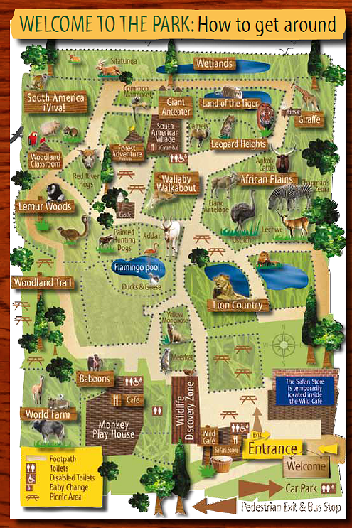

Heading:
What heading will you give your leaflet?
Try to make it: Memorable Direct Interesting Eye-catching
Try to use techniques like: A question A direct statement Alliteration
Picture:
What picture will you use to support your heading?
Just indicate what the picture will be DO NOT WASTE TIME DRAWING!
Features:
What are the main features of what you are advertising/arguing for?
Remember:
- Summarise the main points
- Keep it brief and direct
- Use sub-headings
- Use descriptive/emotive language
- Use positive descriptions and intensifiers
Additional Details:
What additional details do your audience need to know?
Remember:
- Use persuasive language
- Use factual details
- Use other people’s opinions to persuade your audience
- Use (suitable) exaggerations to persuade your audience
Contact Details:
How can your audience find/get involved with your product?
Images:
What images are you going to use throughout your leaflet?
Think about: Your audience, Your product/cause
AGAIN DO NOT DRAW – JUST SAY (WRITE) WHAT WILL BE THERE.

For more ideas, check out the website for the Wildlife Park to see what else they offer.

Task 8:
The government plan to raise the driving age from 17-19. A discussion is being held in your local town hall. You have decided to go along and give your views on this proposal. Write down what you would say.

Persuasive Speeches

PLAN your speech before you write it.

Plan the main points and the structure of your speech.
You may wish to use this guide:
Opening Statement: Where you highlight your issue.
Developing points: 3-5 points (paragraphs) to explain what needs to be done and why it is so important.
Closing Statement: Where you make a final appeal to your audience.

Create sentences that contain a Rhetorical Question, Rule of Three, Metaphor and Alliteration, to include in your speech.

Plan your paragraphs here:

Correct spellings here:

Task 9:
Your 16th birthday is fast approaching and you need a job. Decide on the qualities you need to be successful in your application:
1.
2.
3.
4.
5.
6.
7.
8.
9.
10.

Write a letter of application to an employer of your choice persuading them you are the person for the job.

Plan your paragraphs here using the ideas above. Can you link some ideas together and think of evidence to back you up?

Correct your spellings here;

Task 10:
Write a letter to your headteacher explaining how to improve your school.

Your ideas could include some of the following:
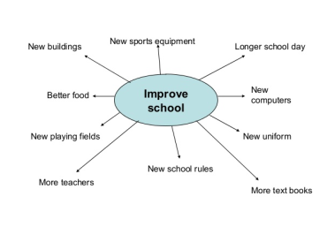
For each paragraph explain:
- The improvements that could be made in detail
- How that will improve the school and who it will effect.
- What the consequences of the improvement will be and how it will benefit the headteacher/school.
- Try to imagine and use the reasons that the head would be interested in, e.g results, money, welfare of students.

Correct your spellings here:

