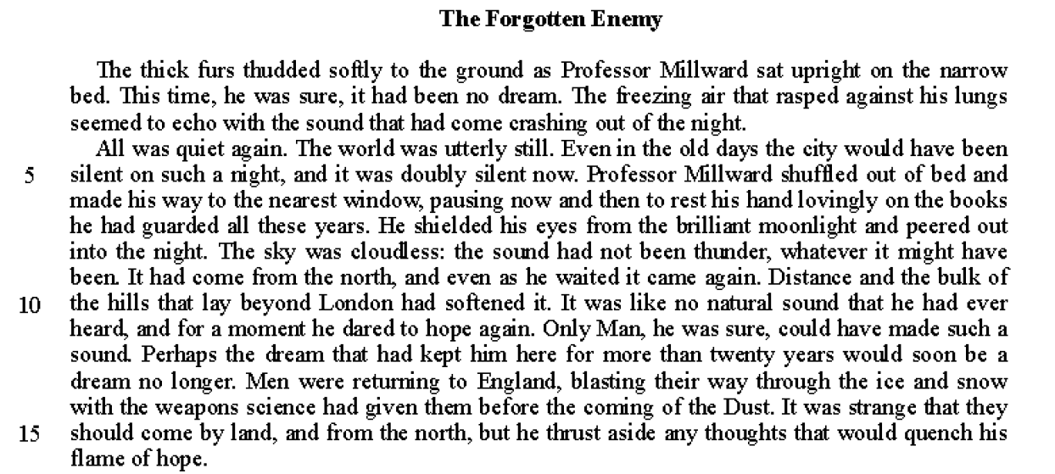
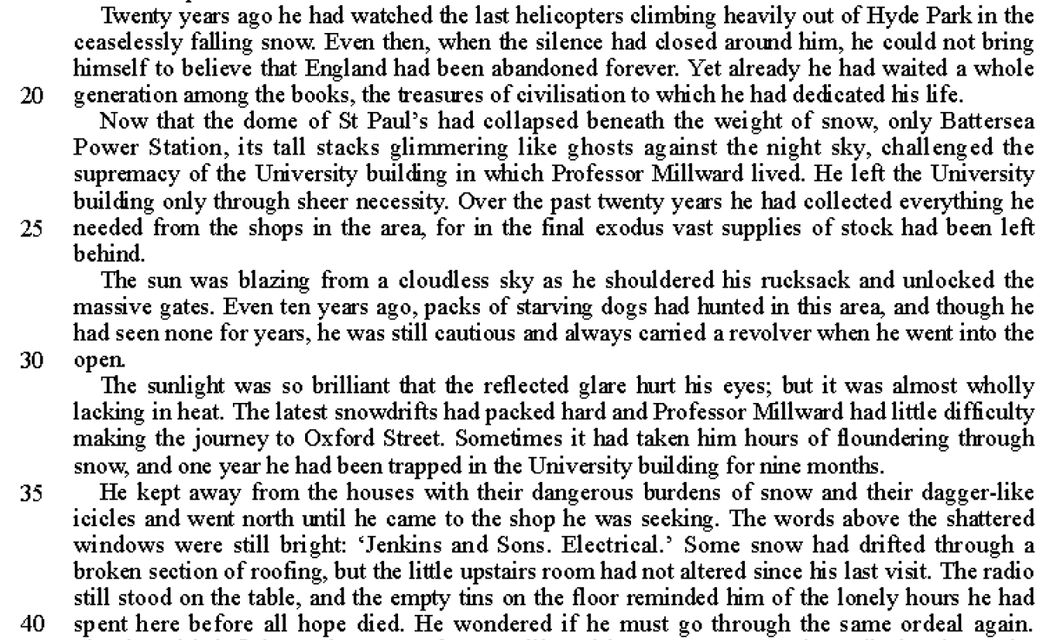

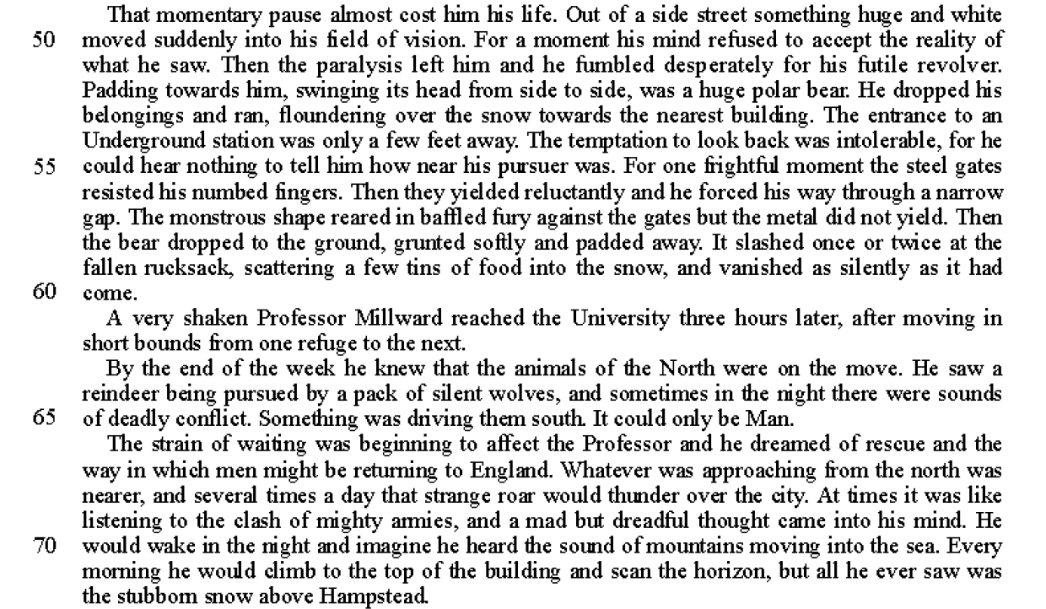
Read lines 1-9
A1 List five things you learn about the setting that Professor Millward is in. (5)

Read lines 10-26
A2 How does the writer show that Professor Millward is in a future that is very different to now. (5)
You must refer to the language used in the text to support your answer, using relevant subject terminology.

Read lines 27-48
A3 What impression do you get of Professor Millward’s life in these lines?
You should write about:
• how Professor Millward thinks and feels;
• the writer’s use of language to show those thoughts and feelings;
• the effects on the reader. (10)

You must refer to the text to support your answer, using relevant subject terminology.

Read lines 49-60
A4 How does the writer create drama and tension in these lines? (10)
You must refer to the text to support your answer, using relevant subject terminology.

Read lines 61-end
A5 ‘At the end of the story the writer makes us feel that Professor Millward’s struggle has been pointless.’ How far do you agree with this statement?
You should write about:
• your own thoughts and feelings about how the writer presents Professor Millward;
• how the writer has made us feel about the professor’s situation.

You must refer to the text to support your answer.

