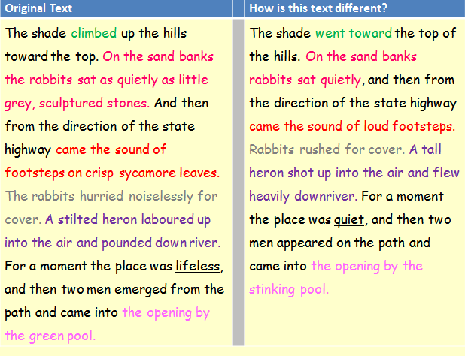

Steinbeck creates atmosphere by

Steinbeck creates an image of…

The verbs ‘hurried’, ‘laboured’ and ‘pounded’ show

He describes the place as being ‘lifeless’ to

The colour ‘green’ emphasises how

The word ‘climbed’