English Literature: Component 1, Section A
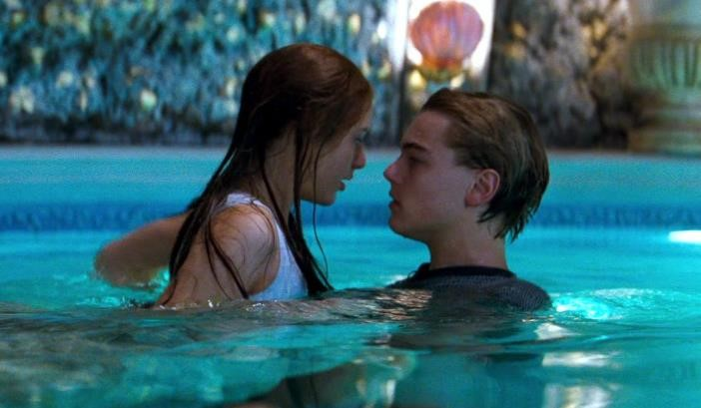

DATE OF EXAM:
1 hour. 40 marks.
Part (a) = 15 marks
Part (b) = 25 marks

Name:
Class:
Teacher:
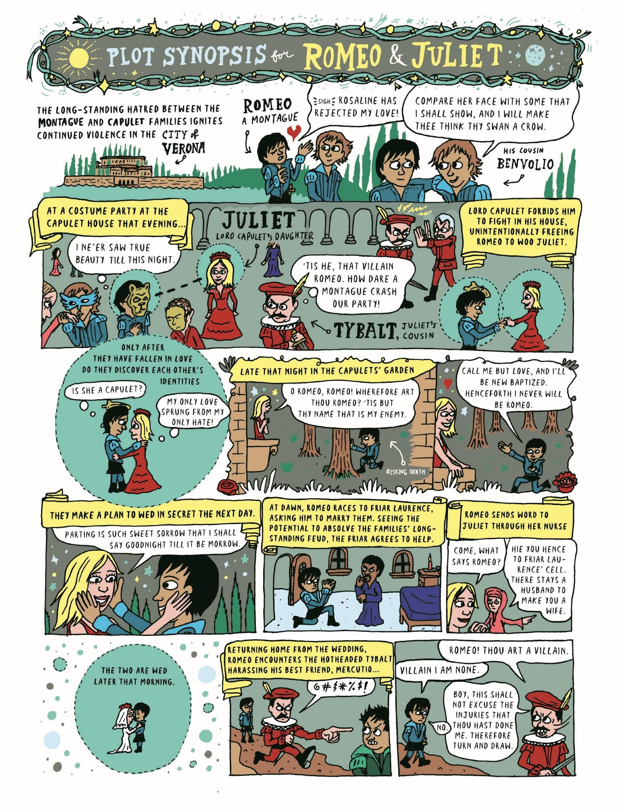

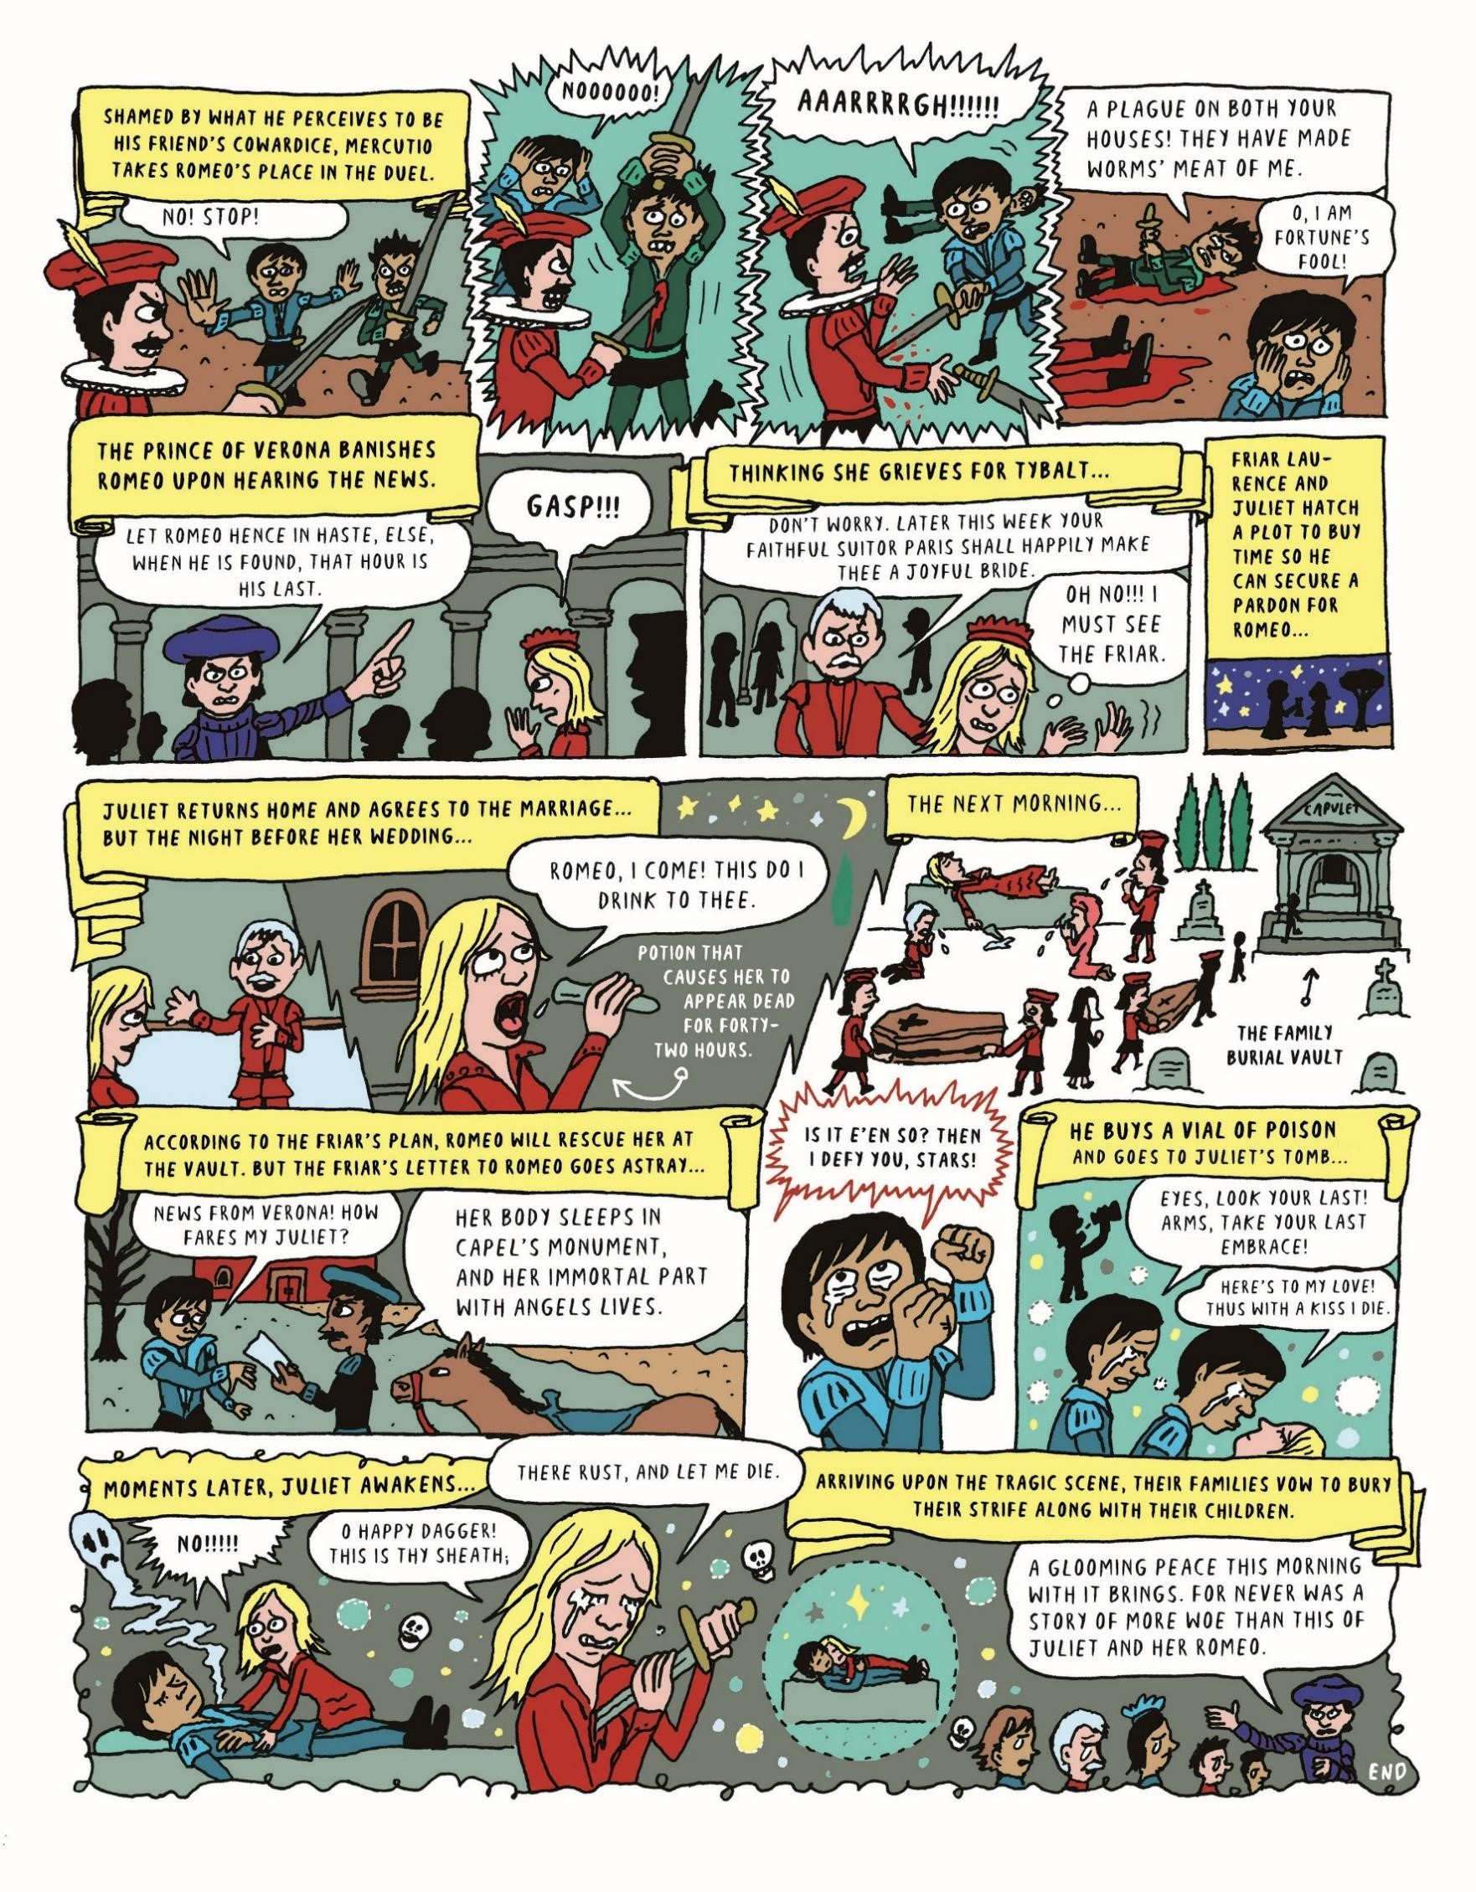

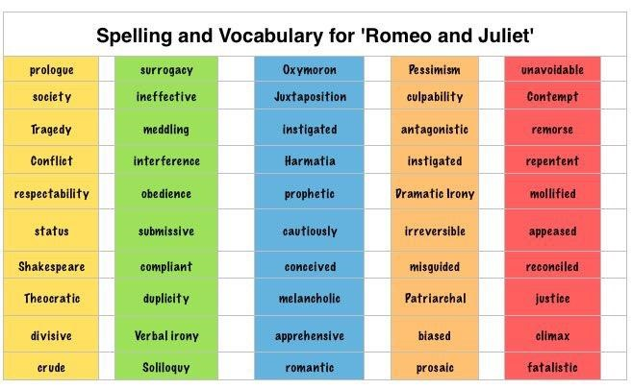

Learn it!

Use it!

When? | What happens?
Act 1 – Prologue | Find out the story in a condensed version
Act 1, Scene 1:  Verona. A public place. | Servants of the Montagues (Romeo) and Capulets (Juliet) start street brawl showing rivalry and tension between the families. We discover Romeo loves Rosalind.
Act 1, Scene 2: A street. | Paris asks Capulet if he can marry Juliet. Romeo discovers that Rosalind will be at the Capulet ball that evening.
Act 1, Scene 3: A room in Capulet's house. | Lady Capulet tells Juliet about Paris’s proposal. The nurse interrupts with a long story of her as a baby.
Act 1, Scene 4: A street. | Romeo has a feeling that something terrible will happen if he goes to the ball but he goes anyway.
Act 1, Scene 5: A hall in Capulet's house. | The Montagues go to the ball and Romeo forgets Rosalind as soon as he sees Juliet. Tybalt recognises them but Lord Capulet will not allow a fight
Act 2, Prologue:  PROLOGUE | The chorus informs us the pain R&J are in as they can’t meet but passion will find a way.
Act 2, Scene 1: A lane by the wall of Capulet's orchard. | Romeo jumps into the Capulet garden to catch a glimpse of  Juliet.
Act 2, Scene 2: Capulet's orchard | The Balcony Scene: Romeo professes his love to Juliet. They arrange a meeting.
Act 2, Scene 3: Friar Laurence's cell. | Romeo goes to Friar Lawrence to arrange to marry Juliet – he agrees thinking it will end the feud between the families
Act 2, Scene 4: A street. | Tybalt sends a challenge to Romeo. The Nurse gets the information about the wedding as a message to Juliet.
Act 2, Scene 5: Capulet's orchard. | The nurse delivers the news to Juliet of her upcoming marriage to Romeo.
Act 2, Scene 6: Friar Laurence's cell. | They marry.
Act 3, Scene 1: A public place. | Romeo tries to avoid fighting. Mercutio is wounded and killed by Tybalt. Romeo then avenges his death and kills Tybalt.  Romeo is exiled for his part in this.
Act 3, Scene 2: Capulet's orchard. | Juliet learns of Tybalt’s death and Romeo’s banishment and is distraught over the loss of her love.
Act 3, Scene 3: Friar Laurence's cell. | Both Romeo and Juliet are distraught at the separation.  Romeo tries to stab himself but is convinced to hold on by Friar Laurence.
Act 3, Scene 4: A room in Capulet's house. | Capulet promises on impulse that Juliet will marry Paris in two days.
Act 3, Scene 5: Capulet's orchard. | Lady Capulet informs Juliet of her upcoming marriage. She is threatened by her father if she refuses to be thrown out. The Nurse says she should marry Paris.
Act 4, Scene 1: Friar Laurence's cell. | Friar plans to give Juliet a drug that makes her appear dead for 48 hours to escape for Mantua and a new life with Romeo
Act 4, Scene 2: Hall in Capulet's house. | Juliet goes to her father and agrees to marry Paris. He moves the wedding forward a day.
Act 4, Scene 3: Juliet's chamber. | Juliet takes the poison.
Act 4, Scene 4: Hall in Capulet's house. | Capulet sends the nurse to waken Juliet.
Act 4, Scene 5: Juliet's chamber. | The Nurse tries to wake Juliet, but finds that she is (apparently) dead. All are grief stricken but Friar Laurence arranges the funeral quickly.
Act 5, Scene 1: Mantua. A street. | Romeo hears wrongly of Juliet’s death, buys poison and returns to join her.
Act 5, Scene 2: Friar Laurence's cell. | Friar John explains why he didn’t deliver the letter and F L sends another.
Act 5, Scene 3: A churchyard; in it a  tomb belonging to the Capulets. | Outside the tomb where Juliet is (apparently) dead. Romeo and Paris fight. Paris is killed. Romeo takes the poison and dies. Juliet wakes and finding Romeo dead kills herself with his dagger.

Who’s who in this fatal game of love?

Montagues
Romeo: Our main male protagonist, about 16. Falls in love easily, rejects his family for love of Juliet, hot-headed, kills Tybalt (Juliet’s cousin), marries young and dies tragically.
Lord Montague and Lady Montague: father and mother to Romeo, maintains the feud between the Capulets and the Montagues. Lady M shows maternal instinct and caring for Romeo – she dies heartbroken at the end.
Mercutio: A family member of the Prince, and Romeo's best friend.
Benvolio: Montague's nephew, Romeo's cousin and thoughtful friend, he makes a genuine effort to defuse violent scenes in public places, though Mercutio accuses him of having a nasty temper in private. He spends most of the play trying to help Romeo get his mind off Rosaline, even after Romeo has fallen in love with Juliet.
Balthasar: Romeo's dedicated servant, who brings Romeo the news of Juliet's death, unaware that her death is a ruse.
Abram: Montague's servant, who fights with Sampson and Gregory in the first scene of the play.

Capulets
Juliet: Our main female protagonist, she is 13 years old. She falls in love quickly and completely, rejects the rules of her family and patriarchy, considered in some of her actions, impulsive when emotional, marries young and dies tragically. The Nurse: Juliet’s companion and confidante, like a mother to Juliet, unquestioningly helps Juliet marry Romeo, advisor and friend.
Lord Capulet: Juliet’s father, arranges her marriage to Paris, no consultation with Juliet on this, disowns her and is rude and angry towards her when she disagrees, epitomises the patriarchal society, rules his home with an iron fist, makes all the important decisions, agrees to let old quarrels die after the death of Juliet
Lady Capulet: Juliet’s mother, distant from Juliet, non-maternal, very young (implies she was 13 herself when she had Juliet – which means she is only 26 in the play!), does as Lord C tells her, could be considered a victim of the patriarchal society Tybalt: Juliet’s cousin, Prince of ‘Cats’. Leader of the Capulet gang, vain, fashionable, supremely aware of courtesy and the lack of it, he becomes aggressive, violent, and quick to draw his sword when he feels his pride has been injured. Once drawn, his sword is something to be feared. He hates Montagues.
Paris: A kinsman of the Prince, and the suitor of Juliet most preferred by Capulet. Once Capulet has promised him he can marry Juliet, he behaves very presumptuous toward Juliet, acting as if they are already married.
Peter: A Capulet servant who invites guests to Capulet's feast and escorts the Nurse to meet with Romeo.
Rosaline: The woman with whom Romeo is infatuated at the beginning of the play. Rosaline never appears onstage, but it is said by other characters that she is very beautiful and has sworn to live a life of chastity.
Sampson & Gregory: Two servants of the house of Capulet, who, like their master, hate the Montagues. At the outset of the play, they successfully provoke some Montague men into a fight.
Peter: A Capulet servant who invites guests to Capulet's feast and escorts the Nurse to meet with Romeo.

Characters Non-Affiliated to a family
Friar Laurence: Priest who secretly marries Romeo and Juliet in hopes that the union might eventually bring peace to Verona.
Paris: A kinsman of the Prince, and the suitor of Juliet most preferred by Capulet. Once Capulet has promised him he can marry Juliet, he behaves very presumptuous toward Juliet, acting as if they are already married.
Prince Escalus: The Prince of Verona. A kinsman of Mercutio and Paris. As the seat of political power in Verona, he is concerned about maintaining the public peace at all costs.

NOTES ON THE PLAY

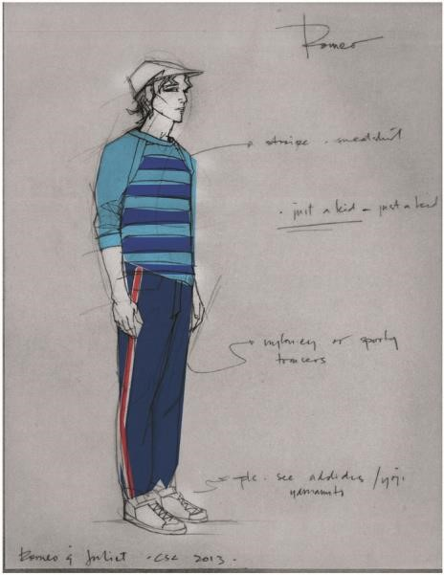
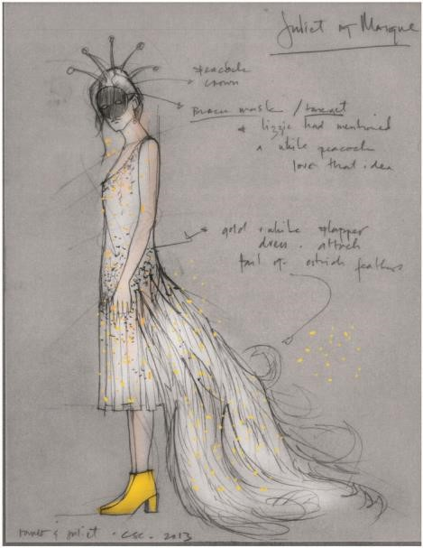
Fate and Tragic Timing
The tragic events of this play often seem like matters of bad timing. Romeo steps in front of Mercutio at the exact second that Tybalt lunges; the Friar’s explanatory letter to Romeo is delayed, so Balthazar’s misinformation reaches him first; Romeo drinks the poison mere moments before Juliet opens her eyes. These instances of close timing make the play even sadder than it otherwise would be, because we can see that the difference between life and death was just a few seconds. A moment earlier, or a moment later, and everything would have been okay. Individually, these moments of tragic timing look like awful accidents, but when taken all together, they seem more like the work of fate.
The theme of fate and foreboding turns up repeatedly in the play’s language. On the way to the Capulet ball, Romeo uneasily senses the approach of “Some consequence yet hanging in the stars”— he has a premonition of doom. After avenging Mercutio’s death by killing Tybalt, Romeo calls himself “fortune’s fool”—he feels that he has been cheated by fate. As the lovers part at daybreak, Juliet envisions Romeo “dead in the bottom of a tomb”, although she has no reason to think that he will soon die. When Romeo hears from Balthazar that Juliet has died, he shouts his defiance to the stars, demonstrating that he blames fate for the tragedy.
In the play’s prologue, Romeo and Juliet are called “starcrossed”, and their love is referred to as “death-marked”. These terms indicate that the lovers were destined to die tragically. But are the play’s events really the result of fate? Do you think that the teens from Verona were doomed from the start, or could this tragedy have been prevented? What factors stopped Romeo and Juliet from living happily ever after?

Warring Families, Warring Generations
The most obvious impediment to Romeo and Juliet’s love is the feud between their parents. The bad blood between the Capulets and the Montagues makes any romance between their heirs dangerous and forbidden. We know that the two families hold an “ancient grudge”—a hate so strong and deep-rooted that their servants fight in the streets. What the play doesn’t tell us is why this feud exists. What happened? Who started it? The audience isn’t given any of these details. It is as though the two households have been fighting for so long that they have forgotten why the fight started in the first place. This ambiguity makes the play’s feudal violence and eventual loss of life seem all the more unfair and pointless. Why should the young people of Verona kill each other over an argument begun by their ancestors? Why should two young people in love be kept apart because of a war that they had nothing to do with?
These questions point to another conflict in the play: that between youth and age. Romeo and Juliet are stuck in the midst of warring families, but they are also two young people forced to live under the rules and values of their parents’ generation. Romeo and Juliet’s love must be kept secret because it would not be understood or tolerated by the rest of society. Even the adults whom the teenagers trust for advice (Friar Laurence and the Nurse) don’t fully understand the intensity of their feelings. The adults of the play are weaker, slower, and less impassioned than their younger counterparts. Juliet comments that “old folks” are “unwieldy, slow, heavy”, and her dawdling Nurse exemplifies this behavior. In contrast, the young people of the play move fast and feel deeply. Their tempers ignite in an instant, and so do their feelings of love.

These Violent Delights Have Violent Ends: Youth, Love, and Violence
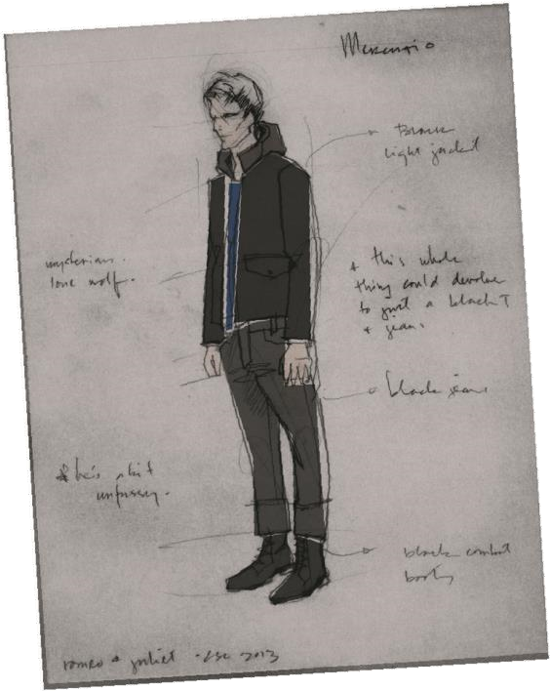
Romeo and Juliet fall deeply in love at first sight, and make plans to marry each other mere hours after they meet. This is a fast-moving relationship by any standards! Just like the violent encounters between the Capulets and the Monagues, their love fires up immediately. Although it seems incredibly romantic to fall for someone instantly, Friar Laurence warns Romeo that this kind of speed can be dangerous. He cautions him to “love moderately” and to act “wisely and slow”. Do you think that this advice is helpful, or does Friar Laurence just not understand what Romeo is going through? Does Friar Laurence actually do anything to try to slow down the young couple’s relationship, or does he ignore his own advice?
Later in the play, when Romeo and Juliet are faced with the prospect of a life without one another, their extreme love turns into extreme grief. Their intense feelings drive them to commit suicide. Do you believe that “violent delights” always “have violent ends”, and that people “who run fast” necessarily stumble? Are these intense emotions and extreme feelings an accurate representation of what it’s really like to be a teen?
Have you ever felt like your love for someone else was the only thing in the world that mattered? Have you ever been so sad that you felt like things would never get better?

But soft, what light through younger window breaks? Light and Darkness in ROMEO & JULIET
This play is filled with references to light and darkness. When we first hear about Romeo, he is described as shutting “fair daylight out” of his room, and making himself “an artificial night” in which to sulk about his unrequited love for Rosaline. Here, darkness is described as the ideal environment for a lover. Darkness continues to serve this role throughout the play, as Romeo and Juliet meet in the dark of night to conceal their relationship. They cannot parade their forbidden love around town in the light of day—instead, they must be together at nighttime, and Romeo must leave Juliet’s bedroom before the sun comes up.
But although Romeo and Juliet interact under the cover of “black-browed night”, their love is a source of metaphorical light. When Romeo first sees Juliet at the ball, he exclaims that she “doth teach the torches to burn bright”. He compares her to other shining sources of illumination: a rich jewel, stars, and the sun. Even when Juliet is lying entombed in the dark Capulet crypt, Romeo says that her presence creates “a feasting presence full of light”. Her beauty makes a grave look like “a lantern” to him.
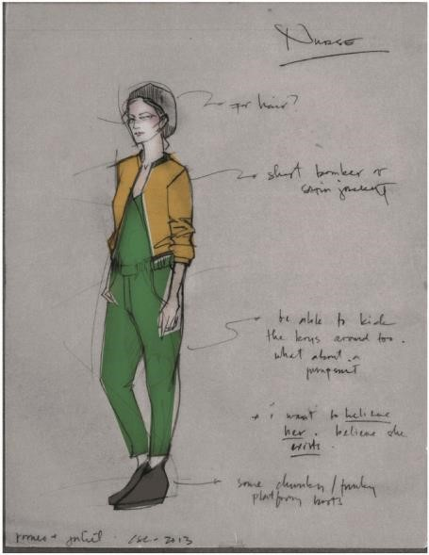
This moment in the play emphasizes another theme traditionally associated with darkness: death. Think of the creepiest scenes you’ve read and seen in books and movies: lots of them are probably set in the dark. There’s a reason that people go trick-or-treating and watch scary films after the sun goes down— darkness can be scary! In this play, though, darkness is associated with death and with love—two themes that seem very different until we see how they are pulled together by the storyline. The cruel circumstances of Romeo and Juliet mean that for them, death is the only place that they can be together. While they are alive, they will be forced to be apart: Romeo banished to Mantua, and Juliet married to Paris. In Romeo and Juliet, Shakespeare deliberately weaves together themes of light and dark and day and night in ways which emphasize the play’s other opposing themes: life and death, love and hate.

VERSE OR PROSE?

All of Shakespeare’s language falls into one of two categories: verse or prose. Prose is what we think of as everyday speech, without specific rules regarding rhyme or rhythm. Verse, then, can be defined as giving order or form to the random stress patterns of prose.
A quick way to tell verse from prose: lines of verse begin with capital letters, while prose will appear in paragraph form.

Blank Verse
Blank Verse is the standard poetic form Shakespeare uses in his plays. It can also be defined as unrhymed iambic pentameter— that is, a line of poetry containing five (“penta” from the Greek prefix meaning five) iambic feet, not rhyming with any adjacent line. That’s ten syllables all together. The pattern flows easily for speakers of English, because the stresses match the human heart beat:
ta DUM ta DUM ta DUM ta DUM ta DUM
A way to remember the word “iambic” is to think of it as: i AM, i AM, i AM, i AM, i AM
If you say, “The Yankees and the Mets are New York’s teams” with natural inflection, you will have spoken a line of iambic pentameter.
The YANK | ees AND | the METS | are NEW | York’s TEAMS
Now say a line from ROMEO & JULIET:
ROMEO
But soft! What light through yonder window breaks?

but SOFT | what LIGHT | through YON | der WIN | dow BREAKS
A repeating combination of stressed and unstressed syllables is known as a foot, which is the basic unit of verse.
An iamb is a foot of poetry containing two syllables, with an unstressed syllable followed by a stressed syllable: ta
DUM.

Prose
Prose is the everyday language used then and now. Since verse was the conventional method of writing in Elizabethan England, Shakespeare was actually pushing the literary boundaries by including prose in his plays.
At first glance, it may seem that Shakespeare used verse and prose to indicate a character’s status (rich, powerful, educated characters speak in verse; poor, common, fools speak in prose) but upon closer look, you’ll find that many characters go back and forth between verse and prose, and they do so at very specific moments in the play.
Actors pay close attention to when characters speak in verse and when they speak in prose because Shakespeare made these choices on purpose, and it can tell the actor a lot about how their character thinks and feels. For example, the Nurse is likely to speak in prose when she is teasing Juliet:

NURSE
Well, you have made a simple choice. You know not how to choose a man. Romeo? No, not he. Though his face be better than any man’s, yet his leg excels all men’s; and for a hand and a foot, and a body, though they be not to be talked on, yet they are past compare. He is not the flower of courtesy, but, I’ll warrant him, as gentle as a lamb.
But she switches to verse when the conversation becomes more serious:
NURSE
Then hie you hence to Friar Laurence’ cell.
There stays a husband to make you a wife.
The Nurse is not the only character in ROMEO & JULIET to speak in both verse and prose. What other characters do this, and why might they choose to do so?

Questions and themes to consider

Generational Differences
How are the adults of the play set apart from the young people? Pay attention to the opening scene, when Capulet and Montague confront each other. How is their behavior different from the rage of Tybalt, or the servants? In Act II, Juliet says that “old folks” are “unwieldy, slow, heavy, and pale as lead”. Where do you see evidence for this in the play?

Family Feud
How does a particular production depict the Capulet/Montague feud? Are the two families distinguished from one another, and if so, how? Where and when might this version of Verona be situated? Do you think that these directorial decisions are effective?

Humour in the Play
Many scholars have commented that Romeo and Juliet seems like it could be a comedy up until Act III Scene 1, when Mercutio is killed. It is certainly true that the first half of this play has many opportunities for humor. Which scene or character did you find the funniest, and why? Why do you think that Shakespeare included funny moments in his tragedy?

Fate and Death
Were Romeo and Juliet really “star-crossed” and fated to die, or could their deaths have been prevented? Do you think that their loss will be a wake up call to their families, and end the violence, or did they die entirely in vain?

Trusted Adults
What do you think of the actions of Friar Laurence and the Nurse, Romeo and Juliet’s closest advisors? Were they more hurtful, or more helpful to the young couple? What could they have done differently to help? Do they deserve any blame for what happened?

Themes in Romeo and Juliet

Love
Love is naturally the play’s dominant and most important theme. The play focuses on romantic love, specifically the intense passion that springs up at first sight between Romeo and Juliet. In Romeo and Juliet, love is a violent, ecstatic, overpowering force that supersedes all other values, loyalties, and emotions. In the course of the play, the young lovers are driven to defy their entire social world: families (“Deny thy father and refuse thy name,” Juliet asks, “Or if thou wilt not, be but sworn my love, / And I’ll no longer be a Capulet”); friends (Romeo abandons Mercutio and Benvolio after the feast in order to go to Juliet’s garden); and ruler (Romeo returns to Verona for Juliet’s sake after being exiled by the Prince on pain of death in II.i.76–78). Love is the overriding theme of the play, but a reader should always remember that Shakespeare is uninterested in portraying a prettied-up, dainty version of the emotion; the kind that bad poets write about, and whose bad poetry Romeo reads while pining for Rosaline. Love in Romeo and Juliet is a brutal, violent and powerful emotion that captures individuals and catapults them against their world, and, at times, against themselves.
The powerful nature of love can be seen in the way it is described, or, more accurately, the way descriptions of it so consistently fail to capture its entirety. At times love is described in the terms of religion, as in the fourteen lines when Romeo and Juliet first meet. At others it is described as a sort of magic: “Alike bewitchèd by the charm of looks” (II.Prologue.6). Juliet, perhaps, most perfectly describes her love for Romeo by refusing to describe it: “But my true love is grown to such excess / I cannot sum up some of half my wealth” (III.i.33–34). Love, in other words, resists any single metaphor because it is too powerful to be so easily contained or understood.
Romeo and Juliet does not make a specific moral statement about the relationships between love and society, religion, and family; rather, it portrays the chaos and passion of being in love, combining images of love, violence, death, religion, and family in an impressionistic rush leading to the play’s tragic conclusion.

The Relationship between Love and Death, Passion, and Violence
The themes of death and violence permeate Romeo and Juliet, and they are always connected to passion, whether that passion is love or hate. The connection between hate, violence, and death seems obvious. But the connection between love and violence requires further investigation.
In general, love is understood to be a gentle, nourishing thing. But as discussed in the section on the theme of love, Shakespeare sees such a dainty view of love as delusional. Love, in Romeo and Juliet is a grand passion, and as such it is blinding; it can overwhelm a person as powerfully and completely as hate can. The passionate love between Romeo and Juliet is linked from the moment of its inception with death: Tybalt notices that Romeo has crashed the feast and determines to kill him just as Romeo catches sight of Juliet and falls instantly in love with her. From that point on, love seems to push the lovers closer to love and violence, not farther from it. Romeo and Juliet are plagued with thoughts of suicide, and a willingness to experience it: in Act III, scene iii, Romeo brandishes a knife in Friar Laurence’s cell and threatens to kill himself after he has been banished from Verona and his love; Juliet also pulls a knife in order to take her own life in Friar Laurence’s presence just three scenes later; after Capulet decides that Juliet will marry Paris, Juliet says, “If all else fail, myself have power to die” (III.v.242); and each imagines that the other looks dead the morning after their first, and only, sexual experience (“Methinks I see thee,” Juliet says, “. . . as one dead in the bottom of a tomb” (III.v.242; III.v.55-56). This theme continues until its inevitable conclusion: double suicide. This tragic choice is the highest, most potent expression of love that Romeo and Juliet can make. It is only through death that they can preserve their love, and their love is so profound that they are willing to end their lives in its defense. In the play, love emerges as an amoral thing, leading as much to destruction as to happiness. But in its extreme passion, the love that Romeo and Juliet experience also appears so exquisitely beautiful that few would want, or be able, to resist its power.

The Conflict between Social Institutions and the Inner Self
Much of Romeo and Juliet involves the lovers’ struggles against public and social institutions that either explicitly or implicitly oppose the existence of their love. Such structures range from the concrete to the abstract: families and the placement of familial power in the father; law and the desire for public order; religion; and the social importance placed on masculine honor. These institutions often come into conflict with each other. The importance of honor, for example, time and again results in brawls that disturb the public peace.
Though they do not always work in concert, each of these societal institutions in some way present obstacles for Romeo and Juliet. The enmity between their families, coupled with the emphasis placed on loyalty and honor to kin, combine to create a profound conflict for Romeo and Juliet, who must essentially rebel against their heritages. Further, the patriarchal power structure inherent in Renaissance families, wherein the father controls the action of all other family members, particularly women, places Juliet in an extremely vulnerable position. Her heart, in her family’s mind, is not hers to give. The law and the emphasis on social civility demands terms of conduct with which the blind passion of love cannot comply. Religion similarly demands priorities that Romeo and Juliet cannot abide by because of the intensity of their love. Though in most situations the lovers uphold the traditions of Christianity (they wait to marry before consummating their love), their love is so powerful that they begin to think of each other in blasphemous terms. For example, Juliet calls Romeo “the god of my idolatry,” elevating Romeo to level of God (II.i.156). The couple’s final act of suicide is likewise un-Christian. The maintenance of masculine honor forces Romeo to commit actions he would prefer to avoid. But the social emphasis placed on masculine honor is so profound that Romeo cannot simply ignore them.
It is possible to see Romeo and Juliet as a sort of battle between the responsibilities and actions demanded by social institutions and those demanded by the private desires of the individual. Romeo and Juliet’s appreciation of night, with its darkness and privacy, and their renunciation of their names, with its attendant loss of obligation, make sense in the context of individuals who wish to escape the public world. But the lovers cannot stop the night from becoming day. And Romeo cannot cease being a Montague simply because he wants to; the rest of the world will not let him. The lovers’ suicides can be understood as the ultimate night, the ultimate privacy.

Fate
In its first address to the audience, the Chorus states that Romeo and Juliet are “star-crossed”— that is to say that fate (a power often vested in the movements of the stars) controls them (Prologue.6). This sense of fate permeates the play, and not just for the audience. The characters also are quite aware of it: Romeo and Juliet constantly see omens. When Romeo believes that Juliet is dead, he cries out, “Then I defy you, stars,” completing the idea that the love between Romeo and Juliet is in opposition to the decrees of destiny (V.i.24). Of course, Romeo’s defiance itself plays into the hands of fate, and his determination to spend eternity with Juliet results in their deaths. The mechanism of fate works in all of the events surrounding the lovers: the feud between their families (it is worth noting that this hatred is never explained; rather, the reader must accept it as an undeniable aspect of the world of the play); the horrible series of accidents that ruin Friar Laurence’s seemingly well-intentioned plans at the end of the play; and the tragic timing of Romeo’s suicide and Juliet’s awakening. These events are not mere coincidences, but rather manifestations of fate that help bring about the unavoidable outcome of the young lovers’ deaths.
The concept of fate described above is the most commonly accepted interpretation. There are other possible readings of fate in the play: as a force determined by the powerful social institutions that influence Romeo and Juliet’s choices; as well as fate as a force that emerges from Romeo and Juliet’s very personalities.

M_{OTIFS}

Light/Dark Imagery
One of the play’s most consistent visual motifs is the contrast between light and dark, often in terms of night/day imagery. This contrast is not given a particular metaphoric meaning—light is not always good, and dark is not always evil. On the contrary, light and dark are generally used to provide a sensory contrast and to hint at opposed alternatives. One of the more important instances of this motif is Romeo’s lengthy meditation on the sun and the moon during the balcony scene, in which Juliet, metaphorically described as the sun, is seen as banishing the “envious moon” and transforming the night into day (II.i.46). A similar blurring of night and day occurs in the early morning hours after the lovers’ only night together. Romeo, forced to leave for exile in the morning, and Juliet, not wanting him to leave her room, both try to pretend that it is still night, and that the light is actually darkness: “More light and light, more dark and dark our woes” (III.v.36).

Alternative Views of Events in the Play
Shakespeare includes numerous speeches and scenes in Romeo and Juliet that hint at alternative ways to evaluate the play. Shakespeare uses two main devices in this regard: Mercutio and servants. Mercutio consistently skewers the viewpoints of all the other characters in play: he sees Romeo’s devotion to love as a sort of blindness that robs Romeo from himself; similarly, he sees Tybalt’s devotion to honor as blind and stupid. His punning and the Queen Mab speech can be interpreted as undercutting virtually every passion evident in the play. Mercutio serves as a critic of the views and beliefs held by the characters around him.
Where Mercutio is a nobleman who openly criticizes other nobles, the views offered by servants in the play are less explicit. There is the Nurse who lost her baby and husband, the servant Peter who cannot read, the musicians who care about their lost wages and their lunches, and the Apothecary who cannot afford to make the moral choice, the lower classes present a second tragic world to counter that of the nobility. The nobles’ world is full of grand tragic gestures. The servants’ world, in contrast, is characterized by simple needs, and early deaths brought about by disease and poverty rather than dueling and grand passions. Where the nobility almost seem to revel in their capacity for drama, the servants’ lives are such that they cannot afford tragedy of the epic kind.

REVISION
ACTIVITIES

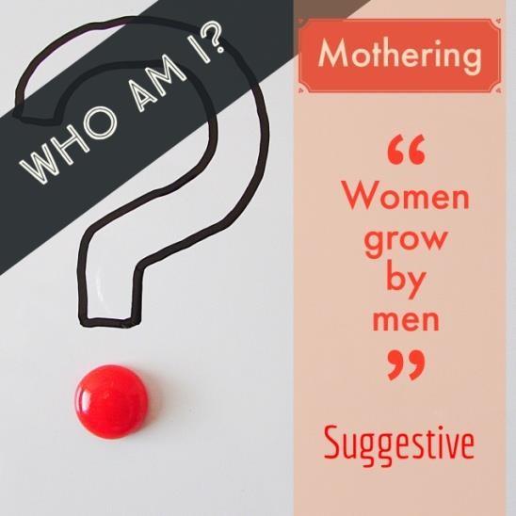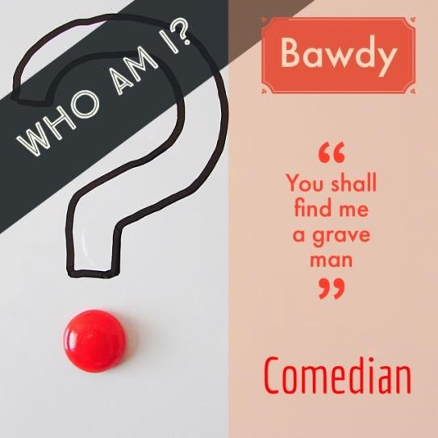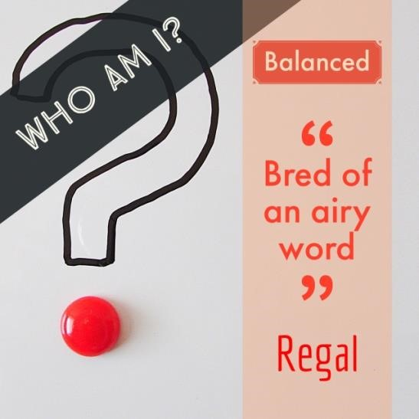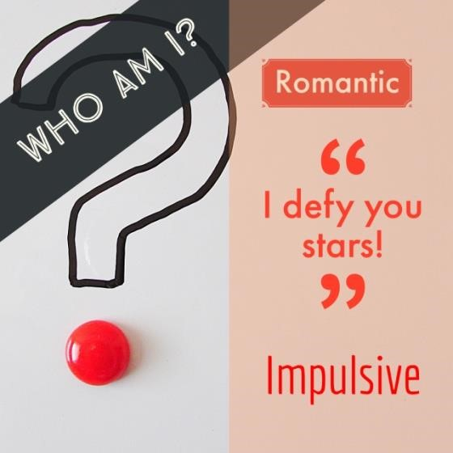

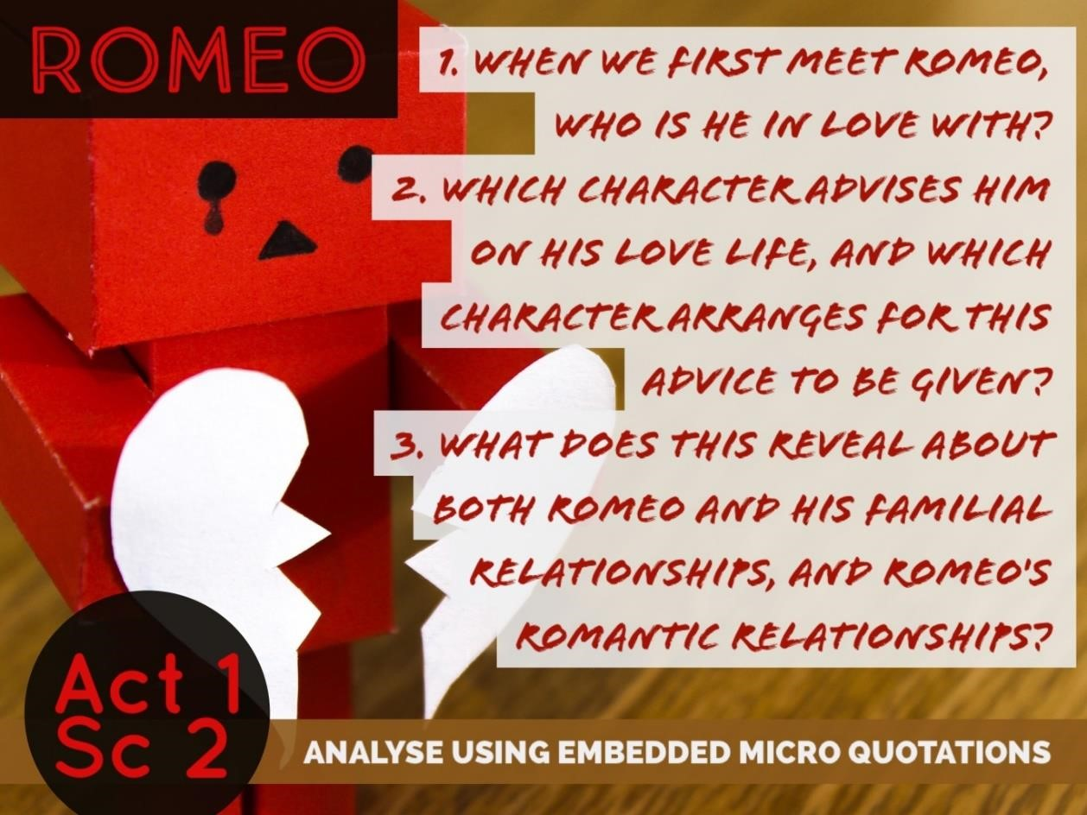

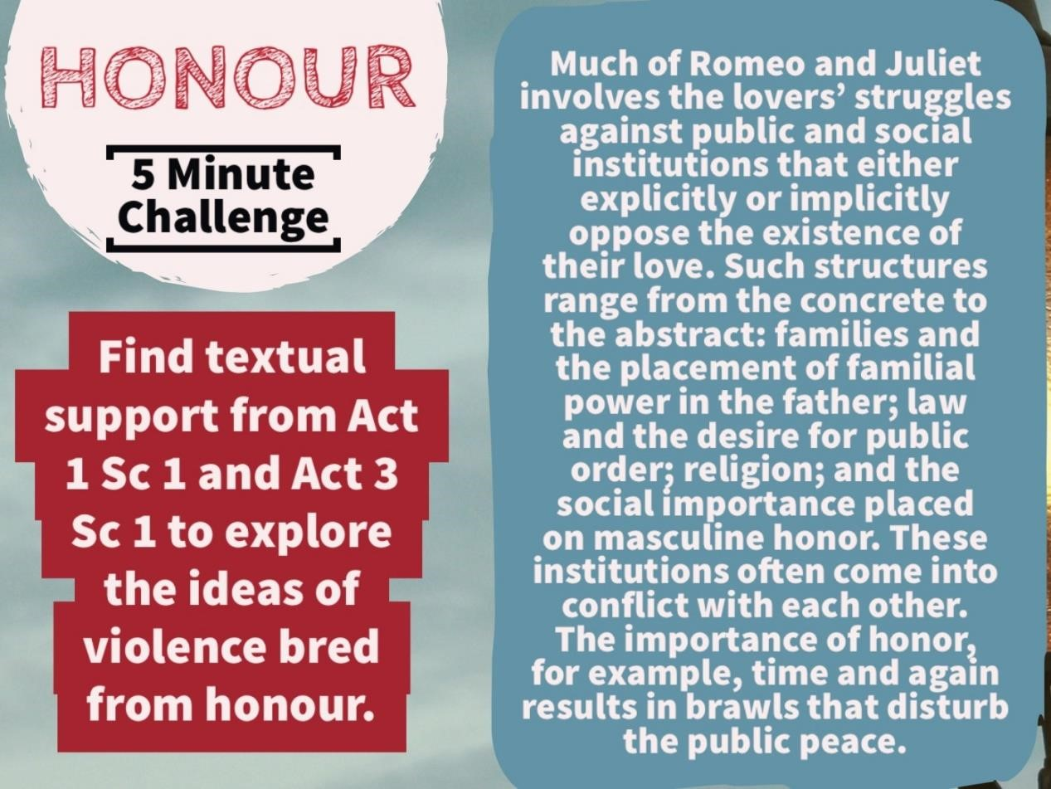
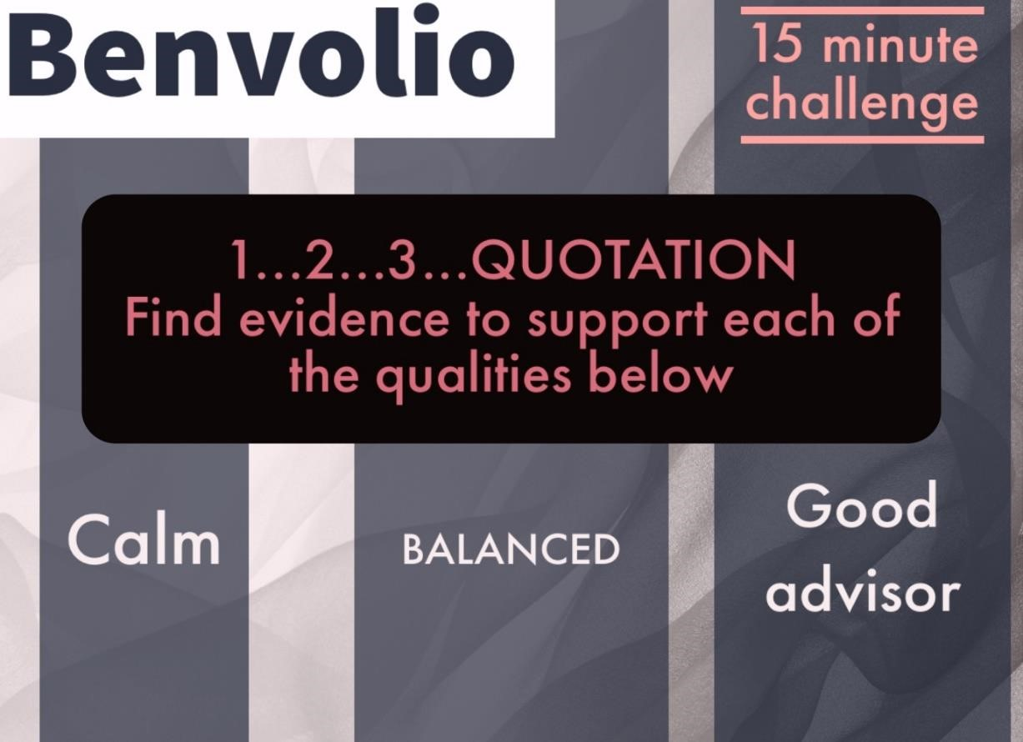

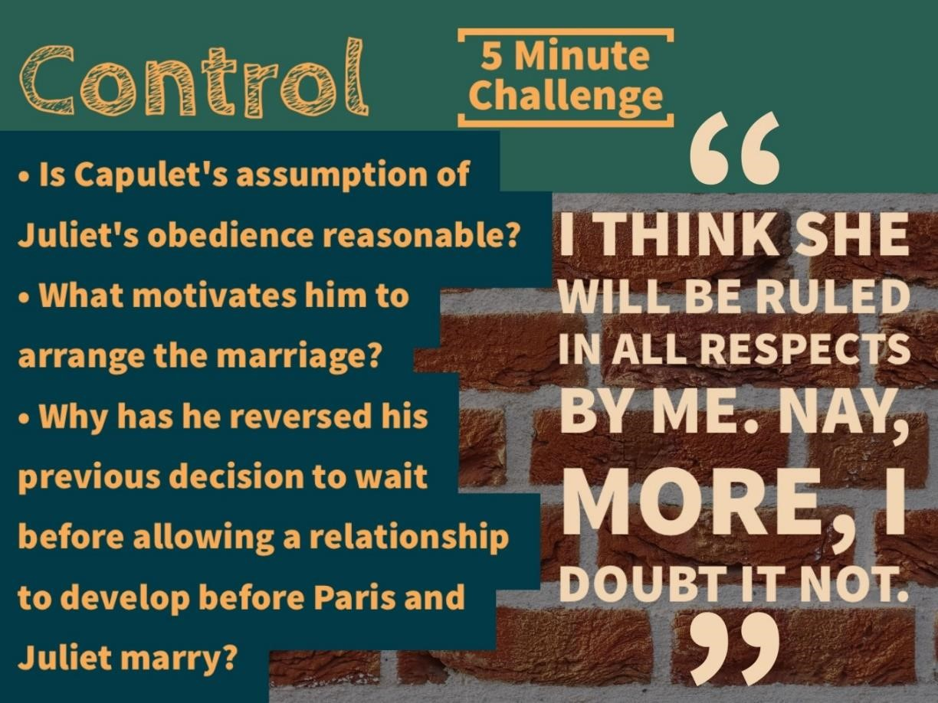
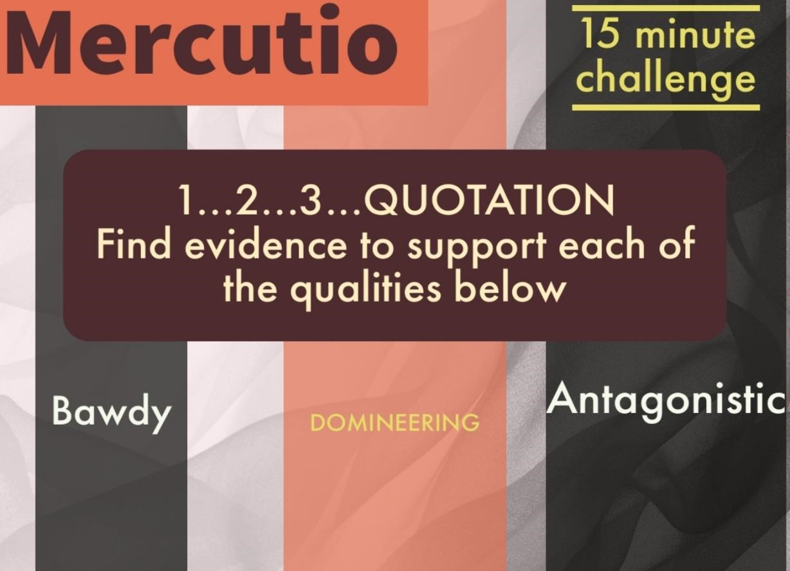

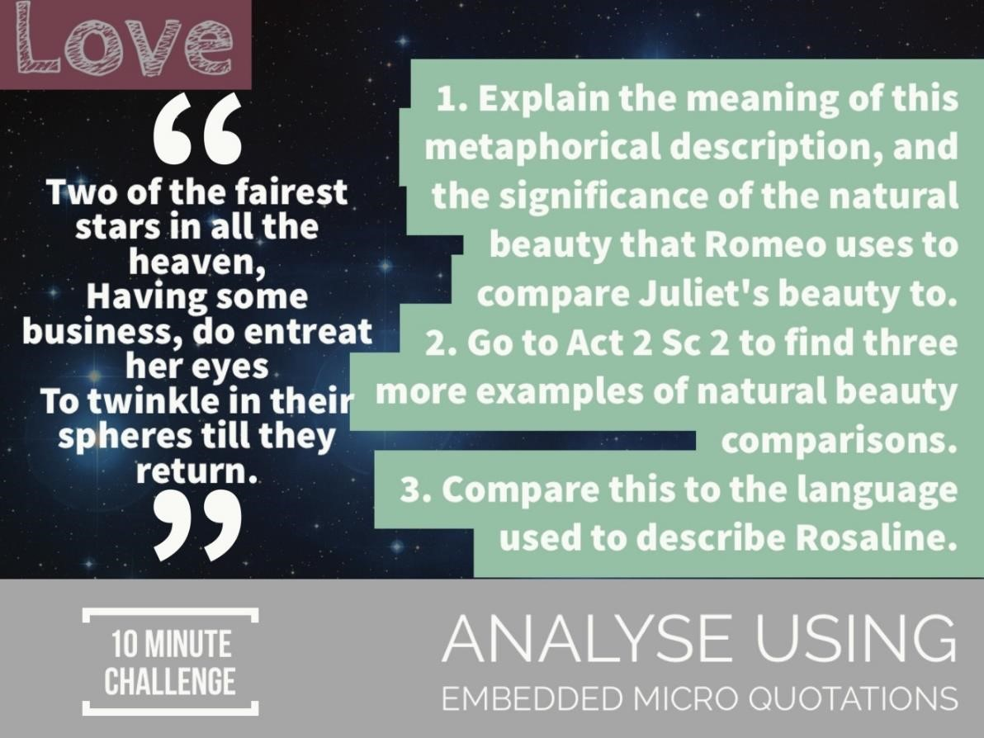
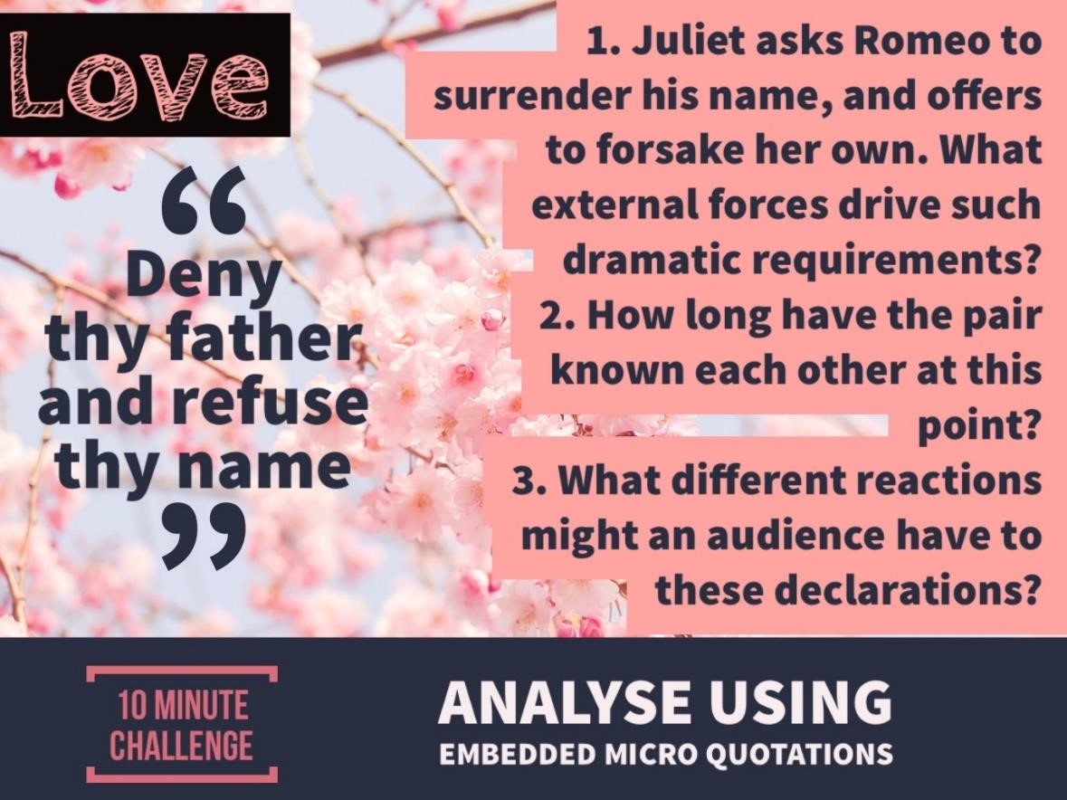

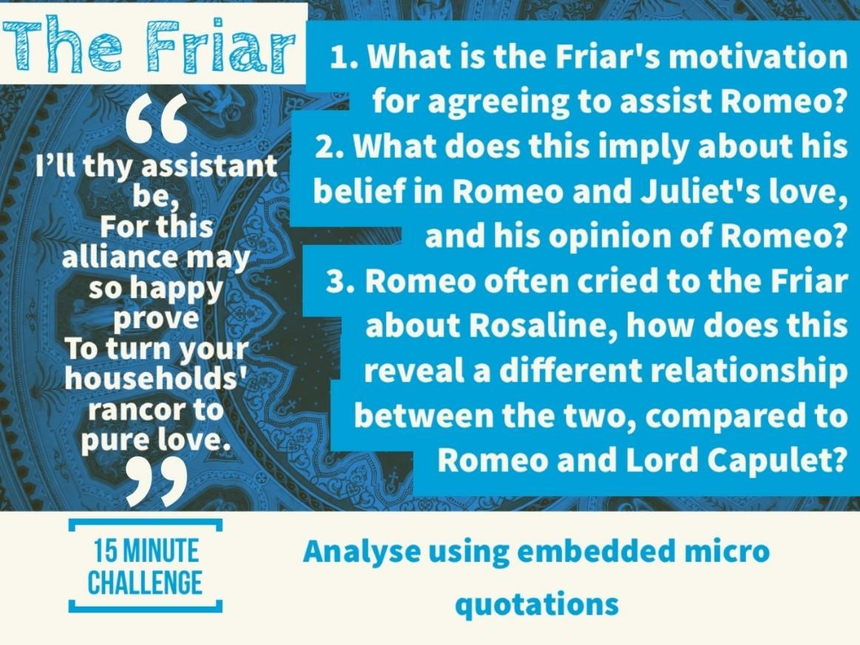
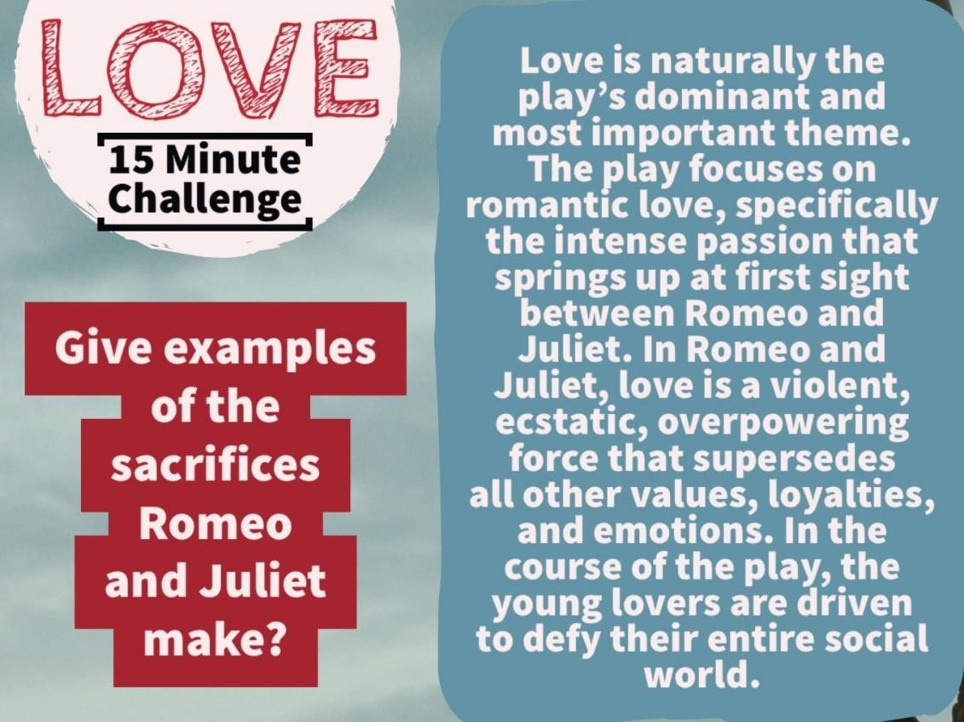

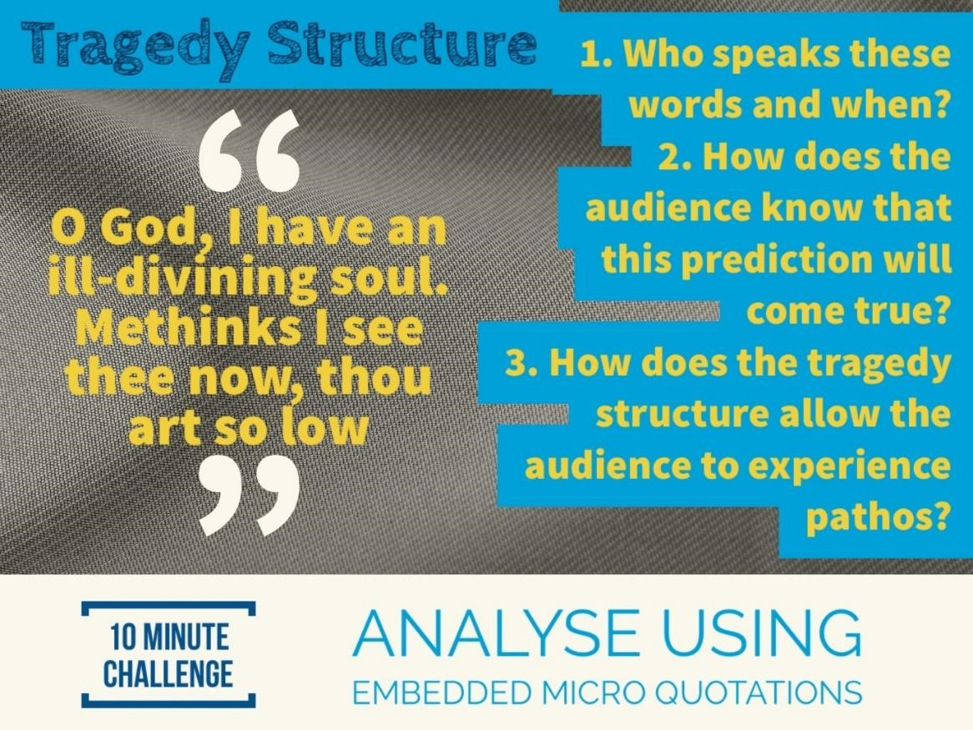
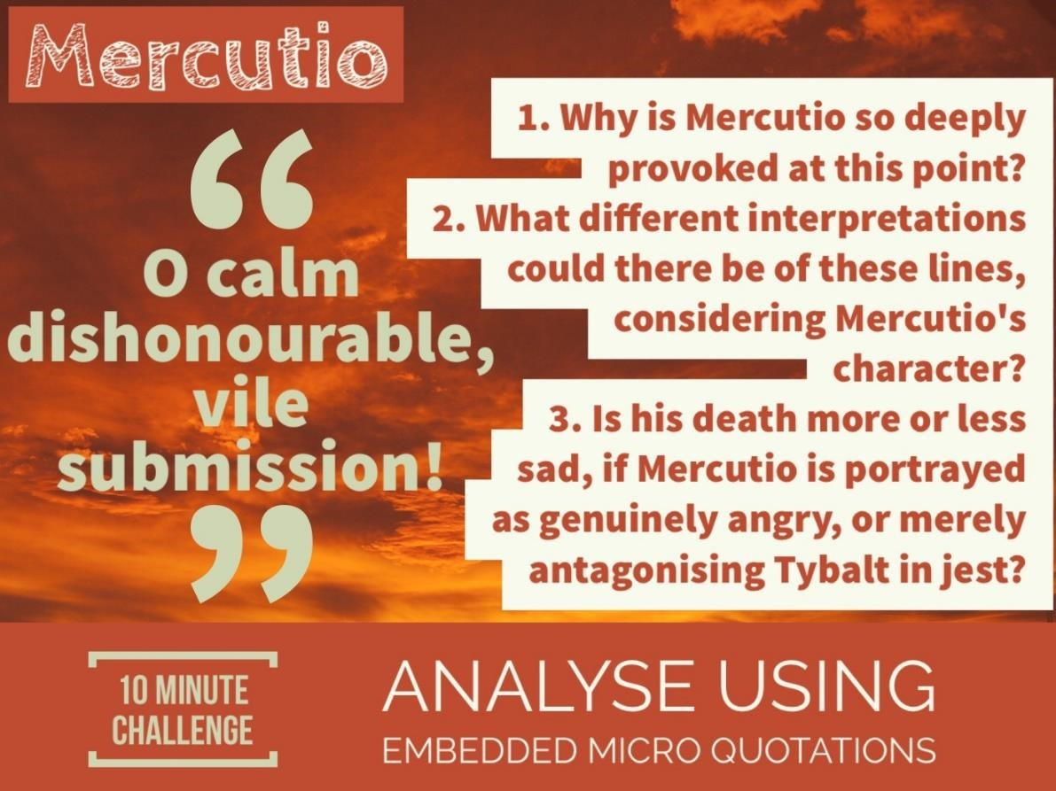

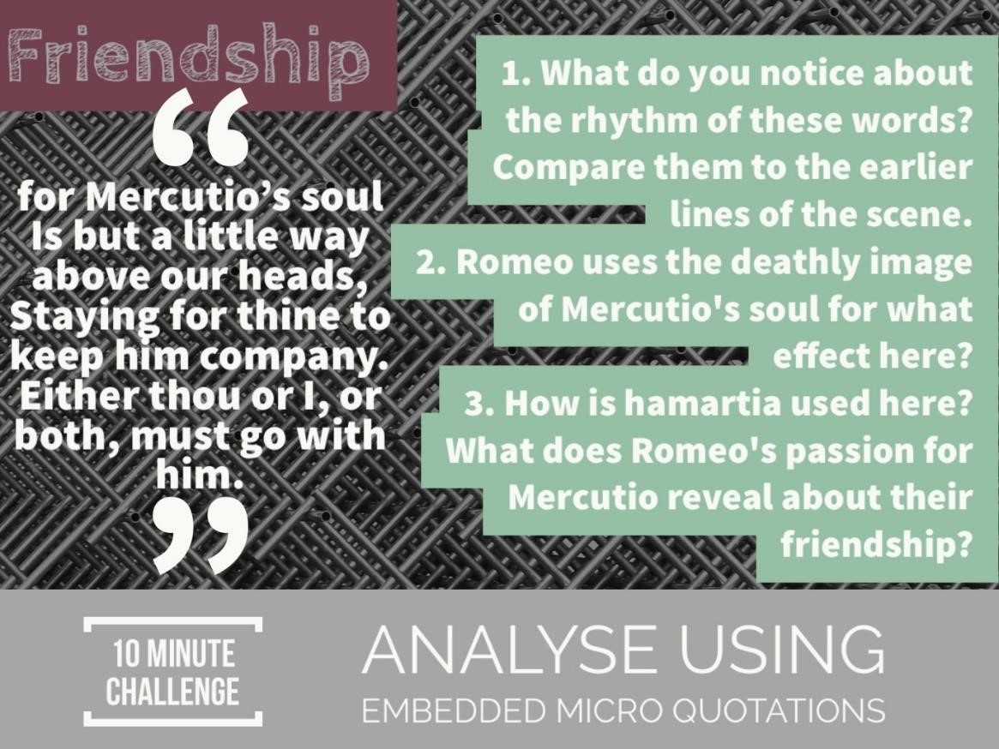
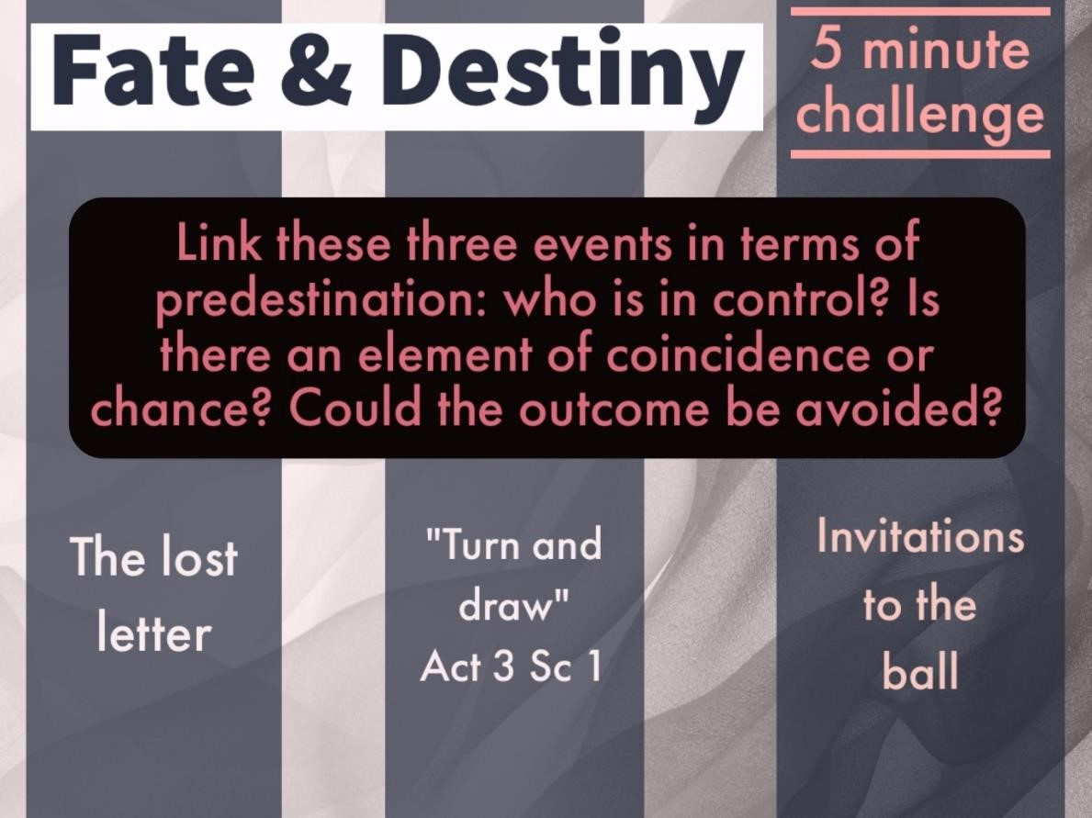

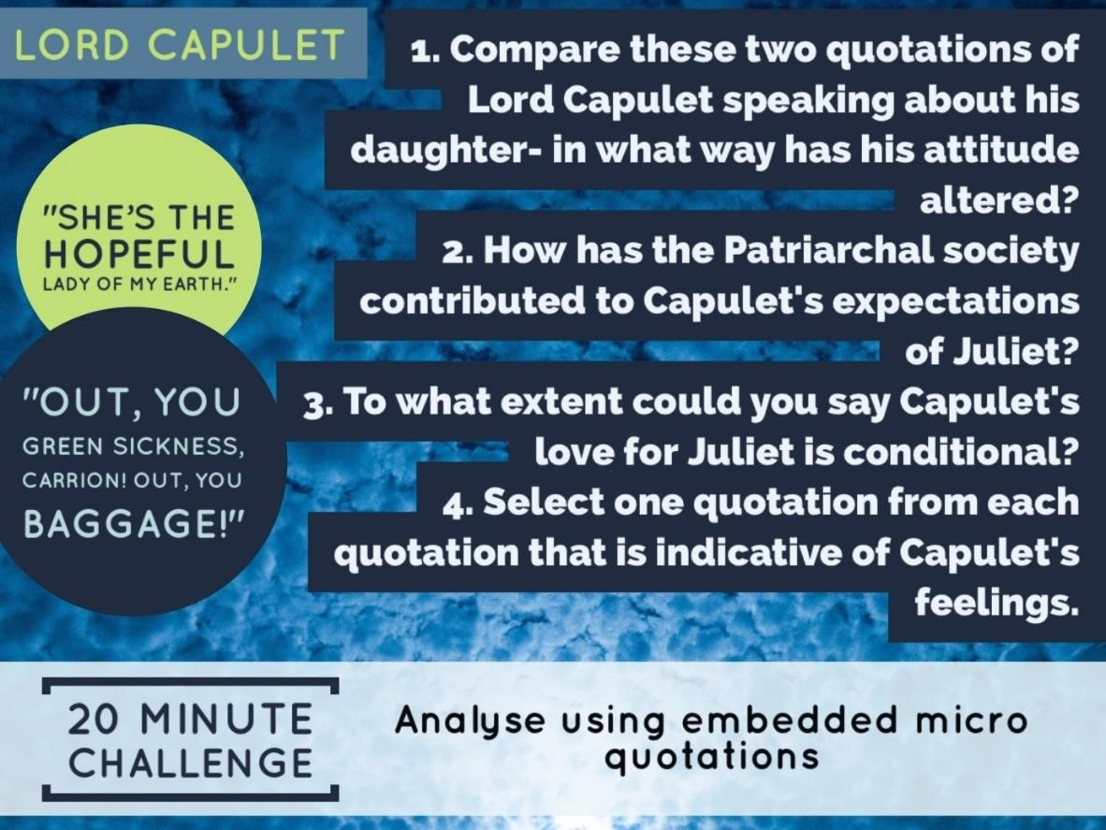
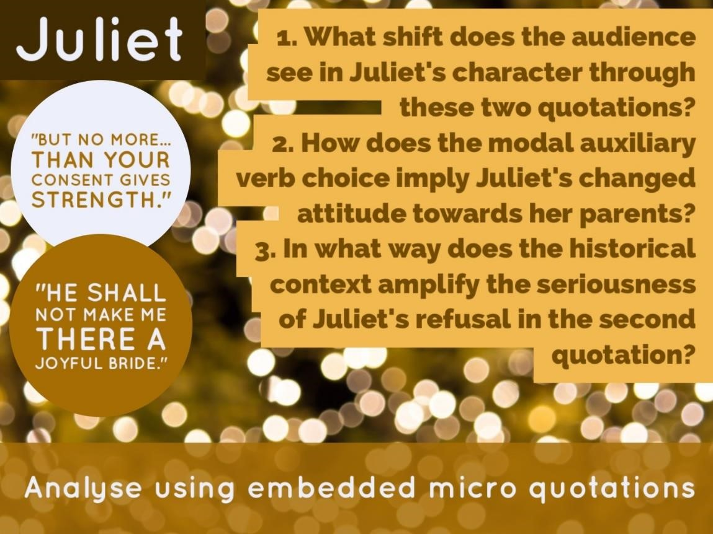

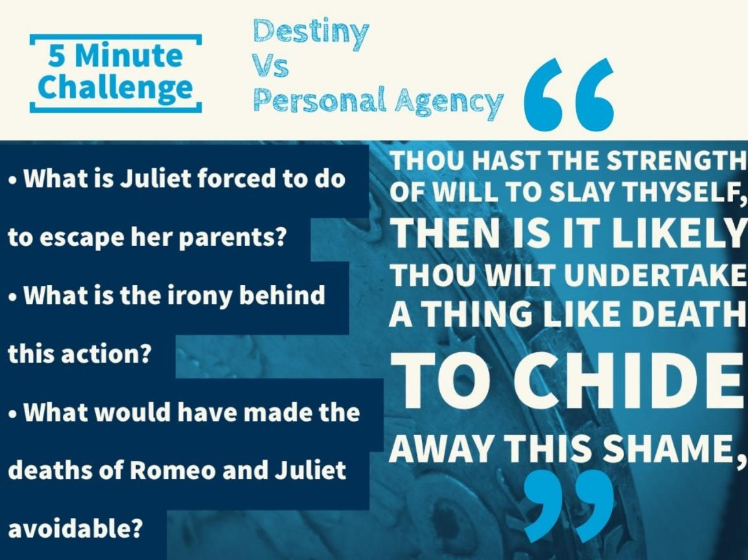

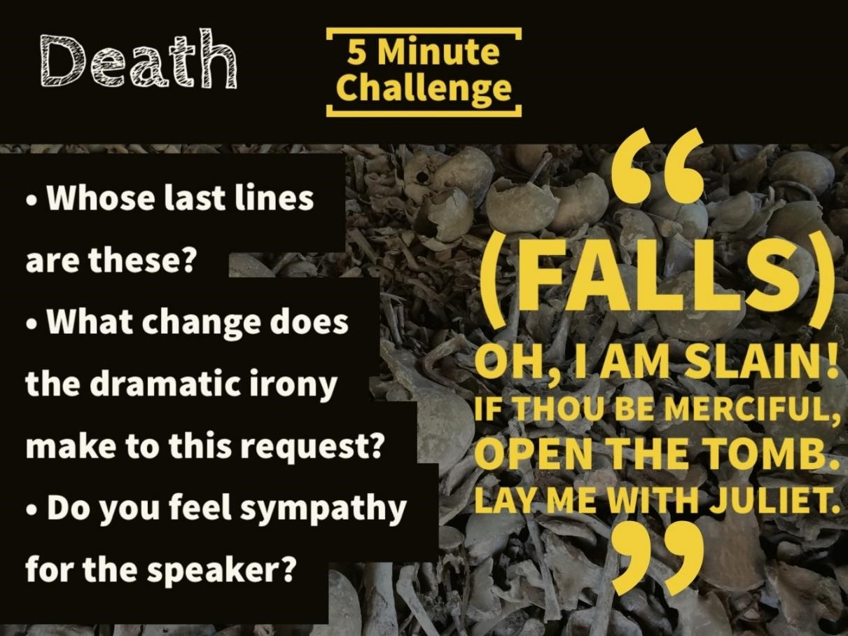

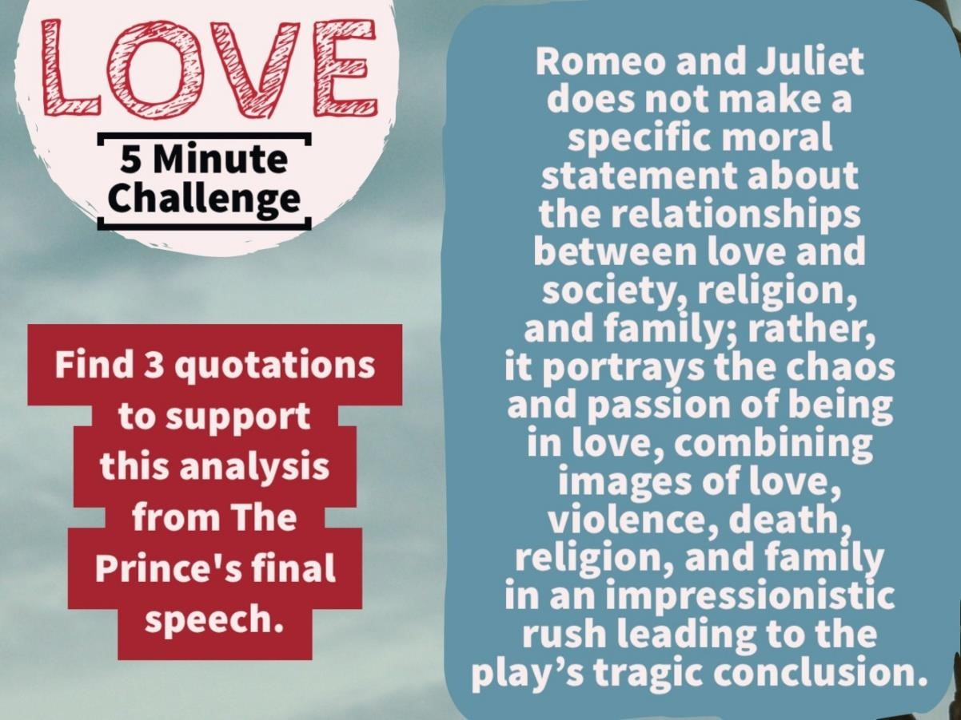

Romeo and Juliet

Answer both part (b).

You are advised to spend about 20 minutes on part (a), and about 40 minutes on part (b).
Read the extract below.

Look at how the Prince speaks and behaves here. What does it reveal to an audience about
his character at this point in the play? Refer closely to details from the extract to support
your answer. [15]
PRINCE
Rebellious subjects, enemies to peace,
Profaners of this neighbour-stained steel,--
Will they not hear? What, ho! you men, you beasts,
That quench the fire of your pernicious rage
With purple fountains issuing from your veins,
On pain of torture, from those bloody hands
Throw your mistemper'd weapons to the ground, And hear the sentence of your moved prince.
Three civil brawls, bred of an airy word,
By thee, old Capulet, and Montague,
Have thrice disturb'd the quiet of our streets,
And made Verona's ancient citizens
Cast by their grave beseeming ornaments,
To wield old partisans, in hands as old,
Canker'd with peace, to part your canker'd hate:
If ever you disturb our streets again,
Your lives shall pay the forfeit of the peace.
For this time, all the rest depart away:
You Capulet; shall go along with me:
And, Montague, come you this afternoon,
To know our further pleasure in this case, To old Free-town, our common judgment-place.
Once more, on pain of death, all men depart.

b) *In the Prologue, Romeo and Juliet are described as “star crossed lovers”. How important do you think fate is in affecting the outcome of the play? [25]

*5 of this question’s marks are allocated for accuracy in spelling, punctuation and the use of vocabulary and sentence structures.

part (b).
You are advised to spend about 20 minutes on part (a), and about 40 minutes on part (b).
Read the extract below.

Look at how the Nurse speaks about Juliet here. What does it reveal to an audience about their relationship at this point in the play? Refer closely to details from the extract to support your answer. [15]

NURSE
Even or odd, of all days in the year,
Come Lammas-eve at night shall she be fourteen.
Susan and she--God rest all Christian souls!-- Were of an age: well, Susan is with God;
She was too good for me: but, as I said, On Lammas-eve at night shall she be fourteen; That shall she, marry; I remember it well.
'Tis since the earthquake now eleven years; And she was wean'd,--I never shall forget it,-- Of all the days of the year, upon that day:
For I had then laid wormwood to my dug,
Sitting in the sun under the dove-house wall;
My lord and you were then at Mantua:-- Nay, I do bear a brain:--but, as I said,
When it did taste the wormwood on the nipple
Of my dug and felt it bitter, pretty fool,
To see it tetchy and fall out with the dug!

b) *How does Shakespeare present the theme of conflict in Romeo and Juliet? [25]

*5 of this question’s marks are allocated for accuracy in spelling, punctuation and the use of vocabulary and sentence structures.

part (b).
You are advised to spend about 20 minutes on part (a), and about 40 minutes on part (b).
Read the extract below.

Look at how Tybalt speaks and behaves here. What does it reveal to an audience about his
character? Refer closely to details from the extract to support your answer.
[15]

TYBALT
This, by his voice, should be a Montague.
Fetch me my rapier, boy. What dares the slave Come hither, cover'd with an antic face, To fleer and scorn at our solemnity? Now, by the stock and honour of my kin, To strike him dead, I hold it not a sin.
CAPULET
Why, how now, kinsman! wherefore storm you so?
TYBALT
Uncle, this is a Montague, our foe, A villain that is hither come in spite, To scorn at our solemnity this night.
CAPULET
Young Romeo is it?
TYBALT
'Tis he, that villain Romeo.
CAPULET
Content thee, gentle coz, let him alone;
He bears him like a portly gentleman; And, to say truth, Verona brags of him
To be a virtuous and well-govern'd youth:

b) *How does Shakespeare present a lack of understanding between the older and younger generations in Romeo and Juliet?
[25]

*5 of this question’s marks are allocated for accuracy in spelling, punctuation and the use of vocabulary and sentence structures.

part (b).
You are advised to spend about 20 minutes on part (a), and about 40 minutes on part (b).
Read the extract below.

Look at how Romeo speaks here. What does it reveal to an audience about his character?
Refer closely to details from the extract to support your answer.
[15]

ROMEO
He jests at scars that never felt a wound.
JULIET appears above at a window
But, soft! what light through yonder window breaks?
It is the east, and Juliet is the sun.
Arise, fair sun, and kill the envious moon, Who is already sick and pale with grief,
That thou her maid art far more fair than she:
Be not her maid, since she is envious; Her vestal livery is but sick and green And none but fools do wear it; cast it off.
It is my lady, O, it is my love!
O, that she knew she were!
She speaks yet she says nothing: what of that?
Her eye discourses; I will answer it.
I am too bold, 'tis not to me she speaks:
Two of the fairest stars in all the heaven, Having some business, do entreat her eyes To twinkle in their spheres till they return.
What if her eyes were there, they in her head?

b) *Benvolio only appears in a few scenes in the play. Show how Benvolio could be described as important to the play as a whole.
[25]

*5 of this question’s marks are allocated for accuracy in spelling, punctuation and the use of vocabulary and sentence structures.

part (b).
You are advised to spend about 20 minutes on part (a), and about 40 minutes on part (b).
Read the extract below.

Look at how Mercutio speaks and behaves here. What does it reveal to an audience about
his character? Refer closely to details from the extract to support your answer.
[15]

MERCUTIO
Good king of cats, nothing but one of your nine lives; that I mean to make bold withal, and as you shall use me hereafter, drybeat the rest of the eight. Will you pluck your sword out of his pitcher by the ears? Make haste, lest mine be about your ears ere it be out.
TYBALT
I am for you. Drawing
ROMEO
Gentle Mercutio, put thy rapier up.
MERCUTIO
Come, sir, your passado. They fight
TYBALT under ROMEO's arm stabs MERCUTIO, and flies with his followers
MERCUTIO
I am hurt.
A plague o' both your houses! I am sped. Is he gone, and hath nothing?
BENVOLIO
What, art thou hurt?
MERCUTIO

b) *Explain the extent to which you think Shakespeare presents the Prince as a strong leader. [25]
*5 of this question’s marks are allocated for accuracy in spelling, punctuation and the use of vocabulary and sentence structures.

Grade 5

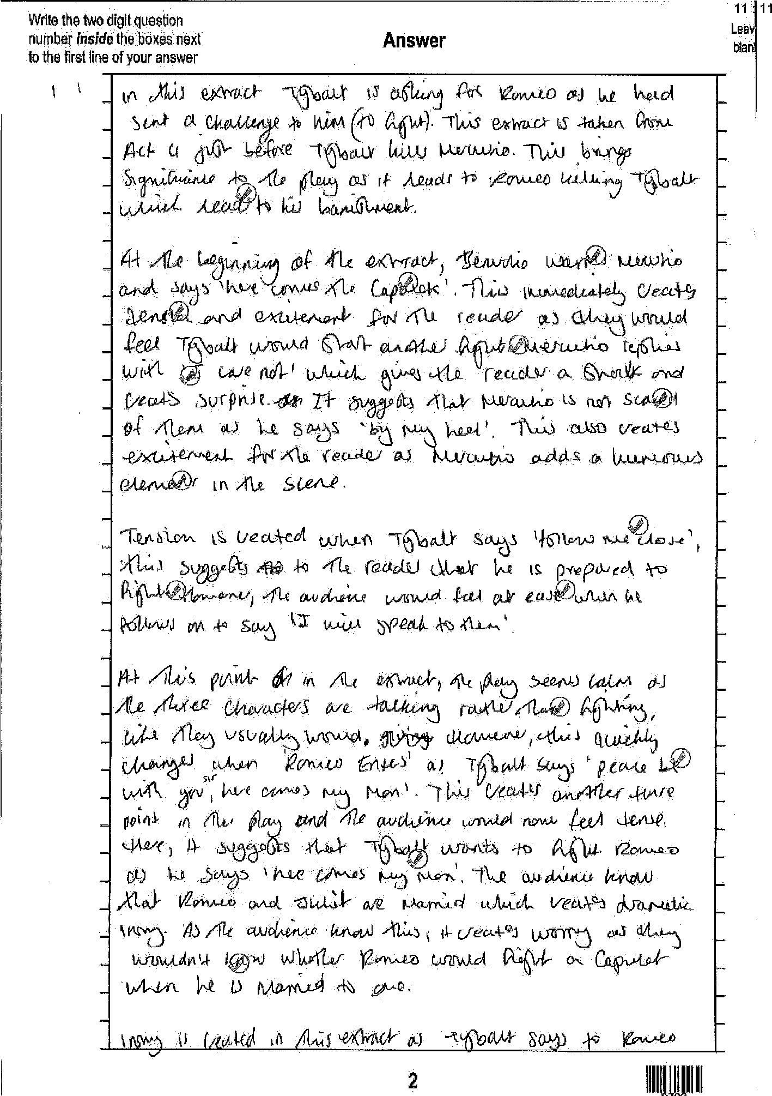

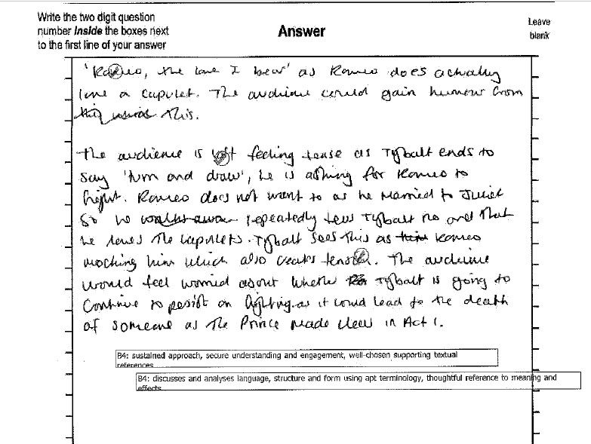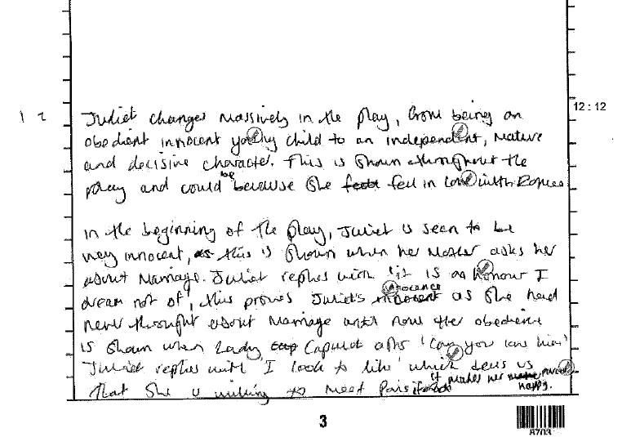

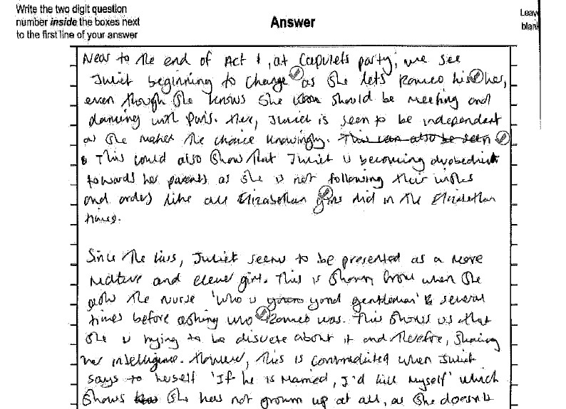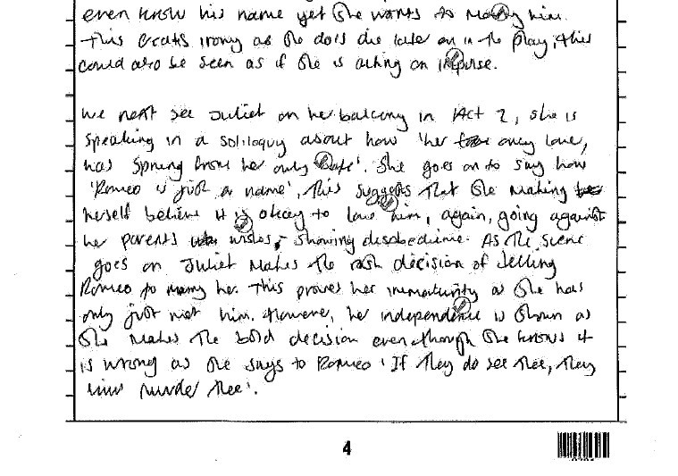

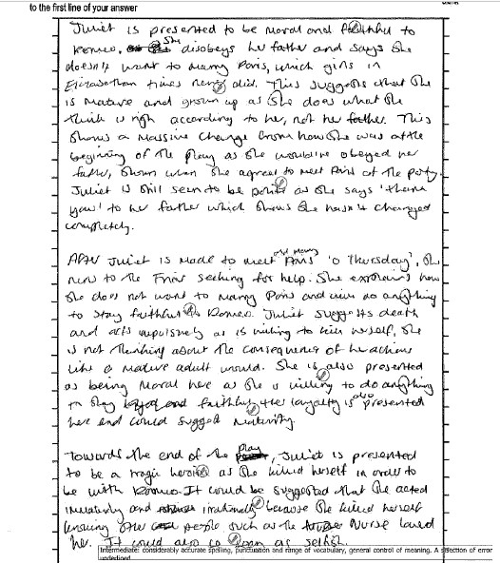

Grade 9
