THE CRATCHITS (STAVE 3)
Place your understanding of the Cratchits on your progress tracker. Mark where you think you are with an X and write the time above it.
MY PROGRESS TRACKER: THE CRATCHITS

TASK ONE: As a group, read from ‘…as it was possible he could have done in any lofty hall’ to ‘Not coming upon Christmas Day!’
Complete the family tree of the Cratchit family. Pay close attention to the names Dickens mentions!
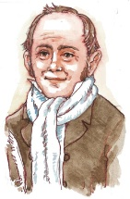

Bob
Cratchit

‘Two smaller Cratchits’

TASK TWO: Explain your initial impressions of the Cratchit family. What are they like? Does your impression differ from how Bob is presented in Stave One? Explain your ideas using quotations.

Look back over this paragraph and complete the tasks below.
Then up rose Mrs Cratchit, Cratchit's wife, dressed out but poorly in a twice-turned gown, but brave in ribbons, which are cheap and make a goodly show for sixpence; and she laid the cloth, assisted by Belinda Cratchit, second of her daughters, also brave in ribbons; while Master Peter Cratchit plunged a fork into the saucepan of potatoes, and getting the corners of his monstrous shirt collar (Bob's private property, conferred upon his son and heir in honour of the day) into his mouth, rejoiced to find himself so gallantly attired, and yearned to show his linen in the fashionable Parks. And now two smaller Cratchits, boy and girl, came tearing in, screaming that outside the baker's they had smelt the goose, and known it for their own; and basking in luxurious thoughts of sage and onion, these young Cratchits danced about the table, and exalted Master Peter Cratchit to the skies, while he (not proud, although his collars nearly choked him) blew the fire, until the slow potatoes bubbling up, knocked loudly at the saucepan-lid to be let out and peeled.

TASK THREE: Highlight all the verbs in the extract. Is there anything they all have in common? Explain in the box below.

TASK FOUR: In a different colour, highlight examples of personification in the extract. Explain the effect in the box below.

TASK FIVE: In a third colour, highlight anything that shows the Cratchit family are poor. Explain your choices as annotations around the text.
*UPDATE YOUR PROGRESS TRACKER. MARK WHERE YOU THINK YOU ARE WITH AN X AND WRITE THE TIME ABOVE OR BELOW IT*
TASK SIX: Read from ‘Not coming upon Christmas day’ to ‘…they soon returned in high procession.’ What kind of character is Tiny Tim? Explain your ideas using quotations.
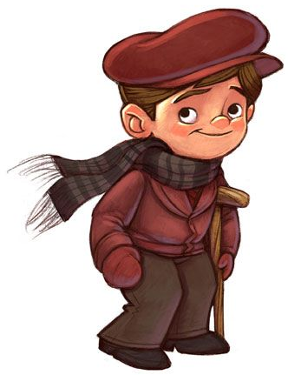

TASK SEVEN: Complete the word search, looking for the themes from ‘A Christmas Carol’. You must NOT spend more than FIVE minutes looking for the words.
Christmas Spirit, Generosity, Poverty, Family, Greed, Redemption, Forgiveness, Joy

Now explain how the Cratchit family relates to these themes. Write in full sentences.

TASK EIGHT: Read from ‘…they soon returned in high procession’ to ‘Any Cratchit would have blushed to hint at such a thing.’ Answer the following questions.
Why does Dickens spend so much time emphasising the Cratchits’ food and celebrations with language that exudes enthusiasm?

How does Dickens use language and punctuation to create this enthusiasm?

*UPDATE YOUR PROGRESS TRACKER. MARK WHERE YOU THINK YOU ARE WITH AN X AND WRITE THE TIME ABOVE OR BELOW IT*

TASK NINE: Read the extract below. We have not read this part of the novel yet. Annotate the extract with notes explaining how the Cratchits are presented. Focus on the language Dickens uses.
There was nothing of high mark in this. They were not a handsome family; they were not well dressed; their shoes were far from being water-proof; their clothes were scanty; and Peter might have known, and very likely did, the inside of a pawnbroker's. But, they were happy, grateful, pleased with one another, and contented with the time; and when they faded, and looked happier yet in the bright sprinklings of the Spirit's torch at parting, Scrooge had his eye upon them, and especially on Tiny Tim, until the last.

FINAL TASK: Choose ONE of the following questions to answer:
How does Dickens use language to present the Cratchits as a family who embrace the spirit of Christmas?
OR
How does Dickens use language to present the Cratchit family?

