Why Was Thomas Becket Murdered in Canterbury Cathedral?
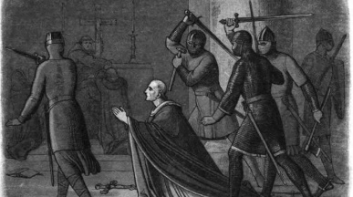
Thomas Becket was the son of a merchant who rose to power during the reign of Henry II. His life came to a violent end when he was murdered at the altar of Canterbury Cathedral on 29 December 1170.
“Will no one rid me of this troublesome priest?”
In 1155 Becket was made Chancellor to Henry II. Henry trusted him and his advice. The king was keen to increase his control over the Church. In 1162 Theobald, the Archbishop of Canterbury, died and Henry saw an opportunity to install his friend in the position.
Becket was made a priest, then a bishop, and finally the Archbishop of Canterbury in a matter of days. Henry hoped that Becket would work with him to bring the Church under control. In particular, Henry wanted to put an end to the practice of clerics being tried in religious courts rather than the king’s court.
Friendship turned sour
Yet Becket’s new role brought about in him a newfound religious fervour. He objected to Henry’s move to erode the power of the church. The issue set the former friends against one another and Becket was charged with treason. He fled to France for six years.
Under threat of excommunication by the Pope, Henry allowed Becket to return to England in 1170 and resume his role as Archbishop. But he continued to defy the king. In a fit of rage, one story claims Henry was heard to cry words similar to: “Will no one rid me of this troublesome priest?”
Four knights took him at his word and on 29 December, murdered Becket at the altar of Canterbury Cathedral.
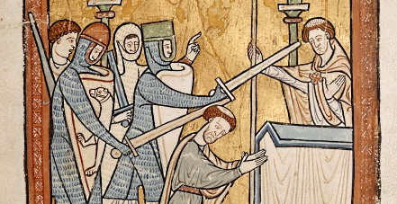
The death of Thomas Becket sent shockwaves through England and beyond.
Three years later the Pope made Becket a saint, following reports of miracles at his tomb. The four knights responsible for his murder were excommunicated and in 1174 Henry walked barefoot to Canterbury Cathedral in penance. Henry’s plans to curb the power of the Church ended in failure.

