**Working Class Life in Victorian England**

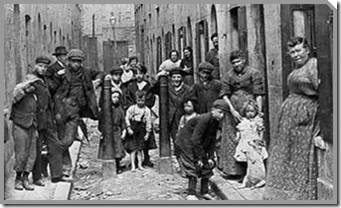

* In the nineteenth century there were developments in technology that meant many people stopped working on the land and instead moved to towns and cities to work in factories.
* This meant that cities were overcrowded and the working classes may have had up to thirty people living in one room.
* Children as young as three worked in factories.
* Those who could not cope were forced to join workhouses.
* Three out of every 20 babies die before their first birthday.
* Life expectancy is about 40 years.

**The Workhouse**

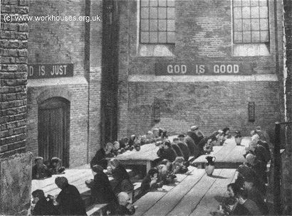

*The Workhouse (also known as The Poor House) was where many poverty-stricken Victorians were sent if they couldn’t afford to support themselves and their families. The Workhouse offered somewhere to live but it came with the requirement that its inmates had to work without receiving a wage! Many people (such as famous novelist Charles Dickens) felt this was incredibly unfair and that these members of society were being taken advantage of.*

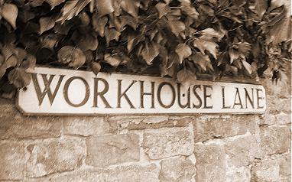

**Entry to the workhouses was voluntary, but it was certainly the last choice for people. People ended-up in the workhouse for a variety of reasons.**

* Usually, it was because they were too poor, old or ill to support themselves. This may have resulted from such things as a lack of work during periods of high unemployment, or someone having no family willing or able to provide care for them when they became elderly or sick.
* Unmarried pregnant women were often disowned by their families and the workhouse was the only place they could go during and after the birth of their child.
* Before mental asylums (for the criminally insane) were created in the mid-nineteenth century, the mentally ill poor were often committed to the workhouse.

**The Workhouse Daily Routine**

|  |  |  |  |  |  |  |  |
| --- | --- | --- | --- | --- | --- | --- | --- |
|  | **Hour of Rising.** | **Interval for Breakfast.** | **Time for setting to Work.** | **Interval for Dinner.** | **Time for leaving off Work** | **Interval for Supper.** | **Time for going to Bed.** |
| 25 March to 29 Sept | 6 o'clock. | From ½ past 6 to 7. | 7 o'clock. | From 12 to 1. | 6 o'clock. | 6 to 7. | 8. |
| 29 Sept to 25 March | 7 o'clock. | From ½ past 7 to 8. | 8 o'clock. | From 12 to 1. | 6 o'clock. | 6 to 7. | 8. |

Workhouse inmates — at least those who were capable of it — were given a variety of work to perform, much of which was involved in running the workhouse. The women mostly did domestic jobs such as cleaning, or helping in the kitchen or laundry. Some workhouses had workshops for sewing, spinning and weaving or other local trades. Others had their own vegetable gardens where the inmates worked to provide food for the workhouse.

C:\Users\krista carson\AppData\Local\Microsoft\Windows\Temporary Internet Files\Content.IE5\7S9EO6LH\MCj03790650000[1].wmf**Charles Dickens**

1812 - 1870

His own story is one of rags to riches. The good fortune of being sent to school at the age of nine was short-lived because his father was imprisoned for bad debt. The entire family, apart from Charles, were sent to the Marshalsea (a prison for people who can’t pay their debts). Charles was sent to work in Warren's blacking factory and endured appalling conditions as well as loneliness and despair. After three years he was returned to school, but the experience was never forgotten.

* Like many others, he began his career as a journalist.
* In April 1836, he married Catherine Hogarth. Within the same month came the publication of the highly successful 'Pickwick Papers', and from that point on there was no looking back for Dickens.
* As well as a huge list of novels he published autobiography, edited weekly periodicals including 'Household Words' and 'All Year Round', wrote travel books and administered charitable organisations.
* He was also a theatre enthusiast, wrote plays and performed before Queen Victoria in 1851. His energy was inexhaustible and he spent much time abroad - for example lecturing against slavery in the United States.
* He separated from his wife in 1858 after the birth of their ten children, but maintained relations with his mistress, the actress Ellen Ternan. He died of a stroke in 1870. He is buried at Westminster Abbey.

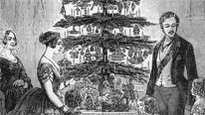**A Victorian Christmas**

At the start of the Victorian period, Christmas wasn’t really celebrated but by the end of the nineteenth century it was the biggest annual celebration.

The Victorians introduced:

* Christmas crackers *(they were filled with sweets)*
* Christmas dinner
* Roast turkey
* Presents
* Christmas cards *(Queen Victoria encouraged her children to make their own at home)*
* Christmas decorations
* Christmas carols

*While Charles Dickens did not invent the Victorian Christmas, his book*A Christmas Carol*is credited with helping to popularise and spread the traditions of the festival. Its themes of family, charity, goodwill, peace and happiness capture the spirit of the Victorian Christmas, and are very much a part of the Christmas we celebrate today.*