KS3 wider reading and enrichment
YEAR 8
Criminal Minds
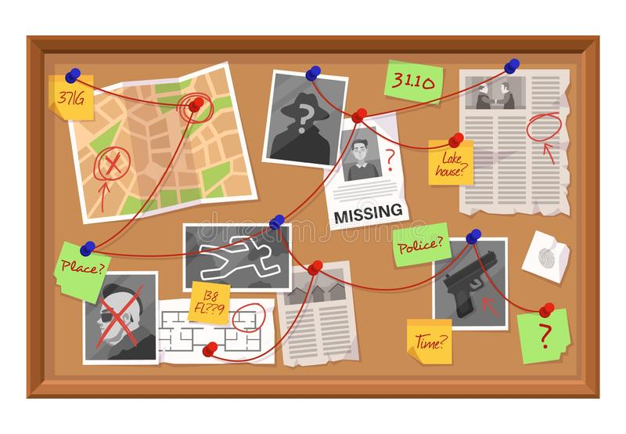

Name: _________________________
Class: _________________________
Teacher: _______________________

How do the police investigate crimes?
When police officers are called to a crime scene, they may be lucky in that the perpetrator is still on the premises. In that case, the police take the criminal away and focus on building a case against them that stands up in court. But what about crimes where the criminal is long gone? How do the police investigate and solve that crime?
The primary tools that police have when investigating crimes are interviews or interrogations and collecting physical evidence. They then use the information that they have collected to piece together a possible scenario as to what happened that the collected evidence will support.
So how do the police investigate crimes? Read on to learn more about the basic police investigation steps that are used to build a criminal case.
The Crime Scene
As soon as the police receive a call that a crime has been committed or is in progress, they send officers to the scene. The officers may be able to catch the criminal right on the scene. The officers will then arrest this person and take them to the police station or the county jail for booking.
However, even if the police caught the perpetrator red-handed, they will still collect evidence at the scene of the crime to support a criminal sentence. This evidence collection will include interviewing all of the potential witnesses at the scene. A site investigation will also be conducted, which may include taking pictures, measurements, taking forensic evidence, making general observations, and taking objects that may be connected to the crime.
At all times, the police and their employees must obey the rules for permissible search and seizure. This means, generally, that if the police want to search any private property, they must first obtain a warrant or have probable cause that would allow a search without a warrant.
Interviewing Witnesses
When the police officers conduct interviews, they're looking to establish the facts of the case, trying to figure out what happened and who might be responsible. Often, they'll interview witnesses separately so that they can have each person's individual recollection of the events.
The police will want to talk to people who have personal knowledge of the crime. In order to have personal knowledge, the witness needed to have seen, heard, smelled, tasted, or touched something first hand. The police will carefully document these witness statements along with the police officer's observations about the witness, so that the information will be available to future police officers, detectives, and prosecutors.
Law Enforcement Observations
A key component of any criminal investigation is the observations of the police officers. Police officers are trained to observe and notice details. They will note the position of weapons, blood stains, clothing, weather and any other detail that might explain the crime or the criminal behaviour.
Physical and Forensic Evidence
The police will also collect physical evidence at the crime scene. This may include taking photographs, measurements, fingerprints, blood samples, and taking any objects that may be related to the crime. Each bit of evidence must then be properly recorded and documented. Physical items will be collected using gloves to preserve fingerprints and to limit contamination. If the crime warrants it, forensic evidence, like fingerprints, blood, or saliva found at the scene will be gathered and sent to labs for analysis.
The evidence items will be placed in a special bag that will be properly marked so it can be identified later. The chain of custody for each piece of evidence will be established starting with the person who collected it and then each transfer of that evidence will be documented to establish an unbroken chain from the time of collection to presentation at trial.
Custodial Interrogations
The go to tool for most criminal investigations is the interrogation of suspects with the intention to trying to get a confession. While, forensic evidence receives lots of attention and is a valuable weapon in the war on crime, it is expensive and time consuming. An interrogation will often result in results much faster and certainly much cheaper.
Police officers and detectives are skilled interrogators. They have studied human behaviour and body language. Interrogation is a science. Detectives know how to gain a suspect's trust and how to manipulate them into a confession. While the police must not violate a person's Miranda and constitutional rights in order to obtain a confession, they are still allowed a lot of latitude. For instance, the police can lie to a suspect. They also can engage in subterfuge or trick a suspect.

Unlocking Vocabulary – find the definitions of the following words:
Perpetrator - ____________________________________________________________________________
Forensic - _______________________________________________________________________________
Permissible - ____________________________________________________________________________
Seizure - ________________________________________________________________________________
Warrant - _______________________________________________________________________________
Prosecutor - _____________________________________________________________________________
Custodial - ______________________________________________________________________________
Subterfuge - _____________________________________________________________________________
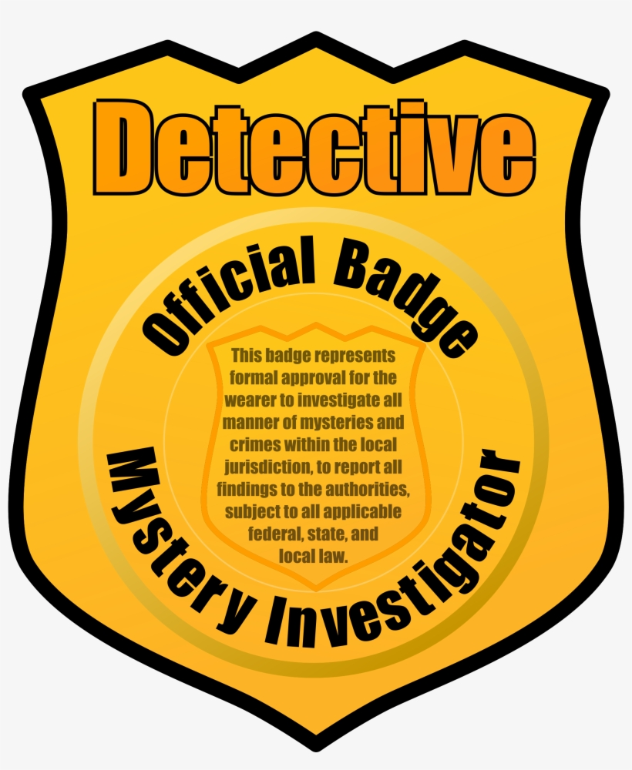
Using the article above create a Leaflet or Fact File sheet on police investigators. Be as creative as you can!
2. Extract from Oliver Twist
It was now intensely dark. The fog was much heavier than it had been in the early part of the night; and the atmosphere was so damp, that, although no rain fell, Oliver’s hair and eyebrows, within a few minutes after leaving the house, had become stiff with the half-frozen moisture that was floating about. They crossed the bridge, and kept on towards the lights which he had seen before. They were at no great distance off; and, as they walked pretty briskly, they soon arrived at Chertsey.
‘Slap through the town,’ whispered Sikes; ‘there’ll be nobody in the way, to-night, to see us.’
Toby acquiesced; and they hurried through the main street of the little town, which at that late hour was wholly deserted. A dim light shone at intervals from some bed-room window; and the hoarse barking of dogs occasionally broke the silence of the night. But there was nobody abroad. They had cleared the town, as the church-bell struck two.
Quickening their pace, they turned up a road upon the left hand. After walking about a quarter of a mile, they stopped before a detached house surrounded by a wall: to the top of which, Toby Crackit, scarcely pausing to take breath, climbed in a twinkling.
‘The boy next,’ said Toby. ‘Hoist him up; I’ll catch hold of him.’
Before Oliver had time to look round, Sikes had caught him under the arms; and in three or four seconds he and Toby were lying on the grass on the other side. Sikes followed directly. And they stole cautiously towards the house.
And now, for the first time, Oliver, well-nigh mad with grief and terror, saw that housebreaking and robbery, if not murder, were the objects of the expedition. He clasped his hands together, and involuntarily uttered a subdued exclamation of horror. A mist came before his eyes; the cold sweat stood upon his ashy face; his limbs failed him; and he sank upon his knees.
‘Get up!’ murmured Sikes, trembling with rage, and drawing the pistol from his pocket; ‘Get up, or I’ll strew your brains upon the grass.’
‘Oh! for God’s sake let me go!’ cried Oliver; ‘let me run away and die in the fields. I will never come near London; never, never! Oh! pray have mercy on me, and do not make me steal. For the love of all the bright Angels that rest in Heaven, have mercy upon me!’
The man to whom this appeal was made, swore a dreadful oath, and had cocked the pistol, when Toby, striking it from his grasp, placed his hand upon the boy’s mouth, and dragged him to the house.
‘Hush!’ cried the man; ‘it won’t answer here. Say another word, and I’ll do your business myself with a crack on the head. That makes no noise, and is quite as certain, and more genteel. Here, Bill, wrench the shutter open. He’s game enough now, I’ll engage. I’ve seen older hands of his age took the same way, for a minute or two, on a cold night.’
Sikes, invoking terrific imprecations upon Fagin’s head for sending Oliver on such an errand, plied the crowbar vigorously, but with little noise. After some delay, and some assistance from Toby, the shutter to which he had referred, swung open on its hinges.
It was a little lattice window, about five feet and a half above the ground, at the back of the house: which belonged to a scullery, or small brewing-place, at the end of the passage. The aperture was so small, that the inmates had probably not thought it worth while to defend it more securely; but it was large enough to admit a boy of Oliver’s size, nevertheless. A very brief exercise of Mr. Sike’s art, sufficed to overcome the fastening of the lattice; and it soon stood wide open also.
‘Now listen, you young limb,’ whispered Sikes, drawing a dark lantern from his pocket, and throwing the glare full on Oliver’s face; ‘I’m a going to put you through there. Take this light; go softly up the steps straight afore you, and along the little hall, to the street door; unfasten it, and let us in.’
‘There’s a bolt at the top, you won’t be able to reach,’ interposed Toby. ‘Stand upon one of the hall chairs. There are three there, Bill, with a jolly large blue unicorn and gold pitchfork on ‘em: which is the old lady’s arms.’
‘Keep quiet, can’t you?’ replied Sikes, with a threatening look. ‘The room-door is open, is it?’
‘Wide,’ replied Toby, after peeping in to satisfy himself. ‘The game of that is, that they always leave it open with a catch, so that the dog, who’s got a bed in here, may walk up and down the passage when he feels wakeful. Ha! ha! Barney ‘ticed him away to-night. So neat!’
Although Mr. Crackit spoke in a scarcely audible whisper, and laughed without noise, Sikes imperiously commanded him to be silent, and to get to work. Toby complied, by first producing his lantern, and placing it on the ground; then by planting himself firmly with his head against the wall beneath the window, and his hands upon his knees, so as to make a step of his back. This was no sooner done, than Sikes, mounting upon him, put Oliver gently through the window with his feet first; and, without leaving hold of his collar, planted him safely on the floor inside.
‘Take this lantern,’ said Sikes, looking into the room. ‘You see the stairs afore you?’
Oliver, more dead than alive, gasped out, ‘Yes.’ Sikes, pointing to the street-door with the pistol-barrel, briefly advised him to take notice that he was within shot all the way; and that if he faltered, he would fall dead that instant.
‘It’s done in a minute,’ said Sikes, in the same low whisper. ‘Directly I leave go of you, do your work. Hark!’
‘What’s that?’ whispered the other man.
They listened intently.
‘Nothing,’ said Sikes, releasing his hold of Oliver. ‘Now!’
In the short time he had had to collect his senses, the boy had firmly resolved that, whether he died in the attempt or not, he would make one effort to dart upstairs from the hall, and alarm the family. Filled with this idea, he advanced at once, but stealthily.
‘Come back!’ suddenly cried Sikes aloud. ‘Back! back!’
Scared by the sudden breaking of the dead stillness of the place, and by a loud cry which followed it, Oliver let his lantern fall, and knew not whether to advance or fly.
The cry was repeated—a light appeared—a vision of two terrified half-dressed men at the top of the stairs swam before his eyes—a flash—a loud noise—a smoke—a crash somewhere, but where he knew not,—and he staggered back.
Sikes had disappeared for an instant; but he was up again, and had him by the collar before the smoke had cleared away. He fired his own pistol after the men, who were already retreating; and dragged the boy up.
‘Clasp your arm tighter,’ said Sikes, as he drew him through the window. ‘Give me a shawl here. They’ve hit him. Quick! How the boy bleeds!’
Then came the loud ringing of a bell, mingled with the noise of fire-arms, and the shouts of men, and the sensation of being carried over uneven ground at a rapid pace. And then, the noises grew confused in the distance; and a cold deadly feeling crept over the boy’s heart; and he saw or heard no more.
Oliver Twist, Charles Dickens

Questions and Comprehension
Unlocking Vocabulary – find the definitions of the following words:
Acquiesced - ____________________________________________________________________________
Subdued - ______________________________________________________________________________
Strew - _________________________________________________________________________________
Invoking - _______________________________________________________________________________
Imprecation - ____________________________________________________________________________
Scullery - ________________________________________________________________________________
Aperture - _______________________________________________________________________________
Imperiously - _____________________________________________________________________________
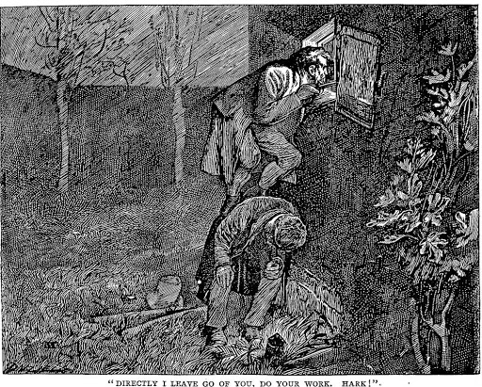
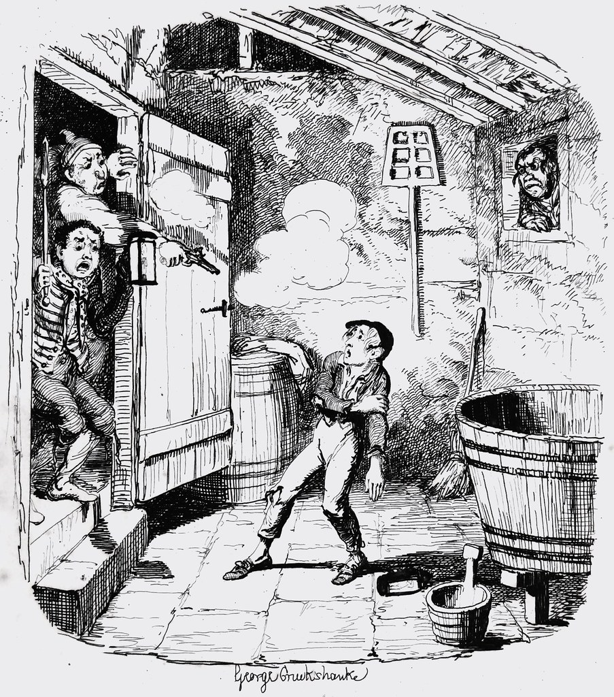

Focus on the text:
- How far did Oliver, Sikes and Crackit walk to the house? Why are they going to the house?
________________________________________________________________________________________
________________________________________________________________________________________
________________________________________________________________________________________
- How is Oliver feeling at the beginning of the extract? How do you know?
________________________________________________________________________________________
________________________________________________________________________________________
________________________________________________________________________________________
- What does Crackit mean when he says Oliver is ‘ “game enough now” ’? Read paragraph seven for help.
________________________________________________________________________________________
________________________________________________________________________________________
________________________________________________________________________________________
- The window is too small an opening for Sikes and Crackit. How do they intend getting into the house?
________________________________________________________________________________________
________________________________________________________________________________________
________________________________________________________________________________________

- What has happened to Oliver at the end of the extract?
________________________________________________________________________________________
________________________________________________________________________________________
________________________________________________________________________________________
- What impression do you get of Sikes? Why? Use quotations to strengthen your answer.
________________________________________________________________________________________
________________________________________________________________________________________
________________________________________________________________________________________
________________________________________________________________________________________
________________________________________________________________________________________
________________________________________________________________________________________

Writing Task – produce a newspaper article about the break in.
Top Tips:
- Use an eye-catching headline
- Your first paragraph should cover the Who, What, When, Where and Why of what happened
- Include quotation from witnesses
- Include a picture if you can (you can draw or use an appropriate picture from the internet)

3. Poetry
('About his person' is the expression police use when they go through the items found on a dead body.)

About His Person
Five pounds fifty in change, exactly,
a library card on its date of expiry.
A postcard stamped,
unwritten, but franked,
a pocket size diary slashed with a pencil
from March twenty-fourth to the first of April.
A brace of keys for a mortise lock,
an analogue watch, self-winding, stopped.
A final demand
in his own hand,
a rolled up note of explanation
planted there like a spray carnation
but beheaded, in his fist.
A shopping list.
A giveaway photograph stashed in his wallet,
a keepsake banked in the heart of a locket.
no gold or silver,
but crowning one finger
a ring of white unweathered skin.
That was everything.

Simon Armitage

Looking at Language
Unlocking Vocabulary – find the definitions of the following words:
Expiry - _________________________________________________________________________________
Franked - ________________________________________________________________________________
Slashed - ________________________________________________________________________________
Brace - __________________________________________________________________________________
Mortise - ________________________________________________________________________________
Analogue - _______________________________________________________________________________
Unweathered - ___________________________________________________________________________
Looking at language
In your own words describe what the poem is about: ________________________________________________________________________________________________________________________________________________________________________________________________________________________________________________________________________________________________________________________________________________________________________________________________________________________________________________________________________________________________________________________________________________
List the items that were found on the man’s body.
________________________________________________________________________________________________________________________________________________________________________________________________________________________________________________________________________________________________________________________________________________________________________________________________________________________________________________________
Which words suggest either the violence of the man's death, or of the events that led up to it? Hint – look at the verbs in particular. Then choose two of the words and explain its connotations.
________________________________________________________________________________________________________________________________________________________________________________________________________________________________________________________________________________________________________________________________________________________________________________________________________________________________________________________________________________________________________________________________________________
Look at these quotes. What do they tell us about the man? How do they make us feel about him?
“a library card on its date of expiry”
________________________________________________________________________________________________________________________________________________________________________________________________________________________________________________________________________________________________________________________________________________________________
“A postcard stamped,
unwritten, but franked,”
________________________________________________________________________________________________________________________________________________________________________________________________________________________________________________________________________________________________________________________________________________________________
“a pocket size diary slashed with a pencil
from March twenty-fourth to the first of April.”
________________________________________________________________________________________________________________________________________________________________________________________________________________________________________________________________________________________________________________________________________________________________
“a ring of white unweathered skin”
________________________________________________________________________________________________________________________________________________________________________________________________________________________________________________________________________________________________________________________________________________________________

Imagine you are a police officer enquiring into the death of this man. You have to write the formal report.
Structure
- Facts: Who, what, where, when.
- What does each item reveal about the man?
- What do you feel is the most important piece of evidence about the man?
- What do the items suggest about the man himself?
- What do you conclude?
4. Read the article from Newsround dated March 2019.
Knife crime: Why are we talking about it?
Knife crime is a particularly big issue in the news at the moment. This is following a number of recent knife attacks on people, particularly in London. After falling for several years, the amount of knife crime in England and Wales is rising again. Out of the 44 police forces across the areas, 42 recorded a rise in knife crime since 2011.
Figures released in February showed the number of deaths as a result of knife crime in England and Wales last year was 285 - the highest since records began in 1946. In November 2018, there were reports that there had been a rise in the number of children under 18 receiving treatment for knife wounds in England, with the number of young victims having increased by 86% in the last four years.
The government has said that it is working to deal with the problem, but a lot of people are angry and say that the problem is not being dealt with effectively.
Although the figures suggest that knife crime is on the increase, it is still relatively unusual for a violent incident to involve a knife - and rarer still for someone to need hospital treatment.
Overall levels of violence (for example, including physical fights) have in fact fallen by about a quarter since 2013.
Why has the amount of knife crime gone up?
There is no one reason to explain this increase.
Many people believe that those who carry knives are simply criminals and that what is needed to stop this behaviour is more police officers on the streets.
In recent years, there has been a decrease in the number of police officers as there has not been as much money available from the government to pay for them. The UK's top police officer Cressida Dick has said that she believes there is "some link" between falling police numbers and a rise in violent crime.
The boss of Thames Valley Police, Chief Constable Francis Habgood, agrees with this, saying it was "common sense" that a reduction in the number of police officers was linked to knife crime. "If you have got fewer people enforcing the law, [...] able to respond when things happen and investigate things, then of course it is going to have an impact on our ability to deal with issues like knife crime," he said.
He explained that in his eight years as chief constable, he has been required to make cuts of more than £100 million and had lost 1,000 officers and staff.
But earlier this week Prime Minister Theresa May said there is "no direct correlation" between falling officer numbers and a rise in violent crime.
Leader of the Labour Party Jeremy Corbyn said that Mrs May "must start listening" to police chiefs over the impact of cutting 21,000 officers, saying: "You cannot keep people safe on the cheap."
Some experts argue that often it is a fear of gangs and crime that leads to young people carrying knives, because they believe it will help to keep them safe. The trouble is that those weapons may then be used, which could make the number of violent incidents go up.
In March 2018, police chief Cressida Dick told the Times newspaper that she believed arguments and peer pressure on social media sites can "rev people up", make people angry and make street violence "more likely".
Others say that young people get involved with gangs and knife crime because they lack opportunities in life. They say there are too few services provided to help and support young people, including education, mental health services and youth centres. They believe that improving these services would help cut the amount of violent crime.
Many of these services have been reduced as a result of the government reducing the money available to spend on these services.
What are laws about carrying a knife?
There are lots of different rules about carrying a knife, but for the most part it is illegal to carry a knife in public without a good reason.
It is also illegal to use any knife in a threatening way.
If you are found to be carrying a knife in the UK, there could be serious punishments.
What is stop and search?
One thing that you might have heard being talked about in relation to knife crime is something called 'stop-and-search'.
As the name might suggest, stop-and-search is a police practice in which a police officer can stop a person briefly to check that they are not carrying any weapons or illegal items - for example, a knife.
There are certain things that police are and aren't allowed to do during stop-and-search, and certain things they have to do (for example, show their credentials and tell the person what they suspect them of carrying).
Over the last few years, the use of stop-and-search by police officers has declined.
The boss of Thames Valley Police, Chief Constable Francis Habgood, has said that the use of stop-and-search in his police force had "considerably" dropped in the last few years, but that he thought it should be used more to deal with the issue of knife crime and young people carrying blades.
Home Secretary Sajid Javid told the annual Police Superintendents' Conference in September: "If stop-and-search means that lives can be saved from the communities most affected, then of course it's a very good thing."
But some people have been critical of stop-and-search as they say that ethnic minorities, especially young black men, are unfairly targeted.
What is being done about knife crime?
Following the most recent attacks, Home Secretary Sajid Javid has called for knife crime to be treated "like a disease". He has met with police bosses to look at ways to deal with the spread of violence.
The prime minister has asked government officials to make dealing with the issue of knife crime a priority and has said she would host a summit "in the coming days" to tackle it. Mrs May also said the problem would require "a whole-of-government effort, in conjunction with the police, the wider public sector and local communities".
The UK's top police officer Cressida Dick has said: "Now is the time for all of us - the public in our communities, across London, across the country, politicians - to say to ourselves 'What else can be done? What can we do to prevent young people getting involved with knife crime?'"
Manchester City captain Vincent Kompany has voiced his opinion too, saying that young people need "the right amount of education and support at every level" to help prevent knife crime.
In March 2018, it was announced that a series of adverts aimed at 10 to 21-year-olds - paid for by the government - would be put on social media and digital channels to try to make young people more aware of the dangers of knife crime. Posters would also be put up in cities in England where knife crime is more common.
Patrick Green, head of the Ben Kinsella Trust (a charity that works to tackle knife crime), said it is "vitally important" that young people understand the dangers associated with carrying a knife.
Many charities and organisations continue to work hard to raise awareness of the dangers of knife crime and - along with all of those working to tackle the issue - hope that this increase will soon be reversed.

In your own words, summarise what this article is about:
________________________________________________________________________________________________________________________________________________________________________________________________________________________________________________________________________________________________________________________________________________________________________________________________________________________________________________________________________________________________________________________________________________
Find examples of the following persuasive techniques:
Statistic - ________________________________________________________________________________
Expert - _________________________________________________________________________________
Triple - __________________________________________________________________________________
Rhetorical question - ______________________________________________________________________
Fact - ___________________________________________________________________________________
In your own words, what opinion do these people have about knife crime?
Name | Position | Opinion about knife crime
Francis Habgood | Chief Constable of Thames Valley Police | That there aren’t enough police officers to deal with the amount of knife crime properly.  Thinks stop-and-search should be used more.
Sajid Javid
Theresa May
Cressida Dick

Jeremy Corbyn

Vincent Kompany

Patrick Green



You have been asked to write an article for a teenage magazine about knife crime. It needs to have an informal tone but be informative. Use this to help you.
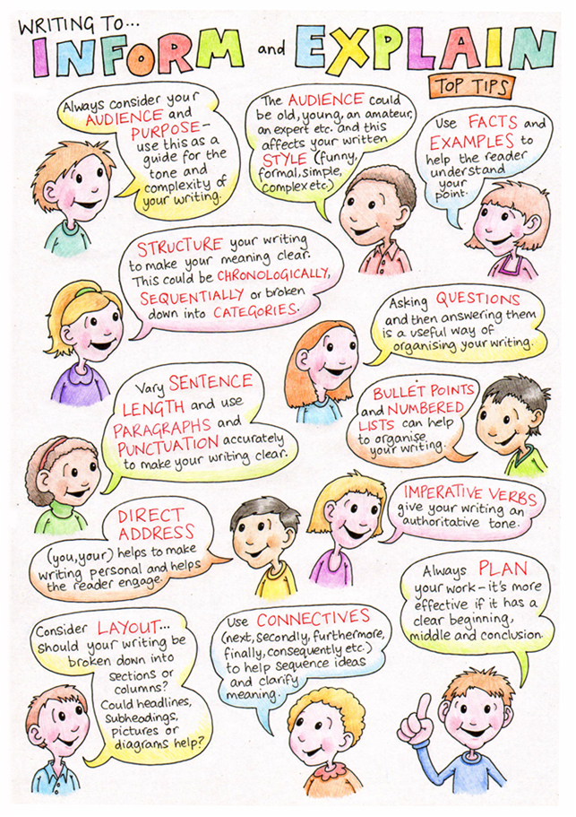

5. Read the extract from Legend by Marie Lu. The novel is set in dystopian Los Angeles, in a time where North America has devolved into two warring countries: The Republic and The Colonies. Mixed into this fight is a rebel group, known as the Patriots.
Day is a 15 year-old boy born into the meanest slums of the Republic and the country's most wanted criminal.
When I was seven years old, my father came home from the warfront for a week's leave. His job was to clean up after the Republic's soldiers, so he was usually gone, and Mom was left to raise us boys on her own. When he came home that time, the city patrols did a routine inspection of our house, then dragged Dad off to the local police headquarters for questioning. They'd found something suspicious, I guess.
The police brought him back with two broken arms, his face bloody and bruised.
Several nights later, I dipped a ball of crushed ice into a can of gasoline, let the oil coat the ice in a thick layer, and lit it. Then I launched it with a slingshot through the window of our local police headquarters, I remember the fire trucks that came whizzing round the corner shortly thereafter, and the charred remains of the police building's west wing. They never found out who did it, and I never came forward. There was, after all, no evidence. I had committed my first perfect crime.
My mother used to hope that I would rise up from my humble roots. Become someone successful, or even famous.
I'm famous all right, but I don't think it's what she had in mind.
* * *
It's nightfall again, a good forty-eight hours since the soldiers marked my mother's door.
I wait in the shadows of a back alley one block from the Los Angeles Central Hospital and watch its staff spill in and out of the main entrance. It's a cloudy night with no moon, and I can't even make out the crumbling Bank Tower sign at the top of the building. Electric lights shine from each floor - a luxury only government buildings and the elite's homes can afford. Military jeeps stack up along the street as they wait for approval to enter the underground parking lots. Someone checks them for proper IDs. I keep still, my eyes fixed on the entrance.
I look pretty awesome tonight. I'm wearing my good pair of shoes - boots made of dark leather worn soft over time, with strong laces and steel toes. Bought them with 150 Notes from our stash. I've hidden a knife flat against the sole of each boot. When I shift my feet, I can feel the cool metal against my skin. My black trousers are tucked into my boots and I carry a pair of gloves and a black handkerchief in my pockets. A dark, long-sleeved shirt is tied around my waist. My hair hangs loose down my shoulders. This time I've sprayed my white-blond strands a deep black, as if I'd dipped them in crude oil. Earlier in the day, Tess had traded five Notes for a bucket oy pygmy pig's blood from the back alley of a kitchen. My arms, stomach, and face are smeared with it. I've also streaked mud on my cheeks, for good measure.

Find evidence for the following statements. There will be more than one piece of evidence for some of the statements and you need to include all parts.
- The war has been going on for a long time.
________________________________________________________________________________________
________________________________________________________________________________________
- Day has brothers.
________________________________________________________________________________________
________________________________________________________________________________________
- The police have a lot of power.
________________________________________________________________________________________
________________________________________________________________________________________
- Day still doesn't know why his father was arrested.
________________________________________________________________________________________
________________________________________________________________________________________
- Day comes from a poor family.
________________________________________________________________________________________
________________________________________________________________________________________
- Day isn't working on his own.
________________________________________________________________________________________
________________________________________________________________________________________
- The hospital is an important building.
________________________________________________________________________________________
________________________________________________________________________________________
- Day is proud of what he's done in the past and what he's doing now.
________________________________________________________________________________________
________________________________________________________________________________________
- Day doesn't want to be seen.
________________________________________________________________________________________
________________________________________________________________________________________
- It is a dark night.
________________________________________________________________________________________
________________________________________________________________________________________
Descriptive writing
- Think back to an event from your childhood, which really sticks out in your memory. It might be your first day at school, the first time you rode a bike without stabilisers or the first time you swam in the sea. Write down three colours you remember from that event

- Write down three sounds you remember:

- Write down three smells you remember:

- Write down three feelings you remember. Angry? Happy? Exhilarated?

- Write three similes or metaphors you could use to describe what happened:

Write about the event from your memory. Use the notes you’ve made to describe things in detail. Try to create a sense of atmosphere.
This extract is taken from Arthur Conan Doyle’s novel, The Hound of the Baskervilles, written in 1902.
In this passage, the detective Sherlock Holmes and his friend Dr Watson are on the moor, investigating the mysterious death of Charles Baskerville and the legend of a gigantic hound.

I have said that over the great Grimpen Mire there hung a dense, white fog. It was drifting slowly in our direction and banked itself up like a wall on that side of us, low, but thick and well defined. The moon shone on it, and it looked like a great shimmering icefield, with the heads of the distant tors as rocks borne upon its surface. Holmes’s face was turned towards it, and he muttered impatiently as he watched its sluggish drift.
…
Every minute that white woolly plain which covered one-half of the moor was drifting closer and closer to the house. Already the first thin wisps of it were curling across the golden square of the lighted window. The farther wall of the orchard was already invisible, and the trees were standing out of a swirl of white vapour. As we watched it the fog-wreaths came crawling round both corners of the house and rolled slowly into one dense bank on which the upper floor and the roof floated like a strange ship upon a shadowy sea. Holmes struck his hand passionately upon the rock in front of us and stamped his feet in his impatience.
“If he isn’t out in a quarter of an hour the path will be covered. In half an hour we won’t be able to see our hands in front of us.”
“Shall we move farther back upon higher ground?”
“Yes, I think it would be as well.”
So as the fog-bank flowed onward we fell back before it until we were half a mile from the house, and still that dense white sea, with the moon silvering its upper edge, swept slowly and inexorably on.
…
“Hist!” cried Holmes, and I heard the sharp click of a cocking pistol.
“Look out! It’s coming!”
There was a thin, crisp, continuous patter from somewhere in the heart of that crawling bank. The cloud was within fifty yards of where we lay, and we glared at it, all three, uncertain what horror was about to break from the heart of it. I was at Holmes’s elbow,
I glanced for an instant at his face. It was pale and exultant, his eyes shining brightly in the moonlight. But suddenly they started forward in a rigid, fixed stare, and his lips parted in amazement. At the same instant Inspector Lestrade gave a yell of terror and threw himself face downward upon the ground. I sprang to my feet, my inert hand grasping my pistol, my mind paralysed by the dreadful shape which had sprung out upon us from the shadows of the fog. A hound it was, an enormous coal-black hound, but not such a hound as mortal eyes have ever seen. Fire burst from its open mouth, its eyes glowed with a smouldering glare, its muzzle and hackles and dewlap were outlined in flickering flame. Never in the delirious dream of a disordered brain could anything more savage, more appalling, more hellish be conceived than that dark form and savage face which broke upon us out of the wall of fog.
With long bounds the huge black creature was leaping down the track, following hard upon the footsteps of our friend. So paralysed were we by the apparition that we allowed him to pass before we had recovered our nerve. Then Holmes and I both fired together, and the creature gave a hideous howl, which showed that one at least had hit him. He did not pause, however, but bounded onward. Far away on the path we saw Sir Henry looking back, his face white in the moonlight, his hands raised in horror, glaring helplessly at the frightful thing which was hunting him down.
But that cry of pain from the hound had blown all our fears to the winds. If he was vulnerable he was mortal, and if we could wound him we could kill him. Never have I seen a man run as Holmes ran that night. I am reckoned fleet of foot, but he outpaced me as much as I outpaced the little professional. In front of us as we flew up the track we heard scream after scream from Sir Henry and the deep roar of the hound. I was in time to see the beast spring upon its victim, hurl him to the ground, and worry at his throat. But the next instant Holmes had emptied five barrels of his revolver into the creature’s flank. With a last howl of agony and a vicious snap in the air, it rolled upon its back, four feet pawing furiously, and then fell limp upon its side. I stooped, panting, and pressed my pistol to the dreadful, shimmering head, but it was useless to press the trigger. The giant hound was dead.
Sir Henry lay insensible where he had fallen. We tore away his collar, and Holmes breathed a prayer of gratitude when we saw that there was no sign of a wound and that the rescue had been in time. Already our friend’s eyelids shivered and he made a feeble effort to move. Lestrade thrust his brandy-flask between the baronet’s teeth, and two frightened eyes were looking up at us.
‘My God!’ he whispered. ‘What was it? What, in heaven’s name, was it?’
‘It’s dead, whatever it is,’ said Holmes. ‘We’ve laid the family ghost once and forever.’

Unlocking Vocabulary – find the definitions of the following words:
Tor - ___________________________________________________________________________________
Sluggish - ________________________________________________________________________________
Wisp - __________________________________________________________________________________
Vapour - ________________________________________________________________________________
Inexorably - ______________________________________________________________________________
Exultant - _______________________________________________________________________________
Inert - __________________________________________________________________________________
Apparition - _____________________________________________________________________________

Read again the paragraph beginning, ‘There was a thin, crisp, continuous patter …’ List four details in this paragraph that describe the hound’s appearance.

Read again paragraphs 1 and 2. Use PEA paragraphs to show how the writer uses language to describe the fog. The first is done for you as an example.
POINT EVIDENCE ANALYSE
Example:
The fog isn’t moving but still manages to seem threatening: “there hung a dense, white fog”. The use of the word ‘hung’ makes me think of something that is dead but is still quite scary. The fog is also ‘dense’ which makes me feel it is impossible to see through and makes me feel trapped and claustrophobic.
Now write four PEA paragraphs of your own:
________________________________________________________________________________________________________________________________________________________________________________________________________________________________________________________________________________________________________________________________________________________________________________________________________________________________________________________________________________________________________________________________________________________________________________________________________________________________________________________________________________________________________________________________________________________________________________________________________________________________________________________________________________________________________________________________________________________________________________________________________________________________________________________________________________________________________________________________________________________________________________________________________________________________________________________________________________________________________________________________________________________________________________________________________________________________________________________________________________________________________________________________________________________________________________________________________________________________________________________________________________________________________________________________________________________________________________________________________________________________________________________________________________________________________________________________________________________________________________________________________________________________________________________________________________________________________________________________________________________________________________________________________________________________________________________________________________________________________________________________________________________________________________________________________________________________________________________________________________________________________________________________________________________________________________________________________________________________________________________________________________________________________________________________________________________________________________________________________________________________________________________________________________________________________________________________________________________________________________________________________________________________________________________________________________________________________________________________________________________________________________________________________________________________________________________________________________________________________________________________________________________________________________________________________________________________________________________________________________________________________________________________________________________________________________________________________________________________________________________________________________________________________________________________________________________________________________________________________________________________________________
Writing Task
Plan out a story using the following to help:
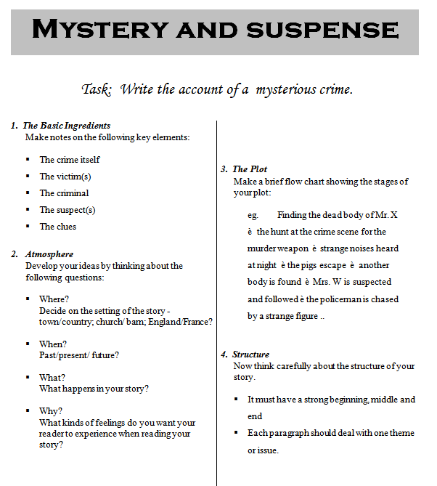

Now use your notes to write the opening. You should introduce your main character and set the scene, as well as giving a glimpse into what the story is going to be about.

