KS3 wider reading and enrichment
YEAR 8
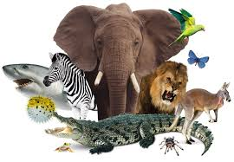
The Animal Kingdom & Natural World

Name: _________________________
Class: _________________________
Teacher: _______________________

Don't like spiders? Here are 10 reasons to change your mind
BY EARTH TOUCH NEWS JANUARY 09 2020
Populations of many invertebrate species, including certain spiders, are highly vulnerable. Some species have become extinct due to habitat loss and degradation.

In dramatic efforts to avoid or kill a spider, people have reportedly crashed their cars, set a house on fire, and even caused such a commotion that police showed up.

A pathological fear of spiders, known as arachnophobia, is of course, a legitimate condition. But in reality, we have little to fear. Read on to find out why you should love, not loathe, our eight-legged arachnid friends.

- SPIDERS HAVEN’T KILLED ANYONE IN AUSTRALIA FOR 40 YEARS

The last confirmed fatal spider bite in Australia occurred in 1979.

Only a few species have venom that can kill humans: some mouse spiders (Missulena species), Sydney Funnel-webs (Atrax species) and some of their close relatives. Antivenom for redbacks (Latrodectus hasseltii) was introduced in 1956, and for funnel-webs in 1980. However, redback venom is no longer considered life-threatening.

- SPIDERS SAVE US FROM THE WORLD’S DEADLIEST ANIMAL

Spiders mostly eat insects, which helps control their populations. Their webs – especially big, intricate ones like our orb weavers’ – are particularly adept at catching small flying insects such as mosquitos. Worldwide, mosquito-borne viruses kill more humans than any other animal.

- THEY CAN LIVE TO AN IMPRESSIVE AGE

The world’s oldest recorded spider was a 43- year-old female trapdoor spider (Gaius villosus) that lived near Perth, Western Australia. Tragically a wasp sting, not old age, killed her.

- SPIDER SILK IS AMAZING

Spider silk is the strongest, most flexible natural biomaterial known to man. It has historically been used to make bandages, and UK researchers have worked out how to load silk bandages with antibiotics. Webs of the golden orb spider, common throughout Australia, are strong enough to catch bats and birds, and a cloak was once woven entirely from their silk.

- THEIR VENOM COULD SAVE YOUR LIFE

The University of Queensland is using spider venom to develop non-addictive pain-killers. The venom rapidly immobilises prey by targeting its nervous system – an ability that can act as a painkiller in humans.

The venom from a Fraser Island funnel web contains a molecule that delays the effects of stroke on the brain. Researchers are investigating whether it could be administered by paramedics to protect a stroke victim on the way to hospital.

Funnel-web venom is also being used to create targeted pesticides which are harmless to birds and mammals.

- THEY COULD COMPETE AT LITTLE ATHLETICS

The Australian huntsman (Family Sparassidae) can run 40 body lengths per second, about eight times faster than the fastest human runners.

Other spiders have great throwing skills. To catch moths, the bolas spider spins a thread with a sticky glob of silk on the end. The glob mimics the scent of a female moth. When a male moth comes to investigate, the spider throws the glob at the moth, catches it then reels it in.

- SPIDERS WANT TO BE LEFT ALONE

Spiders are not aggressive and will either try to run away from people, or defend themselves. Many are exceptional at hiding or camouflaging themselves, in the hope we don’t even see them.

Wrap-around spiders (Dolophones species) flatten themselves around branches to hide during the day, then come out to build webs at night.

- SPIDERS HAVE VERY UNUSUAL SEX LIVES

It’s well known that some female spiders eat their partners during or after sex. But male Tasmanian cave spiders have evolved to avoid this fate. They use kinks in their legs to pin the female’s fangs apart while they mate, which can prevent her from killing him. These spiders are so fascinating, they are the subject of a documentary, Sixteen Legs

More generally, male spiders use their “hands” (called pedipalps), to transfer sperm into female spider “vaginas” (called epigynes).

During courtship, Australian male peacock spiders display their colourful abdomen to the female by using some pretty impressive dance moves.

- SPIDERS ARE GREAT MOTHERS

Some female spiders produce milk for their young, or even sacrifice themselves as food. All spider mothers protect their babies, called spiderlings. However trapdoor spider mothers allow spiderlings to live in the home burrow for nine months, before they dig their own burrows nearby.

- HUMANS NEED SPIDERS TO SURVIVE

It is important to remember that spiders and other invertebrates – animals without spines – make up 98% of animal species. They are vital to the functioning of ecosystems; without them, the remaining 2% of vertebrates, including humans, could not survive.

OK, OK. I care about spiders. Now what?
Spread the word to your friends and family that spiders should be cared for.

By all means, teach children that certain spiders require caution, and should be admired from a safe distance. But if your child has an irrational fear of spiders, address this as early as possible. Encourage positive interest in the spider world by exposing children to books and movies with spiders as the lead protagonists, such as Charlotte’s Web and Spiderman.
Questions and Comprehension
Unlocking vocabulary
Using a dictionary look up the following words and write the definition next to them:
Invertebrate: ____________________________________________________________________________
Commotion: ____________________________________________________________________________
Adept: ________________________________________________________________________________
Intricate: ______________________________________________________________________________
Pesticide:_______________________________________________________________________________
Reels: _________________________________________________________________________________
Sacrifice: ______________________________________________________________________________
Irrational: ______________________________________________________________________________
Using the article above create a Leaflet or Fact File sheet on spiders. Be as creative as you can!

Charlotte's Web: Chapter One
Read the first chapter of Charlotte's Web, by E.B. White.
Before Breakfast

"Where's Papa going with that ax?" said Fern to her mother as they were setting the table for breakfast.

"Out to the hoghouse," replied Mrs. Arable. "Some pigs were born last night."

"I don't see why he needs an ax," continued Fern, who was only eight. "Well," said her mother, "one of the pigs is a runt. It's very small and weak, and it will never amount to anything. So your father has decided to do away with it."

"Do away with it?" shrieked Fern. "You mean kill it? Just because it's smaller than the others?"

Mrs. Arable put a pitcher of cream on the table. "Don't yell, Fern!" she said. "Your father is right. The pig would probably die anyway."

Fern pushed a chair out of the way and ran outdoors. The grass was wet and the earth smelled of springtime. Fern's sneakers were sopping by the time she caught up with her father.

"Please don't kill it!" she sobbed. "It's unfair."

Mr. Arable stopped walking.

"Fern," he said gently, "you will have to learn to control yourself."

"Control myself?" yelled Fern. "This is a matter of life and death, and you talk about controlling myself." Tears ran down her cheeks and she took hold of the ax and tried to pull it out of her father's hand.

"Fern," said Mr. Arable, "I know more about raising a litter of pigs than you do. A weakling makes trouble. Now run along!"

"But it's unfair," cried Fern. "The pig couldn't help being born small, could it? If I had been very small at birth, would you have killed me?"

Mr. Arable smiled. "Certainly not," he said, looking down at his daughter with love. "But this is different. A little girl is one thing, a little runty pig is another."

"I see no difference," replied Fern, still hanging on to the ax. "This is the most terrible case of injustice I ever heard of."

A queer look came over John Arable's face. He seemed almost ready to cry himself.

"All right," he said. "You go back to the house and I will bring the runt when I come in. I'll let you start it on a bottle, like a baby. Then you'll see what trouble a pig can be."

When Mr. Arable returned to the house half an hour later, he carried a carton under his arm. Fern was upstairs changing her sneakers. The kitchen table was set for breakfast, and the room smelled of coffee, bacon, damp plaster, and wood smoke from the stove.

"Put it on her chair!" said Mrs. Arable. Mr. Arable set the carton down at Fern's place. Then he walked to the sink and washed his hands and dried them on the roller towel.

Fern came slowly down the stairs. Her eyes were red from crying. As she approached her chair, the carton wobbled, and there was a scratching noise. Fern looked at her father. Then she lifted the lid of the carton. There, inside, looking up at her, was the newborn pig. It was a white one. The morning light shone through its ears, turning them pink.

"He's yours," said Mr. Arable. "Saved from an untimely death. And may the good Lord forgive me for this foolishness."

Fern couldn't take her eyes off the tiny pig. "Oh," she whispered. "Oh, look at him! He's absolutely perfect."

She closed the carton carefully. First she kissed her father, then she kissed her mother. Then she opened the lid again, lifted the pig out, and held it against her cheek. At this moment her brother Avery came into the room. Avery was ten. He was heavily armed -- an air rifle in one hand, a wooden dagger in the other.

"What's that?" he demanded. "What's Fern got?"

"She's got a guest for breakfast," said Mrs. Arable. "Wash your hands and face, Avery."

"Let's see it!" said Avery, setting his gun down. "You call that miserable thing a pig? That's a fine specimen of a pig -- it's no bigger than a white rat."

"Wash up and eat your breakfast, Avery!" said his mother. "The school bus will be along in half an hour."

"Can I have a pig, too, Pop?" asked Avery.

"No, I only distribute pigs to early risers," said Mr. Arable. "Fern was up at daylight, trying to rid the world of injustice. As a result, she now has a pig. A small one, to be sure, but nevertheless a pig. It just shows what can happen if a person gets out of bed promptly. Let's eat!"

But Fern couldn't eat until her pig had had a drink of milk. Mrs. Arable found a baby's nursing bottle and a rubber nipple. She poured warm milk into the bottle, fitted the nipple over the top, and handed it to Fern. "Give him his breakfast!" she said.

A minute later, Fern was seated on the floor in the corner of the kitchen with her infant between her knees, teaching it to suck from the bottle. The pig, although tiny, had a good appetite and caught on quickly.

The school bus honked from the road.

"Run!" commanded Mrs. Arable, taking the pig from Fern and slipping a doughnut into her hand. Avery grabbed his gun and another doughnut.

The children ran out to the road and climbed into the bus. Fern took no notice of the others in the bus. She just sat and stared out of the window, thinking what a blissful world it was and how lucky she was to have entire charge of a pig. By the time the bus reached school, Fern had named her pet, selecting the most beautiful name she could think of.

"It's name is Wilbur," she whispered to herself.

She was still thinking about the pig when the teacher said: "Fern, what is the capital of Pennsylvania?"

"Wilbur," said Fern, dreamily. The pupils giggled. Fern blushed.

End of Chapter One.
Questions and Comprehension
Unlocking vocabulary
Using a dictionary look up the following words and write the definition next to them:
Runt: ____________________________________________________________________________
Pitcher: ____________________________________________________________________________
Injustice: _______________________________________________________________________________
Untimely: ______________________________________________________________________________
Specimen: ______________________________________________________________________________
Nevertheless: ___________________________________________________________________________
Blissful: ______________________________________________________________________________
Blushed: ______________________________________________________________________________

Looking at language
- How does the writer use language to make the start interesting? ____________________________________________________________________________________________________________________________________________________________________________________________________________________________________________________________________________________________________________________________________________________________________________________________________________________________________________________________________________________________________________________________________________________________
- What is the effect of the use of dialogue? ____________________________________________________________________________________________________________________________________________________________________________________________________________________________________________________________________________________________________________________________________________________________________________________________________________________________________________________________________________________________________________________________________________________________
- How does the writer describe the piglet? ____________________________________________________________________________________________________________________________________________________________________________________________________________________________________________________________________________________________________________________________________________________________________________________________________________________________________________________________________________________________________________________________________________________________
- What do we learn about Fern’s brother Avery? Why do you think the writer chooses to tell us these details? ____________________________________________________________________________________________________________________________________________________________________________________________________________________________________________________________________________________________________________________________________________________________________________________________________________________________________________________________________________________________________________________________________________________________
- What impression do we get of Mr Arable? Why? Use quotations to reinforce your points. ____________________________________________________________________________________________________________________________________________________________________________________________________________________________________________________________________________________________________________________________________________________________________________________________________________________________________________________________________________________________________________________________________________________________________________________________________________________________________________________________________________________________________________________________________________________________________________________________________________________________________________________________________________________________________________________________________

Write the start of a narrative with the title: ‘My New Best Friend’
TOP TIPS:
- Start in the action
- Use a range of sentences
- Show don’t tell – use imagery such as similes/metaphors/onomatopoeia/personification etc.
- Use sensory description
- Use a full range of punctuation, adventurous vocabulary – remember to check your SPaG!

The Jaguar by Ted Hughes

The apes yawn and adore their fleas in the sun.
The parrots shriek as if they were on fire, or strut
Like cheap tarts to attract the stroller with the nut.
Fatigued with indolence, tiger and lion

Lie still as the sun. The boa-constrictor’s coil
Is a fossil. Cage after cage seems empty, or
Stinks of sleepers from the breathing straw.
It might be painted on a nursery wall.

But who runs like the rest past these arrives
At a cage where the crowd stands, stares, mesmerized,
As a child at a dream, at a jaguar hurrying enraged
Through prison darkness after the drills of his eyes

On a short fierce fuse. Not in boredom—
The eye satisfied to be blind in fire,
By the bang of blood in the brain deaf the ear—
He spins from the bars, but there’s no cage to him

More than to the visionary his cell:
His stride is wildernesses of freedom:
The world rolls under the long thrust of his heel.
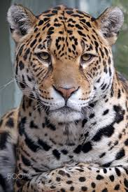
Over the cage floor the horizons come.
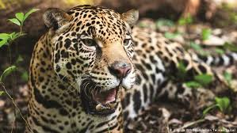
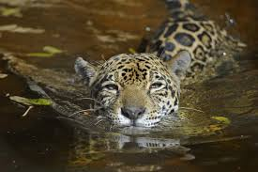

Questions and Comprehension
Thinking task:
What do you think of zoos? Are they good or bad things for people? Are they good or bad things for the animals?
What do you know about Jaguars? Where are they from? What do they look like? What are their habits?
Unlocking vocabulary
Using a dictionary look up the following words from the poem and write the definition next to them:
Adore: ________________________________________________________________________________
Fatigued: ______________________________________________________________________________
Indolence: ______________________________________________________________________________
Fossil: _________________________________________________________________________________
Mesmerized: ____________________________________________________________________________
Enraged: ______________________________________________________________________________
Visionary: ______________________________________________________________________________
Thrust: ________________________________________________________________________________

Looking at language
In your own words describe what the poem is about: _____________________________________________________________________________________________________________________________________________________________________________________________________________________________________________________________________________________________________________________________________________________________________________________________________________________________________________________________________________________________________________________________________________
List the creatures that are mentioned at Hughes’s zoo. _________________________________________________________________________________________________________________________________________________________________________________________________________________________________
Answer these questions about the content of the poem:
a) What is the state of most animals at the zoo? Why do you think they are like this? _________________________________________________________________________________________________________________________________________________________________________________________________________________________________
b) How are the parrots different to the other creatures? ____________________________________________________________________________________________________________________________________________________________________________________________________________________________________________________________________________________________________________
c) What is everyone watching, and why? _________________________________________________________________________________________________________________________________________________________________________________________________________________________________

Look at these particular pieces of language; why does Hughes use them?
a) ‘The parrots shriek as if they were on fire.’ ___________________________________________________________________________
b) ‘It might be painted on a nursery wall.’ ___________________________________________________________________________
c) ‘stares, mesmerized, / like a child at a dream,’ ___________________________________________________________________________
d) ‘more than to the visionary his cell’ ___________________________________________________________________________
Find as many examples of these things as you can:
- simile ________________________________________________________________________________________________________________________________________________________________________________________________________________________

b) metaphor _________________________________________________________________________________________________________________________________________________________________________________________________________________________________
c) alliteration _________________________________________________________________________________________________________________________________________________________________________________________________________________________________
d) enjambment _________________________________________________________________________________________________________________________________________________________________________________________________________________________________
What difference in tone do you find between the first two verses and the last three? ____________________________________________________________________________________________________________________________________________________________________________________________________________________________________________________________________________________________________________
Do you think Hughes is right about the jaguar’s feelings?
____________________________________________________________________________________________________________________________________________________________________________________________________________________________________________________________________________________________________________
Persuasive Writing Task
Have you ever been to a zoo?
Write down 3 reasons for and 3 reasons against zoos.

Write a persuasive article arguing for or against zoos.
- Remember to use paragraphs/ up level vocabulary/ a range of language devices/ a variety of sentences/ proof read for accuracy.

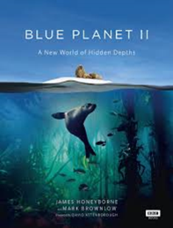
Blue Planet II review: the ocean as you've never seen it before
Bird-eating fish, surfing dolphins, rafts of sea otters … there are some extraordinary things going on under the sea, as David Attenborough’s brilliant new series reveals
A man stands at the front of a ship, looking out. DiCaprio? Soon to be joined by Winslet? And Dion: Every night in my dreams, I see you, I feel you …
Thankfully not, though this will be going the same way – deep down there. This man is older (91) and wiser. He is David Attenborough, of course, and this is Blue Planet II (BBC1). The sequel, 16 years on from the original, now technology has made it possible to go down further, get closer, see clearer, see for the first time whole new worlds. And as the oceans are changing faster than ever before, never has it been more important to understand what’s going in them. It has been more than four years in the making, 125 expeditions, 39 countries, 6,000 hours diving underwater. So spit on your TV screen, rub with a squeaky finger to prevent fogging up, rinse and let’s go …
To South Africa, where bottlenose dolphins surf huge waves just for the hell of it, it seems. Extraordinary footage (filmed by daredevil surf cameramen in inflatable boats, we learn in the diary bit at the end), though I’ve never much cared for dolphins. Predatory, clicky pests; their intelligence only makes them more sinister.
They are not the only brainiacs of the sea. On the Great Barrier Reef, a tuskfish smashes a clam that has clammed up against a particular coral, the same one it uses every day. Yeah, a fish using a tool! Remember when we used to make jokes about goldfish and their three-second memories? Well, no one’s making those jokes any more. A bit like Skodas in that respect.
And check these ones out, giant trevallies in the lagoon of an Indian Ocean atoll. They want bird for tea, young tern, snatched from the surface of the water from below. To a tern, a trevally is like a great white shark – just when they thought it was safe … They’re not even safe when they finally get a bit better at flying. The trevally sees it flying above the surface from below, calculates airspeed, altitude and trajectory, probably does a “your tern, no my tern” gag with its mate. Then it launches itself from the sea like a surface-to-air missile and grabs the poor bird mid-air. Like the very opposite of gannets plummeting into the sea to grab startled sardines; maybe these trevallies have seen that footage on previous Attenborough docs, and it gave them the idea. Revenge!
That’s the one, isn’t it, the OMG did-you-see-that racer-snake moment. The best is the one that just misses, the tern somehow snatches life from the jaws of death, is nudged a little higher on to the breeze and just out of reach of the big fish, which very quickly goes from looking pretty awesome to frankly ridiculous as it bellyflops ignominiously back into the lagoon. The usual moan about the music: too much of it, too in-my-face (Hans Zimmer’s score goes into full ballistic Battle of Britain mode). Otherwise, wow.
To colder waters, where orcas are whacking swarms of herrings with their tails, and sea otters are making themselves into furry rafts of cuteness for their babies, and a mummy walrus – goo goo g’ joob – is looking for an ice floe for her calf to rest up on …
Hang on a second, how did we get here from the wave-riding dolphins and the surface-to-air trevallies? Erm, by sea, that’s how. And that’s it, I think, the only story of this first episode: that there are some extraordinary and brilliant things going on down there, and here it is as you’ve never seen it before. That’s good enough for me. Now say “wow” and “oh em gee” and “did you see” at work and school.
Oh, plus the message that we’re messing it all up, of course, destroying it. Why can’t Mrs Walrus find an ice floe? Because we’ve melted them all. And while that might have been good news for Leo and Kate on a certain ship, for everyone and everything else it’s very, very bad.

Questions and Comprehension
Unlocking vocabulary
Using a dictionary look up the following words and write the definition next to them:
Sequel: ____________________________________________________________________________
Brainiac: ____________________________________________________________________________
Atoll: _______________________________________________________________________________
Trajectory: ______________________________________________________________________________
Plummet: ______________________________________________________________________________
Frankly: ___________________________________________________________________________
Ignominiously: ___________________________________________________________________________
Orca: ______________________________________________________________________________

Looking at language
In your own words summarise what the review is about: _____________________________________________________________________________________________________________________________________________________________________________________________________________________________________________________________________________________________________________________________________________________________________________________________________________________________________________________________________________________________________________________________________________
How does the writer use humour to engage the reader? Find at least TWO examples. __________________________________________________________________________________________________________________________________________________________________________________________________________________________________________________________________________________________________________________________________________________________________________________________________________________________________________________________________

Find TWO other language devices that the writer uses to engage a reader and write about the effect it has. THINK DAFOREST.
D – direct address, description
A – alliteration, anecdote
F – facts, figurative language
O - opinion
R – rhetorical question, repetition
E – emotive language, exaggeration, endorsement
S – statistics, simile, sensory description
T – tone, triplets
- ________________________________________________________________________________________________________________________________________________________________________________________________________________________________________________________________________________________________________________________________________________________________________________________________________________________________________________
- ________________________________________________________________________________________________________________________________________________________________________________________________________________________________________________________________________________________________________________________________________________________________________________________________________________________________________________________________________________________________________________________
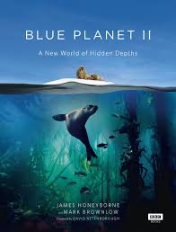
Writing task:
You have been asked to write a review for your school magazine. Write your own review on a wildlife documentary/ wildlife programme or film/ animal movie. Remember to make it chatty; give it a star rating; why it is/ is not worth watching; comment on photography or characters.

Black Beauty

by Anna Sewell 1870
PART 1, CHAPTER 1: MY EARLY HOME
The first place that I can well remember was a large pleasant meadow with a pond of clear water in it. Some shady trees leaned over it, and rushes and water-lilies grew at the deep end. Over the hedge on one side we looked into a plowed field, and on the other we looked over a gate at our master's house, which stood by the roadside; at the top of the meadow was a grove of fir trees, and at the bottom a running brook overhung by a steep bank.
While I was young I lived upon my mother's milk, as I could not eat grass. In the daytime I ran by her side, and at night I lay down close by her. When it was hot we used to stand by the pond in the shade of the trees, and when it was cold we had a nice warm shed near the grove.
As soon as I was old enough to eat grass my mother used to go out to work in the daytime, and come back in the evening.
There were six young colts in the meadow besides me; they were older than I was; some were nearly as large as grown-up horses. I used to run with them, and had great fun; we used to gallop all together round and round the field as hard as we could go. Sometimes we had rather rough play, for they would frequently bite and kick as well as gallop.
One day, when there was a good deal of kicking, my mother whinnied to me to come to her, and then she said:
"I wish you to pay attention to what I am going to say to you. The colts who live here are very good colts, but they are cart-horse colts, and of course they have not learned manners. You have been well-bred and well-born; your father has a great name in these parts, and your grandfather won the cup two years at the Newmarket races; your grandmother had the sweetest temper of any horse I ever knew, and I think you have never seen me kick or bite. I hope you will grow up gentle and good, and never learn bad ways; do your work with a good will, lift your feet up well when you trot, and never bite or kick even in play."
I have never forgotten my mother's advice; I knew she was a wise old horse, and our master thought a great deal of her. Her name was Duchess, but he often called her Pet.
Our master was a good, kind man. He gave us good food, good lodging, and kind words; he spoke as kindly to us as he did to his little children. We were all fond of him, and my mother loved him very much. When she saw him at the gate she would neigh with joy, and trot up to him. He would pat and stroke her and say, "Well, old Pet, and how is your little Darkie?" I was a dull black, so he called me Darkie; then he would give me a piece of bread, which was very good, and sometimes he brought a carrot for my mother. All the horses would come to him, but I think we were his favorites. My mother always took him to the town on a market day in a light gig.
There was a plowboy, Dick, who sometimes came into our field to pluck blackberries from the hedge. When he had eaten all he wanted he would have what he called fun with the colts, throwing stones and sticks at them to make them gallop. We did not much mind him, for we could gallop off; but sometimes a stone would hit and hurt us.
One day he was at this game, and did not know that the master was in the next field; but he was there, watching what was going on; over the hedge he jumped in a snap, and catching Dick by the arm, he gave him such a box on the ear as made him roar with the pain and surprise. As soon as we saw the master we trotted up nearer to see what went on.
"Bad boy!" he said, "bad boy! to chase the colts. This is not the first time, nor the second, but it shall be the last. There—take your money and go home; I shall not want you on my farm again." So we never saw Dick any more. Old Daniel, the man who looked after the horses, was just as gentle as our master, so we were well off.

PART 1, CHAPTER 2: THE HUNT
Before I was two years old a circumstance happened which I have never forgotten. It was early in the spring; there had been a little frost in the night, and a light mist still hung over the woods and meadows. I and the other colts were feeding at the lower part of the field when we heard, quite in the distance, what sounded like the cry of dogs. The oldest of the colts raised his head, pricked his ears, and said, "There are the hounds!" and immediately cantered off, followed by the rest of us to the upper part of the field, where we could look over the hedge and see several fields beyond. My mother and an old riding horse of our master's were also standing near, and seemed to know all about it.
"They have found a hare," said my mother, "and if they come this way we shall see the hunt."
And soon the dogs were all tearing down the field of young wheat next to ours. I never heard such a noise as they made. They did not bark, nor howl, nor whine, but kept on a "yo! yo, o, o! yo! yo, o, o!" at the top of their voices. After them came a number of men on horseback, some of them in green coats, all galloping as fast as they could. The old horse snorted and looked eagerly after them, and we young colts wanted to be galloping with them, but they were soon away into the fields lower down; here it seemed as if they had come to a stand; the dogs left off barking, and ran about every way with their noses to the ground.
"They have lost the scent," said the old horse; "perhaps the hare will get off."
"What hare?" I said.
"Oh! I don't know what hare; likely enough it may be one of our own hares out of the woods; any hare they can find will do for the dogs and men to run after;" and before long the dogs began their "yo! yo, o, o!" again, and back they came altogether at full speed, making straight for our meadow at the part where the high bank and hedge overhang the brook.
"Now we shall see the hare," said my mother; and just then a hare wild with fright rushed by and made for the woods. On came the dogs; they burst over the bank, leaped the stream, and came dashing across the field followed by the huntsmen. Six or eight men leaped their horses clean over, close upon the dogs. The hare tried to get through the fence; it was too thick, and she turned sharp round to make for the road, but it was too late; the dogs were upon her with their wild cries; we heard one shriek, and that was the end of her. One of the huntsmen rode up and whipped off the dogs, who would soon have torn her to pieces. He held her up by the leg torn and bleeding, and all the gentlemen seemed well pleased.
As for me, I was so astonished that I did not at first see what was going on by the brook; but when I did look there was a sad sight; two fine horses were down, one was struggling in the stream, and the other was groaning on the grass. One of the riders was getting out of the water covered with mud, the other lay quite still.
"His neck is broke," said my mother.
"And serve him right, too," said one of the colts.
I thought the same, but my mother did not join with us.
"Well, no," she said, "you must not say that; but though I am an old horse, and have seen and heard a great deal, I never yet could make out why men are so fond of this sport; they often hurt themselves, often spoil good horses, and tear up the fields, and all for a hare or a fox, or a stag, that they could get more easily some other way; but we are only horses, and don't know."
While my mother was saying this we stood and looked on. Many of the riders had gone to the young man; but my master, who had been watching what was going on, was the first to raise him. His head fell back and his arms hung down, and every one looked very serious. There was no noise now; even the dogs were quiet, and seemed to know that something was wrong. They carried him to our master's house. I heard afterward that it was young George Gordon, the squire's only son, a fine, tall young man, and the pride of his family.
There was now riding off in all directions to the doctor's, to the farrier's, and no doubt to Squire Gordon's, to let him know about his son. When Mr. Bond, the farrier, came to look at the black horse that lay groaning on the grass, he felt him all over, and shook his head; one of his legs was broken. Then some one ran to our master's house and came back with a gun; presently there was a loud bang and a dreadful shriek, and then all was still; the black horse moved no more.
My mother seemed much troubled; she said she had known that horse for years, and that his name was "Rob Roy"; he was a good horse, and there was no vice in him. She never would go to that part of the field afterward.
Not many days after we heard the church-bell tolling for a long time, and looking over the gate we saw a long, strange black coach that was covered with black cloth and was drawn by black horses; after that came another and another and another, and all were black, while the bell kept tolling, tolling. They were carrying young Gordon to the churchyard to bury him. He would never ride again. What they did with Rob Roy I never knew; but 'twas all for one little hare.

Questions and Comprehension
Unlocking vocabulary
Using a dictionary look up the following words and write the definition next to them:
Grove: ____________________________________________________________________________
Meadow: ____________________________________________________________________________
Colt: _______________________________________________________________________________
Circumstance: ___________________________________________________________________________
Astonished: _____________________________________________________________________________
Brook: ___________________________________________________________________________
Squire: ___________________________________________________________________________
Farrier: ______________________________________________________________________________

Looking at language
- How does the writer use language to make the start interesting? ____________________________________________________________________________________________________________________________________________________________________________________________________________________________________________________________________________________________________________________________________________________________________________________________________________________________________________________________________________________________________________________________________________________________
- What narrative voice is used? Why is this effective? ___________________________________________________________________________________________________________________________________________________________________________________________________________________________________________________________________________________________________________________________________________________________________________________________________________________________________________________
- What does Black Beauty’s mother tell him in Part 1, Chp 1? ________________________________________________________________________________________________________________________________________________________________________________________________________________________________________________________________________________________________________________________________________________________________________________________________________________________________________________________________________________________________________________________________________________
- How is the Plowboy, Dick described? What does a reader think about him? ________________________________________________________________________________________________________________________________________________________________________________________________________________________________________________________________________________________________________________________________________________________________________________________________________________________________________________________
Close analysis
Look at these particular phrases; why does Sewell use them? Can you identify the language device?
a) ‘They did not bark, nor howl, nor whine, but kept on a "yo! yo, o, o! yo! yo, o, o!" at the top of their voices.’ _______________________________________________________________________________________________________________________________________________________________________________________________________________________________________________________________________________________________________________________________________________________________________________________
b) ‘On came the dogs; they burst over the bank, leaped the stream, and came dashing across the field followed by the huntsmen .’ _________________________________________________________________________________________________________________________________________________________________________________________________________________________________________________________________________________________________________________________________________________________________________________________________________________________________________________________________

c) ‘but we are only horses, and don't know .’ __________________________________________________________________________________________________________________________________________________________________________________________________________________________________________________________________________________________________________________________________________________________________________________________________________________________________________________________________
d) ‘it was young George Gordon, the squire's only son, a fine, tall young man, and the pride of his family.’ __________________________________________________________________________________________________________________________________________________________________________________________________________________________________________________________________________________________________________________________________________________________________________________________________________________________________________________________________
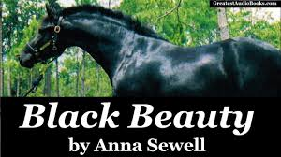
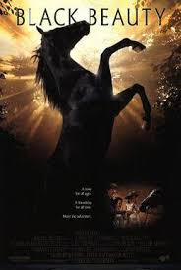

Black Beauty is an anthropomorphic fantasy novel, which takes the concept of talking animals to a new level. In fact, Anna Sewell effectively created the subgenre. Anthropomorphism is the giving of human characteristics to nonhumans.
Your task is to write a short narrative in first person as if you were an animal. It is completely your choice of what animal you can be. Use the narrative arc on the next sheet for your planning.

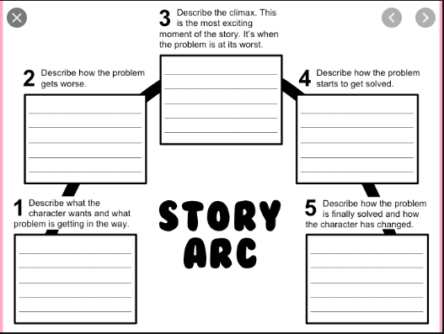

Call of the wild: How the animal kingdom votes

From wild dogs to honeybees, Elizabeth Preston uncovers the evidence behind group choice among various species of animals
Elizabeth Preston
Thursday 12 March 2020 00:00
Are humans the only animals that vote? As the early 2020 presidential election season suggests, there are probably more natural and efficient ways to make a group choice. But we’re certainly not the only animals on Earth that vote. We’re not even the only primates that primary. Any animal living in a group needs to make decisions as a group, too. Even when they don’t agree with their companions, animals rely on one another for protection or help finding food. So they have to find ways to reach consensus about what the group should do next, or where it should live. While they may not conduct continent-spanning electoral contests like Super Tuesday, species ranging from primates all the way to insects have methods for finding agreement that are surprisingly democratic.
Meerkats
As meerkats start each day, they emerge from their burrows into the sunlight, then begin searching for food. Each meerkat forages for itself, digging in the dirt for bugs and other morsels, but they travel in loose groups, each animal up to about 30ft from its neighbours, says Marta Manser, an animal behaviour scientist at the University of Zurich in Switzerland. Nonetheless, the meerkats move as one unit, drifting across the desert while they search and munch.

The meerkats call to one another as they travel. One of their sounds is a gentle mew that researchers refer to as a “move call”. It seems to mean, “I’m about ready to move on from this dirt patch. Who’s with me?”
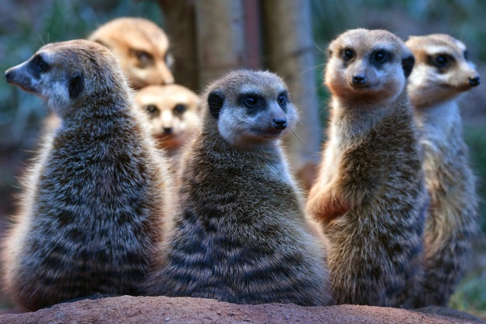
In a 2010 study, Manser and her colleagues studied move calls in a dozen meerkat groups living in the Kalahari Desert in South Africa. Groups ranged from six to 19 individuals. But the scientists found that only about three group members had to mew before the whole party decided to move along. The group didn’t change direction, but it would double its speed to reach better foraging grounds.
Biologists call this phenomenon – when animals change their behaviour in response to a critical mass of their peers doing something – a quorum response. Manser thinks quorum responses show up in human decision making too.
“If you’re in a group and somebody says, ‘Let’s go for a pizza’, and nobody joins in, nothing is going to happen,” she says. But if the person craving pizza is joined by a couple of friends, their argument becomes much more convincing. In another set of experiments, Manser and a co-author found that it didn’t matter whether meerkats making move calls were dominant or subordinate within the group. Rather, she says, “it depends on how determined an individual appears”.
She thinks this also has a human parallel. “Even if you don’t have the rank,” she says, as long as you pretend you know what you’re doing, “the group will follow”.

Honeybees
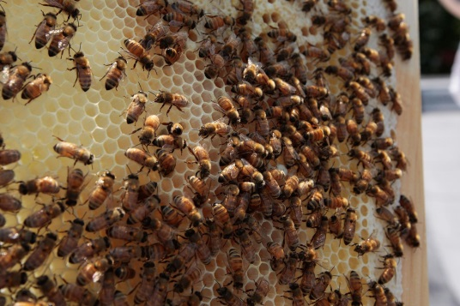
In the spring, you may discover a swarm of bees dangling from a tree branch like a dangerous bunch of grapes. These insects are in the middle of a tough real estate decision.
When a honeybee colony splits in two, a queen and several thousand workers fly away from a hive together. The swarm finds someplace to pause for hours or days while a few hundred scouts fan out to search for a new home. When a scout finds a promising hole or hollow, she inspects it thoroughly. Then she flies back to the swarm, still buzzing on its tree branch. Walking on the swarm’s surface, she does a waggling, repetitive dance that tells the other bees about the site she found – its quality, direction and how far away it is.
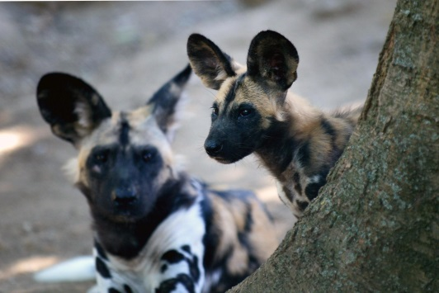
More scouts return to the swarm and do their own dances. Gradually, some of the scouts become persuaded by others, and switch their choreography to match. Once every scout agrees, the swarm flies off to its new home. In his 2010 book Honeybee Democracy, Thomas D Seeley, a Cornell University biologist, writes that we can learn a lesson from the bees: “Even in a group composed of friendly individuals with common interests, conflict can be a useful element in a decision making process.”
African Wild Dogs
Like pet dogs, African wild dogs spend some of their time enthusiastically socialising and some of it lazing around. Members of a pack jump up and greet one another in high-energy rituals called rallies. After a rally, the dogs may move off together to start a hunt – or they may go back to resting. In a 2017 study, researchers discovered that the decision to hunt or stay seems to be democratic. To cast a vote for hunting, the dogs sneeze.
The more sneezes there were during a rally, the more likely the dogs were to begin hunting afterward. If a dominant dog had gotten the rally started, the pack was easier to persuade – just three sneezes might do the trick. But if a subordinate dog started the rally, it took a minimum of 10 sneezes to prompt a hunt.
The researchers note that dogs might actually cast their votes via some other, hidden signal. The sneezes could help the animals clear out their noses and get ready to sniff for prey. Either way, the wild dogs end their achoo-ing with a decision they all agree on.

Questions and Comprehension
Unlocking vocabulary
Using a dictionary look up the following words and write the definition next to them:
Consensus: _____________________________________________________________________________
Democratic: ____________________________________________________________________________
Forage: ________________________________________________________________________________
Phenomenon: __________________________________________________________________________
Morsel: ________________________________________________________________________________
Dominant: _____________________________________________________________________________
Choreography: __________________________________________________________________________
Subordinate: ____________________________________________________________________________

Comprehension
Working chronologically, you must answer the following comprehension questions in FULL SENTENCES:
- What two things do animals in a group rely on one another for? ___________________________________________________________________________________________________________________________________________________________________________________________________________________________________________________
- How do meerkats travel when looking for food? ___________________________________________________________________________________________________________________________________________________________________________________________________________________________________________________
- Where and when did Marta Manser do her study? ___________________________________________________________________________________________________________________________________________________________________________________________________________________________________________________
- What is a quorum response? ___________________________________________________________________________________________________________________________________________________________________________________________________________________________________________________
- What are the bees called that search for a new home? ___________________________________________________________________________________________________________________________________________________________________________________________________________________________________________________

- How do bees let their swarm know about a new home? ___________________________________________________________________________________________________________________________________________________________________________________________________________________________________________________
- What is a rally? ___________________________________________________________________________________________________________________________________________________________________________________________________________________________________________________
- How do African Wild Dogs make the decision to hunt? ___________________________________________________________________________________________________________________________________________________________________________________________________________________________________________________
Looking at language
Please re-read the section on Honeybees. Identify:
- A simple sentence: _________________________________________________________________________________
- A compound sentence: __________________________________________________________________________________________________________________________________________________________________
- A complex sentence: __________________________________________________________________________________________________________________________________________________________________
- A simile and the effect it creates: _____________________________________________________________________________________________________________________________________________________________________________________________________________________________________________________________________________________________________________________________________________________________________________________________________________________
- An endorsement and the effect it creates : ___________________________________________________________________________________________________________________________________________________________________________________________________________________________________________________

