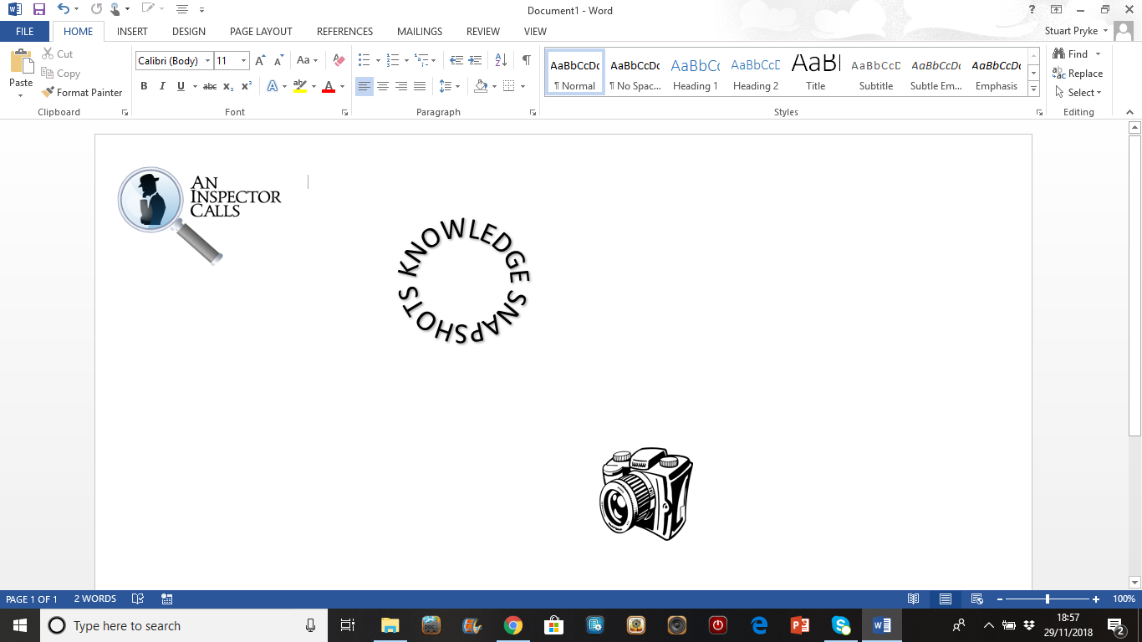**ReviewTask**

***SNAPSHOT 8***

An Inspector Calls: plot structure

***SNAPSHOT 4***

***SNAPSHOT 3***

***SNAPSHOT 10***

***SNAPSHOT 11***

***SNAPSHOT 9***

***SNAPSHOT 7***

***SNAPSHOT 6***

***SNAPSHOT 5***

**SNAPSHOT 1**

***SNAPSHOT 2***