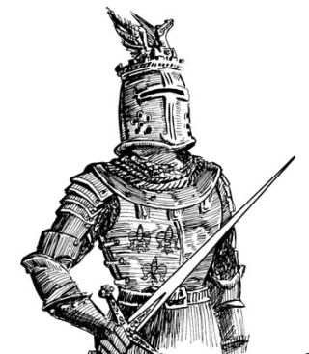
The Code of Chivalry
Chivalry, or the chivalric code, is the traditional code of conduct associated with the medieval institution of knighthood. Chivalry arose from an idealised German custom. It was originally conceived of as an aristocratic warrior code — involving gallantry and individual training and service to others. Over time its meaning has been refined to emphasise more ideals such as the knightly virtues of honour, courtly love and courtesy.
The Knight's Code of Chivalry was a moral system that stated all knights should protect others who cannot protect themselves, such as widows, children and elders. All knights needed to have the strength and skills to fight wars; they not only had to be strong but they were also extremely disciplined and were expected to use their power to protect the weak and defenseless.
Knights vowed to be loyal, generous, and "of noble bearing". Knights were required to tell the truth at all times and always respect the honour of women. Knights not only vowed to protect the weak but also vowed to guard the honor of all fellow knights. They always had to obey those who were placed in authority and were never allowed to refuse a challenge from an equal. Knights lived by honor and for glory. Knights were to fear God and maintain His Church.
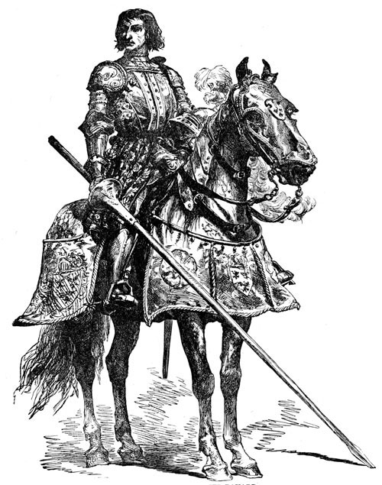
A man had to have an excellent reputation and have proven himself to rise to the level of knight. Below are some of the vows he swore to uphold:
- To serve the liege lord in valour and faith
- To protect the weak and defenceless
- To live by honour and for glory
- To fight for the welfare of all
- To obey those placed in authority
- To guard the honour of fellow knights
- To eschew unfairness, meanness and deceit
- To keep faith
- At all times to speak the truth
- To respect the honour of women
- Never to refuse a challenge from an equal
- Never to turn the back upon a foe

