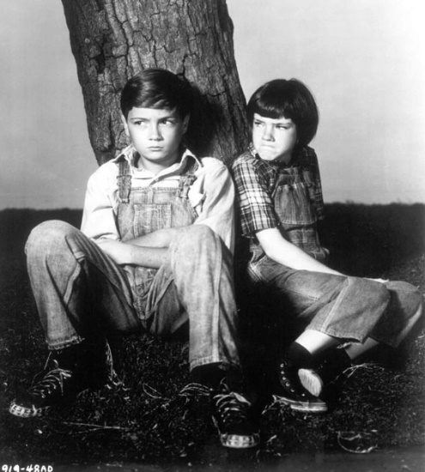
To Kill a Mocking Bird

Chapter 1

Chapter 1 has a lot of information and we are introduced to many new characters.
- Firstly, tell the story of Boo Radley as he is a major character in the novel. Explain how he got involved with the gang, stayed at home and then stabbed his father in the leg. Stick to the facts, not gossip!
- Next, find 2 quotes to sum up the following main characters – Scout, Jem, Dill and Atticus
- Finally, find one quote used to describe the following characters – Calpurnia, Mrs. Dubose, Mrs. Radley, Mr. Radley, Nathan Radley, Miss Stephanie Crawford

