Quotes: | Emotions/Viewpoint/Feelings
in search of bread and adventure
imagining I was one of the Tour de France greats
limitations of a bike, rather than its freedoms
 | he becomes uninspired and feels it impedes his image
“However,…gear…an inflated sense of sporting prowess…”
“tackling the gentle contours”
 | a renewed sense of energy and enthusiasm, a feeling of passion begins to flow
“and suddenly…silence.” | The ellipsis and sudden full-stop makes him seem like he’s having a spiritual awakening.
“British Lycra Brotherhood” | He feels…

Viewpoint and Attitude Exemplar:

Charles Starmer-Smith develops a progression of attitude towards biking throughout his life. First, as a boy, he begins with “in search of bread and adventure” which shows he feels a sense of searching, as if the bike will propel him to find new adventures so he feels an excitement and anticipation for more “adventure”. The bike seems to make him use his imagination as if he feels like it makes him more than his simple self. “freedom of pedal power as I sped past vineyards, forests and fields, imagining…” he uses alliterative “p” as if he is thinking that he is more powerful, a kind of superhero. The commas make it seem like he feels like there is no end to how fast he can accelerate. He feels unstoppable and confident.

Furthermore, during his adolescence, he feels…

Presently, he feels a change back to imaginative power with freedom as he “tackles the gentle contours” as even though he is out of shape, he feels like he belongs to a bike and the verb “tackles” shows his enthusiastic aggressiveness, that he feels more of a testosterone, adrenaline rush. “tackles and gentle” are opposites which shows he thinks of the hills and valleys as a weak obstacle to his power. He further feels a spiritual challenge, “and suddenly…silence.” An ellipsis is used to show him having a sudden realisation that the bike will change his life, a spiritual reverence of silence, with a full-stop, shows that he feels empowered but in a more serious, devoted way, like he feels like an acolyte to a new religion.

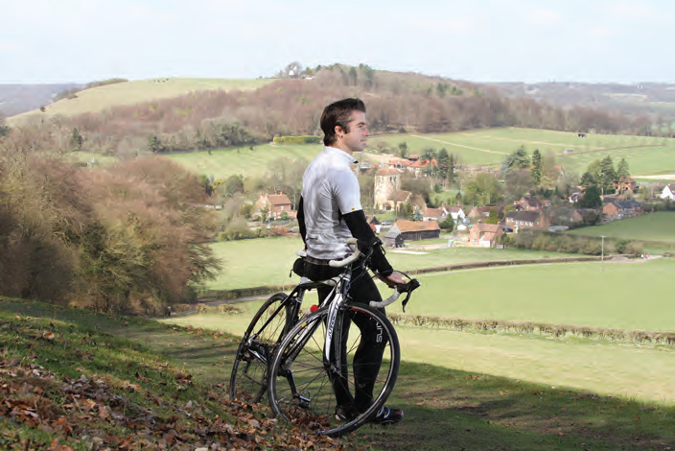

QUESTION: What is Charles Starmer-Smith’s attitude towards biking?

My own conversion to cycling has come late. I remember childhood holidays in France where I would pedal among the villages in search of bread and adventure, revelling in the freedom of pedal power as I sped past vineyards, forests and fields, imagining I was one of the Tour de France greats.

Then came adolescence and girls and guitars and cars. Cycling was no longer cool and the limitations of a bike, rather than its freedoms, became all too apparent. It couldn’t play Pearl Jam on the stereo, with the roof down and a pretty girl in the passenger seat, like my battered silver Mini.

However, there is nothing like purchasing new gear to give you an inflated sense of your sporting prowess. Only a week ago, tackling the gentle contours of Richmond Park, I was puffing like a man on an epic ascent of some legendary alpine peak. Now, dressed in the outfit I spent a small fortune on this morning, I stride down the stairs with new purpose, ready to join the British Lycra Brotherhood. I feel streamlined and ready for anything the Alps of Surrey can throw at me.

‘I want a divorce.’ My wife’s words stop me in my tracks. She looks both amused and horrified as I put on my helmet and fluorescent bib. ‘You look like a Village People tribute act.’ Deflated, I hurry past the mirror and wheel my bike out into the winter drizzle for the short journey to the North Downs.

A wave of smugness washes over me as I weave easily through the noisy commuters and choking traffic which stall everyone else’s progress. One right turn towards Box Hill and suddenly...silence.
(4171-02A)
3
The North Downs Way, which runs from Hampshire through Surrey, awaits. The first rays of sun streak across the chalk hillside, but there’s still a chill in the air. I zip up my jersey, looking enviously at the thick coats of the sheep. But I soon forget the cold. With the wind at my back I hear the hum of the tyres and the whirr of the chain. Below me a patchwork of green fields. No deadlines. No delays. For these precious moments I care for little but the verdant hills and plunging valleys – and the panoramic views my efforts have earned.

The British Lycra Brotherhood – for whom mornings, evenings, weekends and holidays are all about pedal power and for whom travel is not just about the destination but the journey there – can welcome its latest recruit. My love of cycling has come full circle.

But how has it come to this? The rise of cycling in Britain has been well documented. A string of champions on the track, from Chris Hoy to Victoria Pendleton, and now on the road, with the new Sky Team led by Bradley Wiggins, has done much to inspire a new generation of Britons on to their bikes.

Aided by an overpriced and overcrowded transport system and savings from the ‘Cycle to Work’ initiative, the bicycle is now seen as an answer to rising carbon emissions. But it is the escapism it gives that is the real draw. You don’t need to emulate the endless wave of intrepid cyclists crossing the Americas or circumnavigating the globe to be part of this revolution.

The landscape of Britain is perfect for cycling. Across every hill and valley, country lane and woodland track, the national cycle network covers a mind-boggling 10,000 miles, and we are clocking more than a million journeys on these routes each day.

