An Inspector Calls – J B Priestley
‘When you’re married, you’ll realise that men with important work to do sometimes have to spend nearly all their time and energy on their business.’
Act One – Who Said It?
‘We can’t let these Bernard Shaws and H. G. Wellses do all the talking’

‘Sounds a bit fishy to me’
‘Look here, sir. Wouldn’t you rather I was out of this?’
‘It’s too late. She’s dead.’
‘I’m delighted about this engagement and I hope it won’t be too long before you’re married’
‘My God, it’s a bit thick, when you come to think of it-‘
‘So I’m really responsible?’
‘What’s the matter with her?’
‘I said she changed her name to Daisy Renton’
‘Please, sir, an inspector’s called.’
‘Yes. We can keep it from him’
‘It’s the way I like to go to work’
‘But these girls aren’t cheap labour – they’re people’
‘You didn’t just come here to see me, then?’
‘Can’t blame her’
‘I say there isn’t a chance of war’
‘You’re squiffy’
‘You seem to be a nice well-behaved family’
‘It’s my duty to ask questions.’
‘Oh - how horrible!’
‘Steady the Buffs!’
‘What about war?’
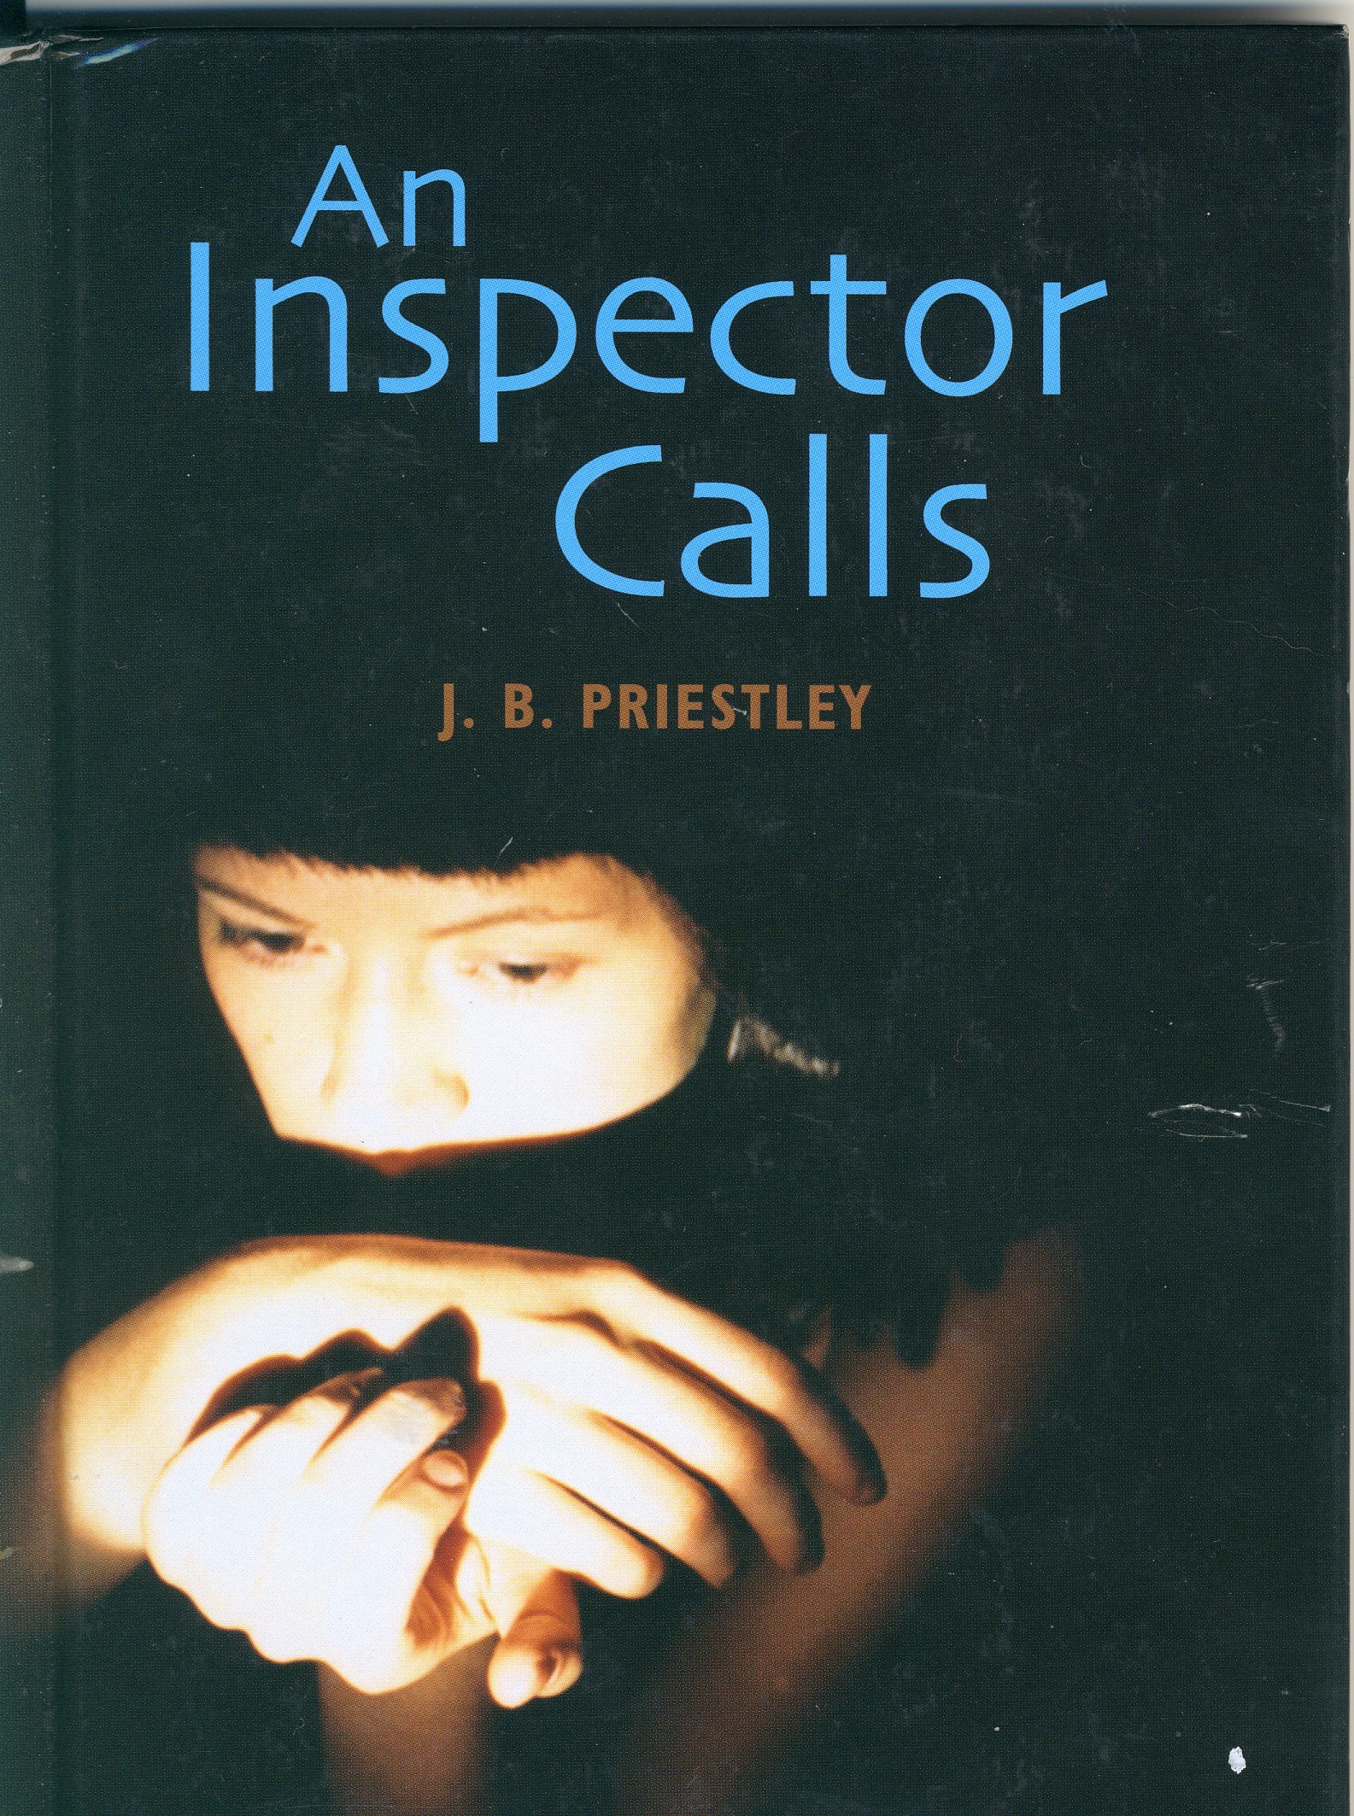
‘Somebody at the front door’
‘A man has to make his own way- has to look after himself -and his family too, of course.’

