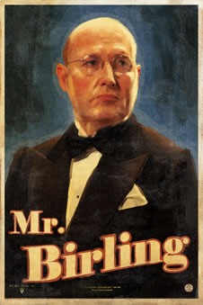

VITAL QUOTATIONS:
‘The Germans don’t want war’
‘unsinkable, absolutely unsinkable’
‘community and all that nonsense’
‘a man has to mind his own business and look out for himself and his own.’
‘is there bound to be a public inquiry?’

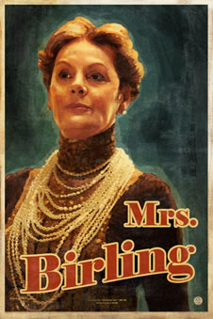

VITAL QUOTATIONS:
‘girls of that class…’
‘I didn’t like her manner. She impertinently made use of our name.’
‘I did nothing I’m ashamed of.’
‘I blame the young man. He ought to be dealt with very severely.’
(To Inspector Goole) ‘You know of course that my husband was Lord Mayor only two years ago...’

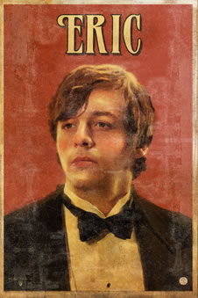

VITAL QUOTATIONS:
‘You’re not the kind of father a chap could go to when he’s in trouble. That’s why.’
‘You killed her – and the child she’d have had too – my child’
‘You’re beginning to pretend as if nothing’s really happened at all. And I can’t see it like that. The girl’s still dead, isn’t she?’
‘we helped to kill her.’

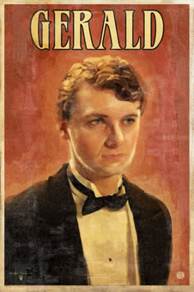

VITAL QUOTATIONS:
‘My God! ...I’ve suddenly realized – taken it in properly – that she’s dead!’
‘I didn’t install her there so I could make love to her.’
‘I didn’t feel about her as she felt about me.’

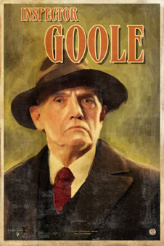

VITAL QUOTATIONS:
“Public men, Mr. Birling, have responsibilities as well as privileges.”
“We don't live alone. We are members of one body. We are responsible for each other. And I tell you that the time will soon come when, if men will not learn that lesson, then they will be taught it in fire and blood and anguish. Good night.”
“I’m losing all patience with you people”
This is the most important quotation in the whole play.
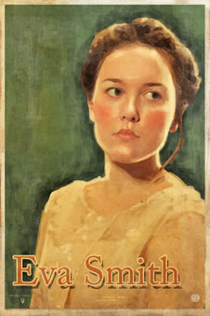

VITAL QUOTATIONS:
She doesn’t say anything as she’s dead! However:
- Mention how she symbolises the suffering of the working classes
- She is used and taken advantage of by rich men (metaphor for rich abusing the poor)
- The writer uses her as an example of how greed can overcome responsibility/social conscience/compassion
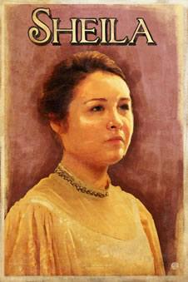

VITAL QUOTATIONS:
‘But these girls aren’t cheap labour – they’re people.’
‘I felt rotten about it at the time and now I feel a lot worse.’
‘he’s giving us rope so that we’ll hang ourselves.’
‘You were the wonderful fairy prince. You must have enjoyed it, Gerald.’

