Act 4 Scene 1 (p103 Ca, P60 Ox)

OBERON
Welcome, good Robin.
See'st thou this sweet sight?
Her dotage now I do begin to pity:
For, meeting her of late behind the wood,
Seeking sweet favours from this hateful
fool,
I did upbraid her and fall out with her;
For she his hairy temples then had
rounded
With a coronet of fresh and fragrant
flowers;
When I had at my pleasure taunted her
And she in mild terms begg'd my patience,
I then did ask of her her changeling child;
Which straight she gave me, and her fairy
sent
To bear him to my bower in fairy land.
And now I have the boy, I will undo
This hateful imperfection of her eyes:
And, gentle Puck, take this transformed
scalp
From off the head of this Athenian swain;
That, he awaking when the other do,
May all to Athens back again repair
And think no more of this night's
accidents
But as the fierce vexation of a dream.
But first I will release the fairy queen.
Be as thou wast wont to be;
See as thou wast wont to see:
Dian's bud o'er Cupid's flower
Hath such force and blessed power.
Now, my Titania; wake you, my sweet
queen.

TITANIA
My Oberon! what visions have I seen!
Methought I was enamour'd of an ass.

OBERON
There lies your love.

TITANIA
How came these things to pass?
O, how mine eyes do loathe his visage
now!

OBERON
Silence awhile. Robin, take off this head.

PUCK
Now, when thou wakest, with thine
own fool's eyes peep.

Your tasks:

1. Re- read the extract and analysise for language and structure
2. Quotation finder: Find 2/3 quotations which:

a) suggests that Oberon feels bad for making a fool of Titania.
b) shows that Oberon thinks of Bottom as a common or insignificant character.
c) shows that Oberon has taken pleasure from winding Titania up.
d) reveals that Oberon got what he wanted all along.
e) shows the audience that Oberon wants it all to be over and nothing
more than a dream.
f) shows that, once released from the effect of the potion, Titania is
repulsed by Bottom.
g) that Bottom will be the same once again.

3. See the lines in bold which begin: ‘Be as thou wast wont to be;’

a) Say them out loud to your self – (you may need to do this quietly). Listen to how it sounds, can you hear a rhythm? What has created this?

b) What do you notice about HOW these lines differ from Oberons’ usual speech?

c) Why do you think Shakespeare has used this here?

4. Select any of your quotations from 1 a – g and write a PEA paragraph to explain the thoughts and feelings of the character.

ACT 4 Scene 2
The couples are awoken by the arrival of the Duke and Hippolyta (along with Egeus who still wishes Hermia to marry Demetrius). Theseus asks the four young lovers to explain how they came to be in the wood.

LYSANDER
My lord, I shall reply amazedly,
Half sleep, half waking: but as yet, I swear,
I cannot truly say how I came here;
But, as I think,--for truly would I speak,
And now do I bethink me, so it is,--
I came with Hermia hither: our intent
Was to be gone from Athens, where we
might,
Without the peril of the Athenian law.
DEMETRIUS
My lord, fair Helen told me of their
stealth,
Of this their purpose hither to this wood;
And I in fury hither follow'd them,
Fair Helena in fancy following me.
But, my good lord, I wot not by what
power,--
But by some power it is,--my love to
Hermia,
Melted as the snow, seems to me now
As the remembrance of an idle gaud
Which in my childhood I did dote upon;
And all the faith, the virtue of my heart,
The object and the pleasure of mine eye,
Is only Helena. To her, my lord,
Was I betroth'd ere I saw Hermia:
But, like in sickness, did I loathe this food;
But, as in health, come to my natural
taste,
Now I do wish it, love it, long for it,
And will for evermore be true to it.
THESEUS
Fair lovers, you are fortunately met:
Of this discourse we more will hear anon.
Egeus, I will overbear your will;
For in the temple by and by with us
These couples shall eternally be knit:
Away with us to Athens; three and three,
We'll hold a feast in great solemnity.
Come, Hippolyta.
Exeunt THESEUS, HIPPOLYTA, EGEUS, and
train
DEMETRIUS
These things seem small and
undistinguishable,
HERMIA
Methinks I see these things with parted
eye,
When every thing seems double.
HELENA
So methinks:
And I have found Demetrius like a jewel,
Mine own, and not mine own.
DEMETRIUS
Are you sure
That we are awake? It seems to me
That yet we sleep, we dre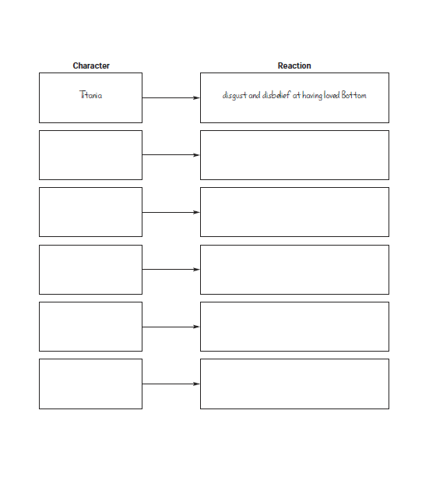am.

