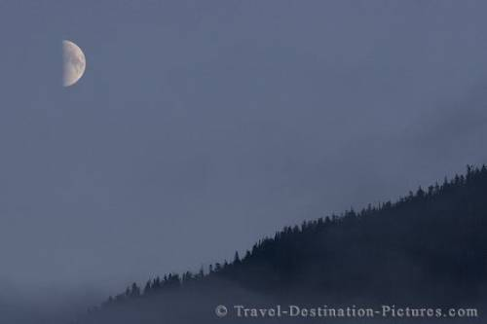***A Midsummer Night’s Dream:***

[Act 1, Scene 1 from line 202]

Hermia and Lysander love each other and after Egeus (Hermia’s father) says she must marry Demetrius or be killed, they decide to run away.

Helena is a friend of Hermia’s; Helena is in love with Demetrius who is the man Hermia is supposed to marry and is upset because Demetrius loves Hermia and not her.

Helena bumps into Hermia and Lysander and they tell her their plan.

**HERMIA**: Take comfort: he no more shall see my face;

Lysander and myself will fly this place.

Before the time I did Lysander see,

Seem'd Athens as a paradise to me:

O, then, what graces in my love do dwell,

That he hath turn'd a heaven unto a hell!

**LYSANDER**: Helen, to you our minds we will unfold:

To-morrow night, when Phoebe doth behold

Her silver visage in the watery glass,

Decking with liquid pearl the bladed grass,

A time that lovers' flights doth still conceal,

Through Athens' gates have we devised to steal.

**HERMIA**: And in the wood, where often you and I

Upon faint primrose-beds were wont to lie,

Emptying our bosoms of their counsel sweet,

There my Lysander and myself shall meet;

And thence from Athens turn away our eyes,

To seek new friends and stranger companies.

1. Look carefully at Hermia’s first speech; how did Hermia see Athens before she met Lysander?

2. Hermia uses powerful language to explain how she feels about Athens; she describes it as ‘a hell’; write down all of the words and phrases this makes you think of.

3. Lysander tells Helena their plan- what are they going to do?

4. What are Hermia and Lysander going to ‘seek’ away from Athens? (read Hermia’s last speech).

**Challenge:** writer either a diary entry for Hermia OR write an informal letter to your father, Egeus, explaining why you are going to go against his wishes and run away with Lysander.