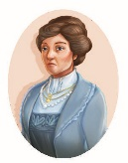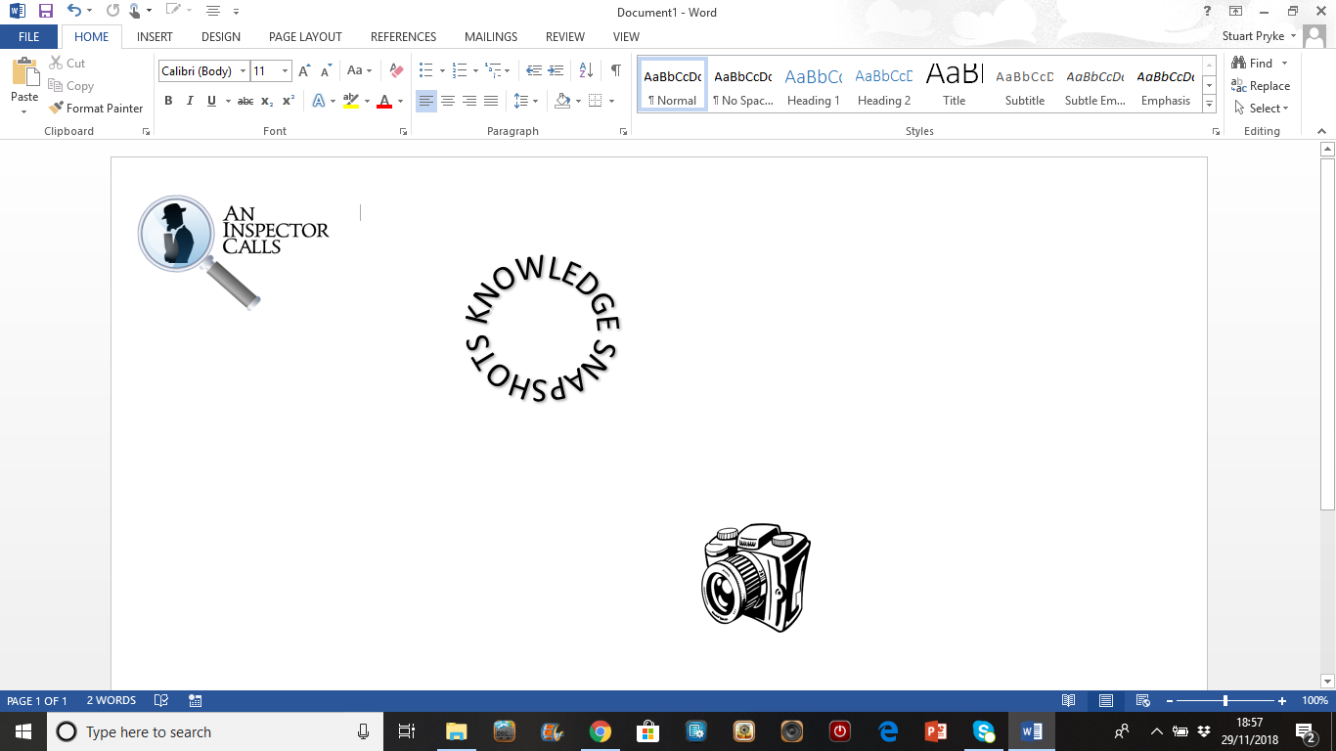

***‘He certainly didn’t make me confess.’ –* Priestley casts doubt in the minds of the Birling family so the audience can evaluate whether the Birlings have really changed. If they believe the Inspector was not real but still change their ways, the Inspector’s message has worked. As it turns out, the older generation do not change and Mrs Birling continues to be the cold woman she always was.**

***‘I’ve done nothing wrong – and you know it.’ –* Mrs Birling does not change throughout the play. She, and people like her, are the reason why the lower classes suffer. Because she is completely unwilling to accept responsibility, she unwittingly condemns her unborn grandchild to death and her son to punishment for fathering a child outside of wedlock. Although Mrs Birling does not realise the baby is her grandchild, it is interesting Priestley chooses Mrs Birling as the character who finds out Eva is pregnant. A baby that has the potential to build bridges between classes threatens the ways of people like Mrs Birling, which is why the baby has to die. There is no place for it in society and since Mrs Birling is all about self-preservation, it is her that unknowingly contributes to its untimely demise.**

***‘He’s only a boy.’* Mrs Birling demonstrates numerous times how she is not a typical maternal figure in the play. She is completely unaware of Eric’s drinking, perhaps because she has not noticed the younger generation and their difficulties growing up under the harsh set of rules imposed by the older generation. Even when Gerald and Sheila talk about Alderman Meggarty, Mrs Birling is shocked. People in the play are not who they appear to be and Mrs Birling is a chief culprit in presenting an ideal self to society as opposed to her real self.**

***‘… her husband’s social superior.’ –* The fact Mrs Birling is ‘old money’ contributes to her desire to protect herself. She is wealthy and always has been and will do anything to ensure this happens. The fact she says to Sheila ‘You’ll have to get used to that, just as I had’ shows she expects Sheila to conform to the traditional role of women in Edwardian society. Teaching the younger generation in this way ensures the future of the upper classes. Sheila is expected to behave like her mother, thus creating an upper class, capitalist cycle.**

**Mrs Birling is initially described by Priestley as being a rather ‘cold’ woman, meaning she is unapproachable and distant. Like Mr Birling, she is interested in self-preservation and will do anything to get what she wants. She sees it as her duty to protect the Birling name and is so self-involved that she neglects her duty as a mother. She is distant from Eric at the beginning of the play, an unstable relationship that contributes to the underlying tension at the beginning of the play.**

***‘In the morning they’ll be as amused as we are.’ –* Another sign that Mrs Birling does not change. Priestley makes it clear that the older generations are a lost cause. They will pay no attention to his warning of ‘fire and blood and anguish.’ The older generation will cause the war through their dated beliefs and the younger generations will be the ones to fight the war for them. Mrs Birling, as a result, is loathed by the audience for ignorance, hypocrisy and refusal to change. It’s not that she can’t change, it’s that she won’t.**

***‘’You’re a… prominent member of the Brumley Women’s Charity… aren’t you?’ –* Once again, Mrs Birling plays the part of the kind, caring upper class citizen yet uses her power in the wrong way. Priestley is warning his audiences not to be fooled by those who say they are doing good when they are not.**

***‘Girls of that class – ‘* Mrs Birling completely disregards the lower classes. Indeed, there is a hint of disgust here through the use of the word ‘that’. Priestley does this to make Mrs Birling completely unlikeable to an audience in the same way as her husband is made to look a fool. She is completely ignorant to the plight of the lower classes, believing they are a member of ‘that class’ for a reason.**

***‘(Mrs Birling enters, briskly and self-confidently)’ –* As soon as Mrs Birling meets the Inspector, her arrogance is evident. She flaunts her wealth and supposed power in front of the Inspector in an attempt to intimidate him, yet this does not work and the upper class capitalists look foolish as a result.**

***‘No – Eric – please – I didn’t know – I didn’t understand’ –* A rare moment of regret from Mrs Birling here, but is it sincere? Mrs Birling only shows remorse when she realises a member of her family is involved. She does not show true signs of change.**

Sybil Birling