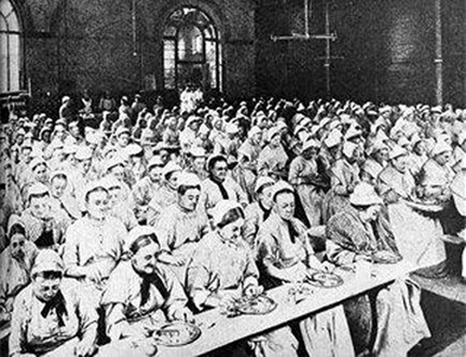

What was life like for workers in the Victorian era?

_________________________________________________________________________________________________________________________________________________________________________________________________________________________________________

What was the main reason for low wages?

__________________________________________________________________________________________________________________________________________________________________________________________________________________________________________

What were the slums like?

________________________________________________________________________________________________________________________________________________________________________________________________________________________

_________________________________________________________________________________________________________________________________________________________

What impression do you get from the picture about life in the workhouses?

____________________________________________________________________________________________________________________________________________________________________________________________________________________

____________________________________________________________________________________________________________________________________________________________________________________________________________

What were the consequences of the Great Depression?

____________________________________________________________________________________________________________________________________________________________________________________________________________

_________________________________________________________________________________________________________________________________________________________

Poverty in the Victorian era and early Twentieth Centaury.

19th century Britain saw a huge population increase accompanied by rapid urbanisation stimulated by the [Industrial Revolution](http://en.wikipedia.org/wiki/Industrial_Revolution). The large numbers of skilled and unskilled people looking for work kept wages down to a barely subsistence level. Available housing was scarce and expensive, resulting in overcrowding. These problems were magnified in London, where the population grew at record rates. Large houses were turned into flats and tenements, and as landlords failed to maintain these dwellings [slum](http://en.wikipedia.org/wiki/Slum) housing developed. [Kellow Chesney](http://en.wikipedia.org/wiki/Kellow_Chesney) described the situation as follows: "Hideous slums, some of them acres wide, some no more than crannies of obscure misery, make up a substantial part of the metropolis... In big, once handsome houses, thirty or more people of all ages may inhabit a single room." Significant changes happened in the British [Poor Law](http://en.wikipedia.org/wiki/Timeline_of_the_Poor_Law_system#1800s) system in [England and Wales](http://en.wikipedia.org/wiki/English_Poor_Laws), [Scotland](http://en.wikipedia.org/wiki/Scottish_Poor_Laws), and [Ireland](http://en.wikipedia.org/wiki/Irish_Poor_Laws). These included significant expansions in [workhouses](http://en.wikipedia.org/wiki/Workhouses) (or [poorhouses](http://en.wikipedia.org/wiki/Poorhouses) in Scotland), although with changing populations during the era.

Poverty and The Great Depression

How does your source contrast with what Mr Birling says?

____________________________________________________________________________________________________________________________________________________________________________________________________________

What was the Great Depression? How far did it spread? Who was the worst affected?

____________________________________________________________________________________________________________________________________________________________________________________________________________

What were the consequences of the Great Depression?

____________________________________________________________________________________________________________________________________________________________________________________________________________

_________________________________________________________________________________________________________________________________________________________

Mr Birling: “And we’re in for a time of steadily increasing prosperity.

**The Great Depression.**

The **Great Depression in the United Kingdom**, also known as **the Great Slump**, was a period of national economic [downturn](http://en.wikipedia.org/wiki/Recession) in the 1930s, which had its origins in the global [Great Depression](http://en.wikipedia.org/wiki/Great_Depression). It was Britain's largest and most profound [economic depression](http://en.wikipedia.org/wiki/Depression_(economics)) of the 20th century. The Great Depression originated in the United States in late 1929 and quickly spread to the world. Britain had never experienced the boom that had characterized the U.S., Germany, Canada and Australia in the 1920s, so its bust appeared less severe. Britain's world trade fell in half (1929–33), the output of heavy industry fell by a third, employment profits plunged in nearly all sectors. At the depth in summer 1932, registered unemployed numbered 3.5 million, and many more had only part-time employment.

Particularly hardest hit by economic problems were the industrial and mining areas in the north of England, Scotland, Northern Ireland and Wales. Unemployment reached 70% in some areas at the start of the 1930s (with more than 3 million out of work nationally) and many families depended entirely on payments from local government known as the dole.

**Consequences of the Great Depression**

Following the end of the Second World War, the majority of the British people, and particularly the [working class](http://en.wikipedia.org/wiki/Working_class) and returning servicemen and women, did not want a return to pre-war Conservative economic policies, which they blamed for the hardship of the 1930s, and there was a mood for widespread social change. At the [1945 general election](http://en.wikipedia.org/wiki/United_Kingdom_general_election,_1945), to the surprise of many observers, [Winston Churchill](http://en.wikipedia.org/wiki/Winston_Churchill) was defeated by the [Labour Party](http://en.wikipedia.org/wiki/UK_Labour_Party) headed by [Clement Attlee](http://en.wikipedia.org/wiki/Clement_Attlee).

The Labour government built up from pre-war foundations what was to become a comprehensive 'cradle-to-grave' [welfare state](http://en.wikipedia.org/wiki/Welfare_state), and established a tax funded [National Health Service](http://en.wikipedia.org/wiki/National_Health_Service), which gave treatment according to need rather than ability to pay as the previous tax funded system had been.