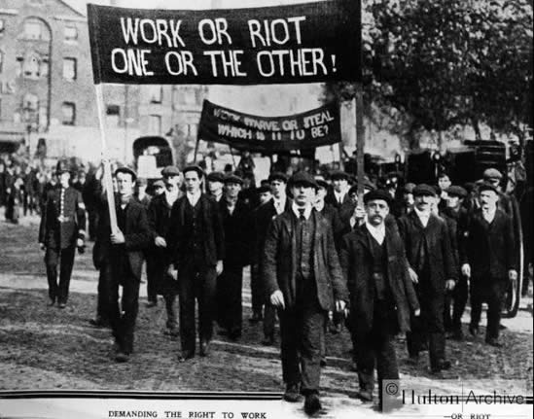

What does this source and the picture tell us about the growing unrest amongst the working class?

____________________________________________________________________________________________________________________________________________________________________________________________________

How does this go against Mr Birling’s statement?

___________________________________________________________________________________________________________________________________________________________________________________________________

___________________________________________________________________________________________________________________________________________________

**Mr Birling: “Last month, just because the miners came out on strike, there’s a lot of wild talk about possible labour trouble in the near future. Don’t worry. We’ve seen the worst of it.”**

The early 20th century saw the beginning of a movement away from an elite few controlling everything towards a situation where society tried to be more equal. There were an increasing number of strikes during this period that demonstrated this.

The second industrial revolution saw tremendous technological advances as science became industrialised. This trend generated a range of responses: although mass production ensured uniform quality at prices affordable to most people, some condemned much of the output as ugly and mourned the disappearance of craftsmanship. Some developments led to the boredom of repetitive labour in factories where appalling working conditions were rife. At the same time, the competitive advantage gained by the new science-based industries often destroyed older industries across the globe. The growing numbers of industrial workers concentrated in big cities were an important force for social change. The privations they initially suffered eventually led to the growth of trade unions and a politically mobilised working class.